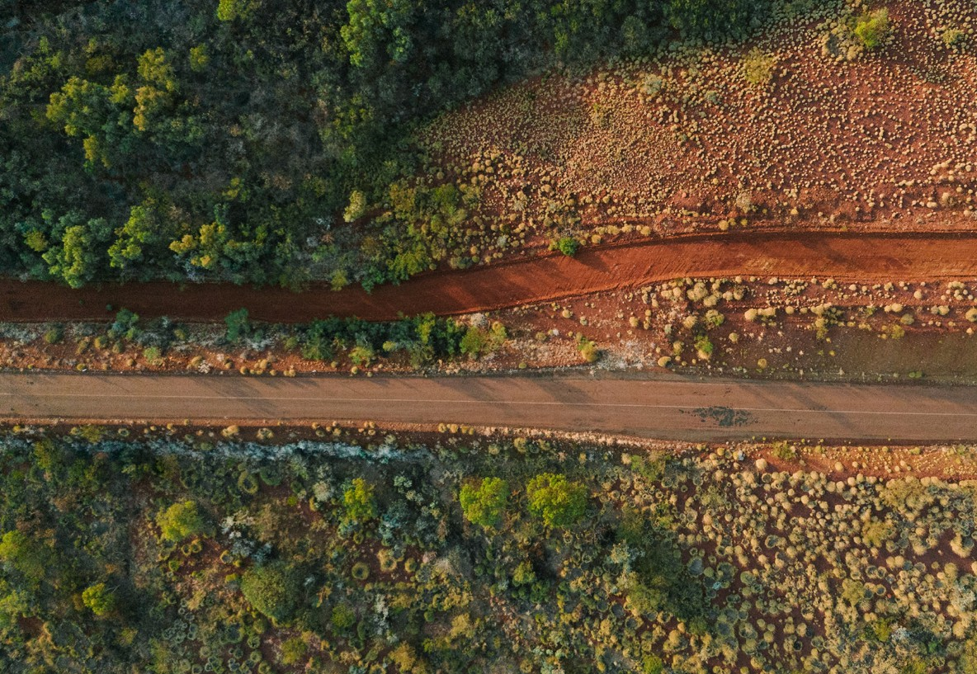




Regional Profiles
Pilbara
Total Area: 506,778 sq. km Population: 55,039 Working Zones: East Pilbara, Newman, Port Hedland and South Hedland, Ashburton, Karratha and Roebourne (maps at end of profile)

Region Selection Rationale

Exposure to decarbonisation | Potential to harness economic opportunities from decarbonisation
- Carbon intensity: High - 7 gas-fired power stations and 40 safeguards. As of 2023-24, safeguards in the region account for 68% of WA safeguard scope 1 emissions.  - Urgency: High – heavy reliance on fossil fuels, driven by energy- intensive gas extraction and iron ore mining industries.  - Adaptive capacity: Moderate (Karratha and Roebourne (average); Port Hedland and South Hedland; Newman (below average); Ashburton & East Pilbara (least adaptive)).  - Readiness: High – WA’s state government plans include expansion of renewable energy infrastructure and emission reduction. Private sector initiative: mining companies have committed to significant decarbonisation targets. | - Natural capital: substantial mineral resources, strong solar energy and green industry potential.  - Workforce compatibility: High proportion of workers in the region are in jobs highly compatible with clean energy industries.  - Enabling infrastructure: Medium – Port infrastructure, including facilities at Port Hedland and Dampier, support mineral exports and is being adapted for future renewable energy and hydrogen exports. Port Hedland airport – largest airport in region. Connected by Great Northern Highway and NW Coastal Highway.

Carbon-Intensive Industries

Gas Fired Power Stations (GFPS)

Name |  | Owner | Scope 1 emissions (tCO2-e) (23/24) | % of WA scope 1 emissions (23/24) | % of Aus scope 1 emissions (23/24)
Yurralyi Maya |  | Rio Tinto | 410,351 | 0.6% | 0.1%
Port Hedland |  | APA | 340,466 | 0.5% | 0.1%
South Hedland |  | TransAlta | 306,419 | 0.4% | 0.1%
Karratha |  | ATCO | 53,106 | 0.1% | 0.02%
Paraburdoo |  | Rio Tinto | 289,565 | 0.4% | 0.1%
West Angelas |  | Rio Tinto | 197,559 | 0.3% | 0.1%
Cape Lambert |  | Rio Tinto | 108,551 | 0.2% | 0.04%
Total | 7 | 4 | 1,706,017 | 2% | 1%

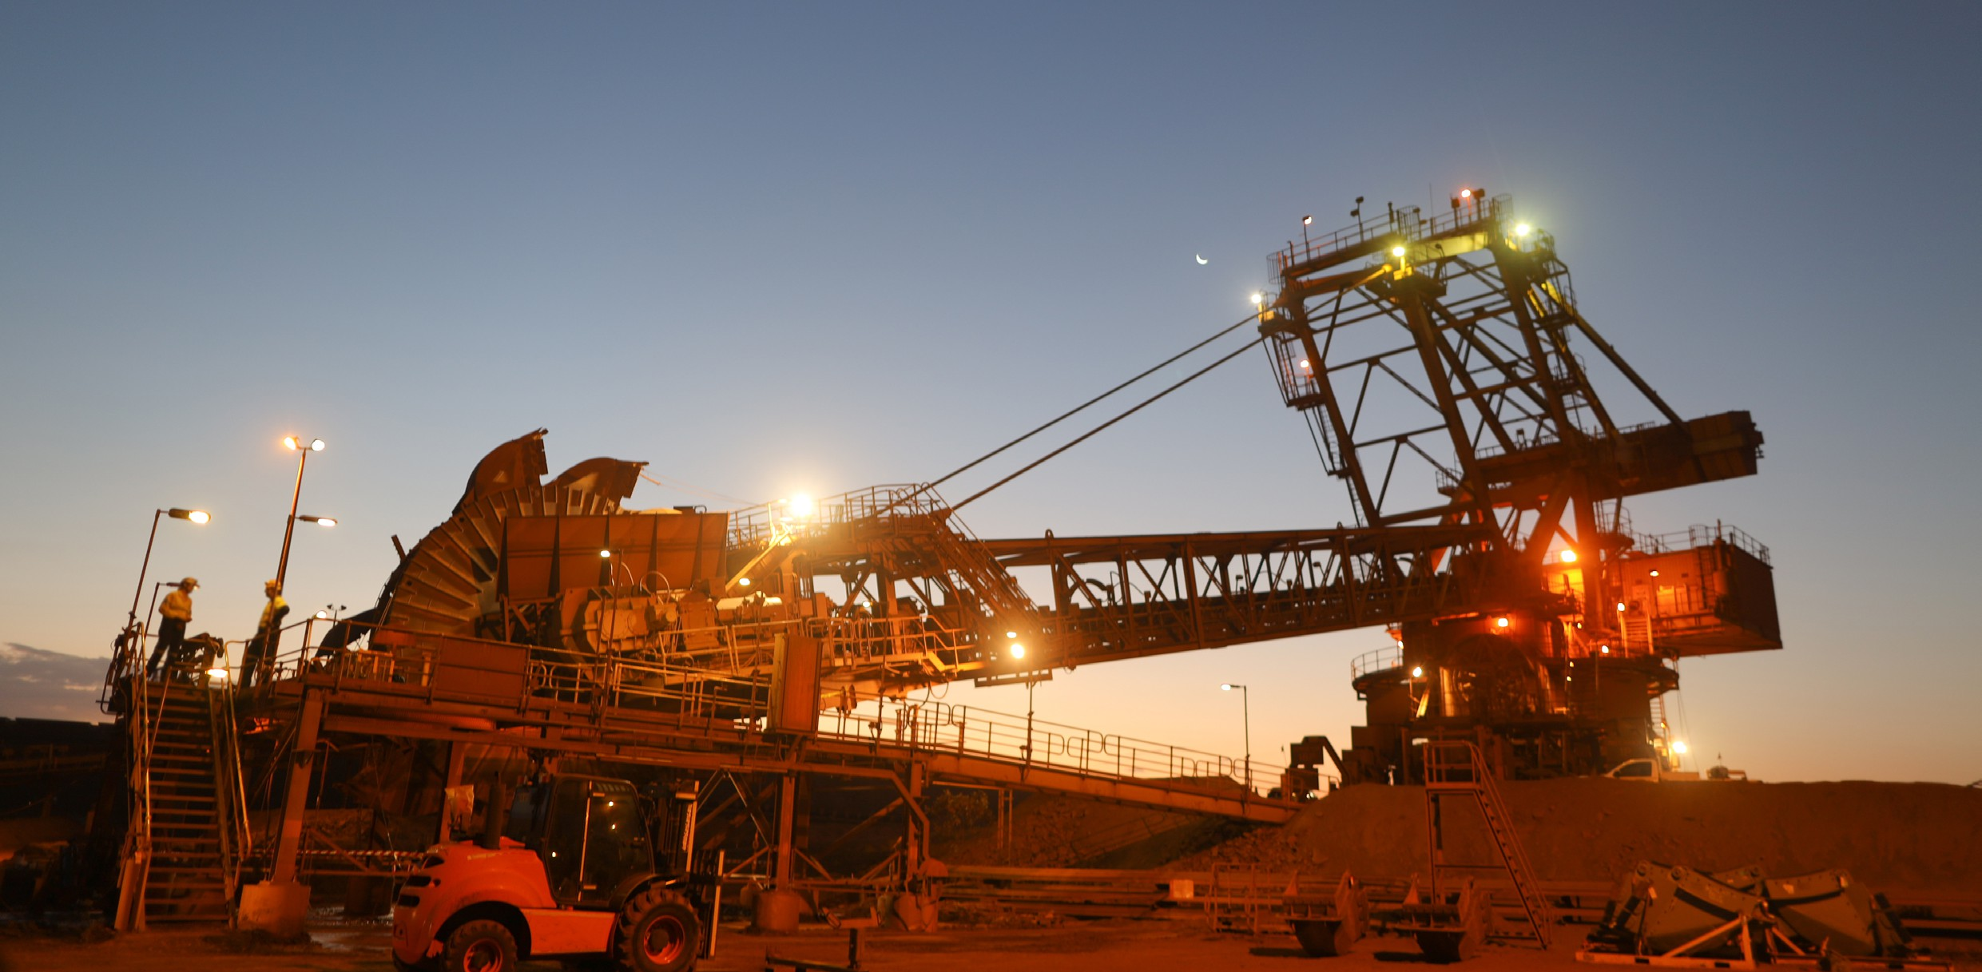

Manufacturing

Name | Owner | Scope 1 emissions (tCO2-e) (23/24) | % of WA scope 1 emissions (23/24) | % of Aus scope 1 emissions (23/24)
YPF Ammonia Plant | Yara Pilbara Fertilisers Pty Ltd | 1,366,029 | 2% | 0.5%

Safeguard Facilities (Emit 100,000+ tonnes CO2 annually - power stations connected to grid are exempt)

Type | No. | Scope 1 emissions (tCO2-e) (23/24) | % of WA scope 1 safeguard emissions (23/24) | % of Aus scope 1 safeguard emissions (23/24)
Electricity generation | 3 | 1,040,732 | 2% | 1%
Fertiliser and pesticide manufacturing | 1 | 1,366,029 | 3% | 1%
Metal ore mining | 25 | 6,855,870 | 14% | 5%
Oil & Gas Extraction | 8 | 21,716,129 | 46% | 17%
Rail freight transport | 3 | 1,470,398 | 3% | 1%
Total Safeguards | 40 | 32,449,158 | 68% | 25%

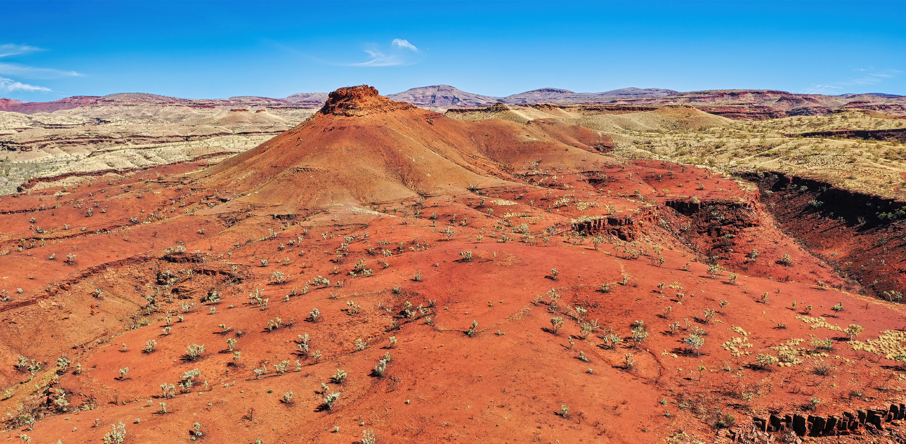

Major Industries

Gross Regional Product (GRP): $88.8 billion (20.3% of WA’s Gross State Product)

Ranked Industries with most value | Value (m) | % of GRP
Mining | $82,479 | 92.9%
Construction | $1,884 | 2.1%
Rental, Hiring & Real Estate Services | $1,090 | 1.2%
Transport, Postal & Warehousing | $635 | 0.7%
Public Administration & Safety | $351 | 0.4%

Ranked Employing Industries (by usual residence) | No. of employees (% of workforce) | Ranked Employing Industries (by place of work) | No. of employees (% of workforce)
Total labour force living in region | 27,594 | Total labour force working in region | 55,594
Mining | 9,072 (34%) | Mining | 28,014 (50%)
Construction | 2,394 (9%) | Construction | 5,554 (10%)
Education | 1,971 (7%) | Accommodation & Food Services | 2,729 (5%)
Healthcare & Social Assistance | 1,889 (7%) | Transport, Postal and Warehousing | 2,579 (5%)
Transport, Postal and Warehousing | 1,680 (6%) | Health Care and Social Assistance | 2,056 (4%)

Major Investments

Major clean energy and heavy industry projects (excluding cancelled and completed) (top 5 projects by value)

Project | Description | Category | Status | Value
Australian Renewable Energy Hub | To integrate solar and onshore wind power, green hydrogen and green ammonia for export and domestic markets | Green hydrogen | Under development | $30,000 m
Port Hedland Green Steel (POSCO) | Reduce magnetite iron ore to HBI  before being shipped to South Korea for steelmaking; the project would replace natural gas for green hydrogen to reduce carbon emissions | Green metals | Proposed | $27,000 m
Balla Balla River desalination plant | Plant will provide nearby industry 150 gigalitres per year of desalinated seawater | Water | Announced | $5,000 m
Yindjibarndi Energy Hub | Development of renewable energy and storage projects on Yindjibarndi Ngurra (country). Plans include up to 3GW of wind, solar and battery storage to be in construction in the next several years. | Renewable energy | Announced | $1,000 m
Pilbara Generation Project | A new hybrid solar gas energy solution to support the incorporation of large scale renewable energy and battery storage that will power existing projects | Renewable energy | Announced | $718 m

Transmission Infrastructure Projects

NWIS (North West Interconnected Grid System) Transmission Planning Update

Name | Description | Status | Timing | Costs
Pilbara Green Link | 550 km of transmission lines will connect Horizon Power’s infrastructure to the Australian Renewable Energy Hub (AREH) and other renewable energy projects.  Aim is to support renewable energy generation and decarbonisation efforts in the mining sector. | Announced | Construction to commence in 2025 | N/A
Transmission Upgrades | Includes various expansions to existing NWIS to improve capacity and facilitate the integration of renewable energy projects. | Ongoing | N/A | N/A

Employment

Indicator (2021 Census unless otherwise stated) | Pilbara | WA
Average working age | 37 | 37
Median income (annual gross, exc. super) | $78.0K - $91.0K | $41.6K - $52.0K
Participation in workforce | 67% | 64%
Female participation in workforce | 65% | 60%
Unemployment rate (Dec 2024) | 2.2% | 3.4%
Regional Labour Market Index (Mar 2025) | Below average | N/A

Demographics

Indicator (2021 Census) | Pilbara | WA
Median age | 32 | 38
First Nations (% of population) | 15% | 3%
Population growth (2016-2021) | -8% | 8%
Educational attainment (% of population aged 15 & above):
Below Y12 | 45% | 40%
Y12 or equivalent | 55% | 60%
Cert III & IV | 31% | 19%
Bachelor and above | 16% | 26%

Housing

Indicator (2021 Census unless otherwise stated) | Pilbara | WA
Homelessness | 0.7% | 0.4%
Commonwealth Rent Assistance (Dec 2024) | 1% | 4%
Mortgage stress | 8% | 13%
Rental stress | 9% | 28%

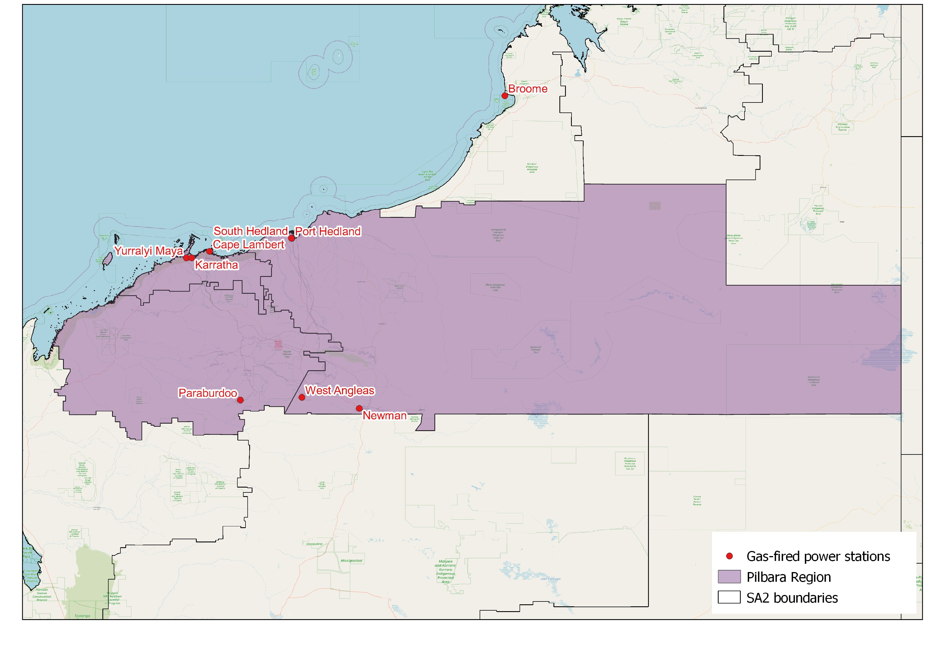
Map of Region – Power Stations and Mines

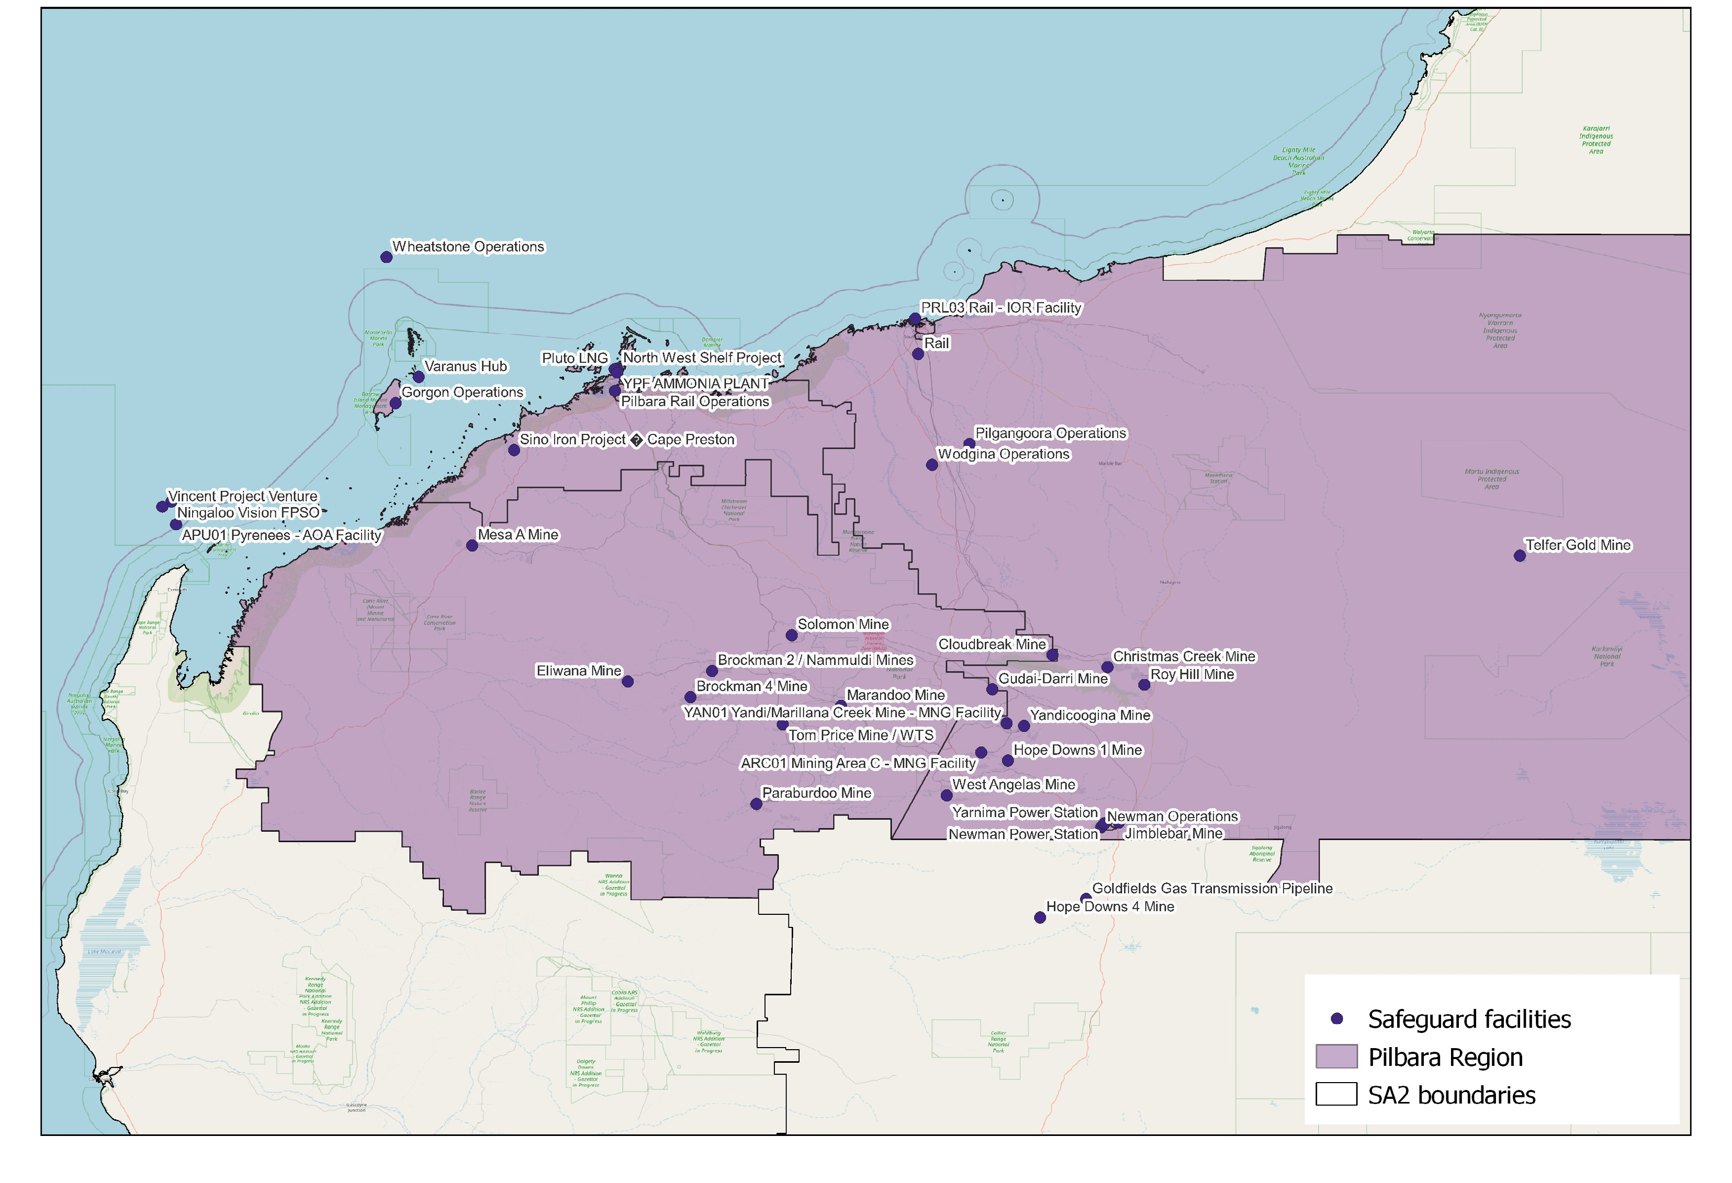
Map of Region – Safeguards

Net Zero Economy Authority | Pilbara Regional Profile | June 2025 7

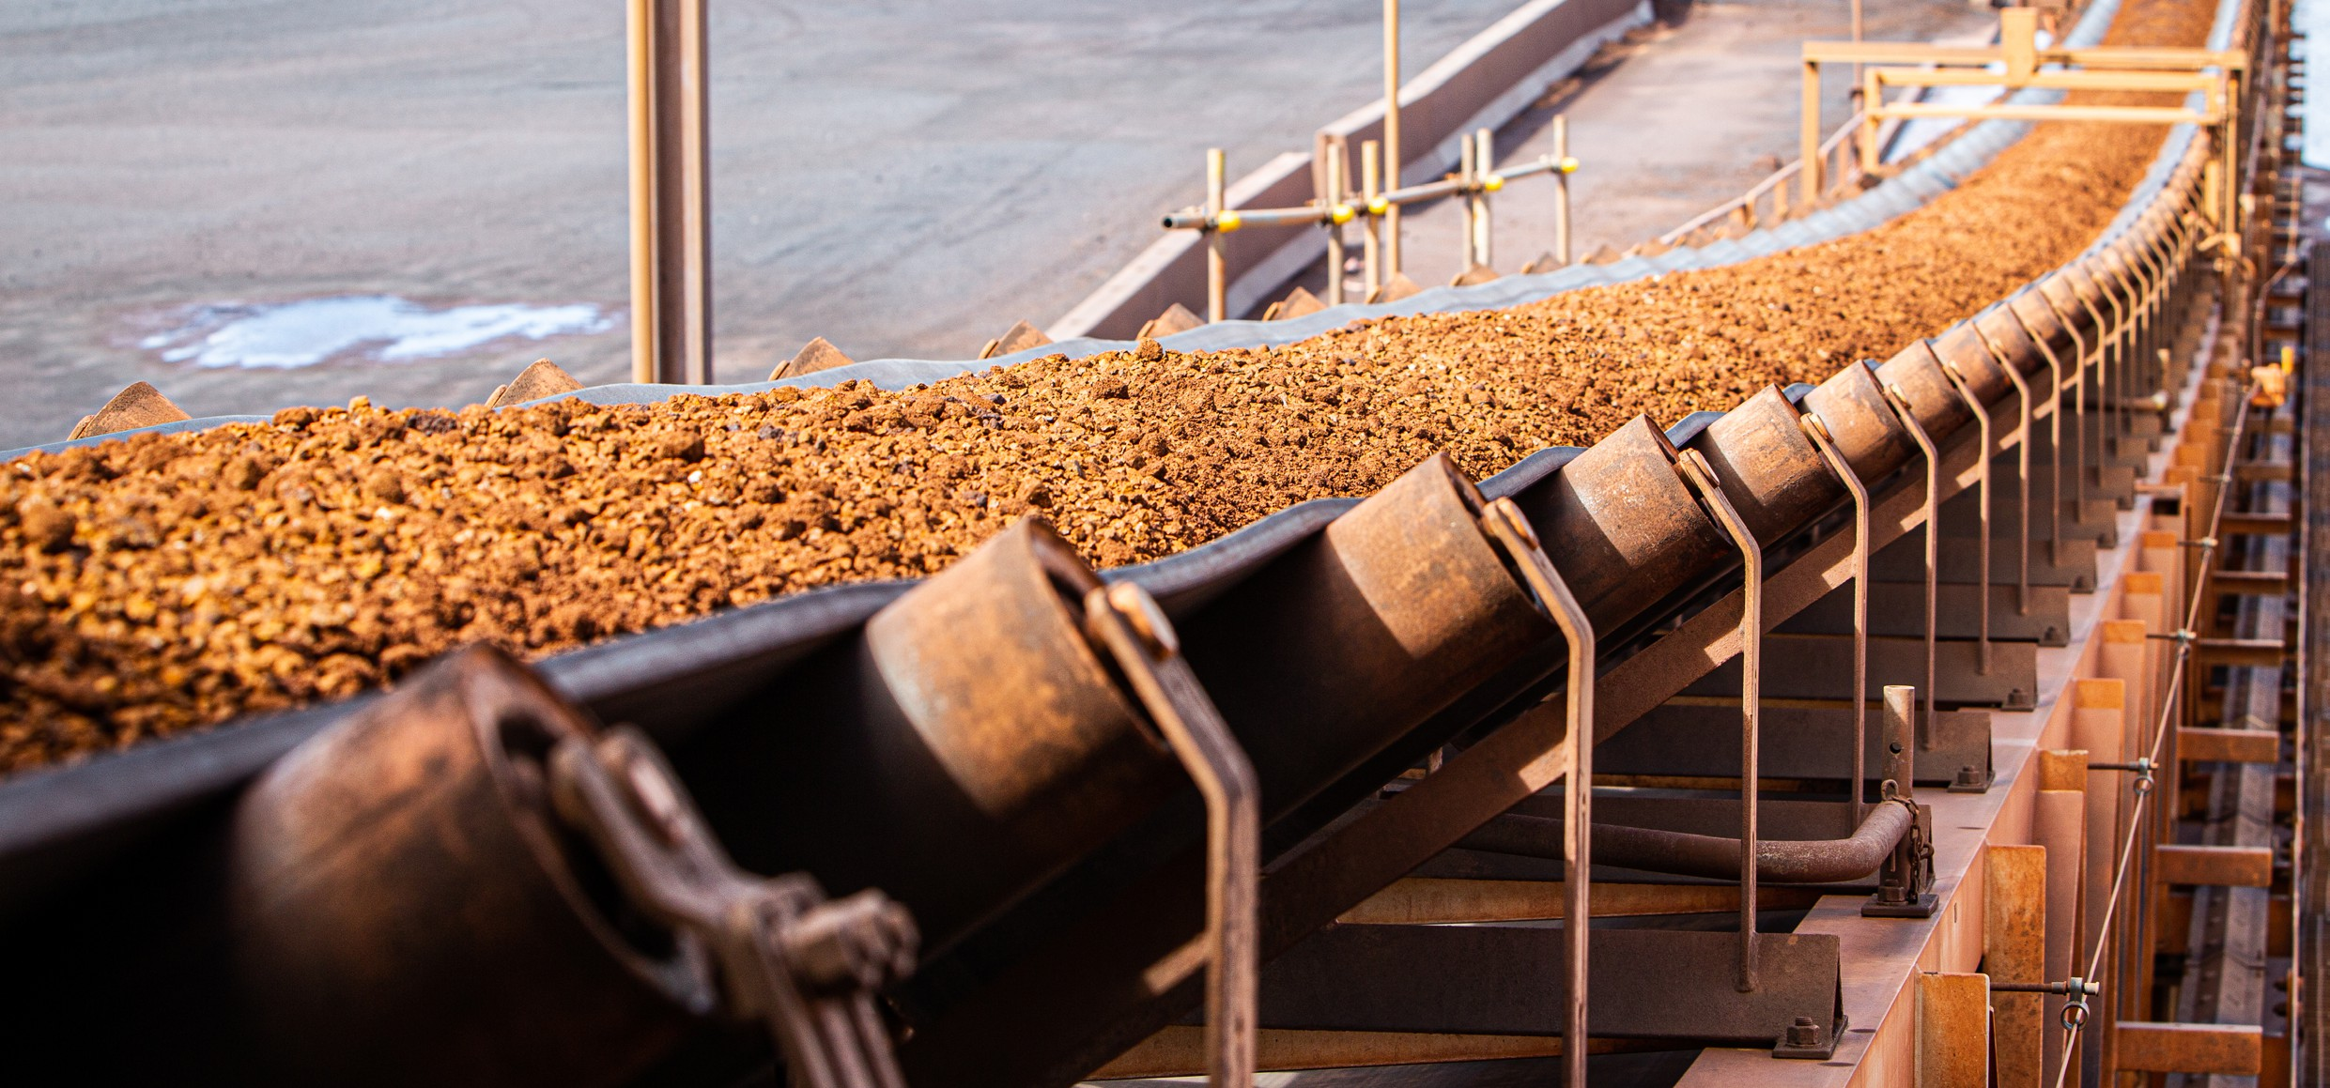

Data Sources

Section | Source | Date
Overview
Total Population | Census, ABS | 2021
Area | Mesh Blocks - SA2 Allocation Files, ABS | 2021
Region Selection Rationale
All | Regional identification framework | February 2025
Carbon Intensive Industries
Gas Fired Power Stations | Greenhouse & energy information by designated generation facility, CER (Pilbara)  Greenhouse & energy information - published data highlights (WA) | 2023-24
Manufacturing | Safeguard facilities data, CER | 2023-24
Safeguard facilities | Safeguard facilities data, CER | 2023-24
Major Industries
Ranked industries by most value | Economic dataa, REMPLAN | 2025
Ranked Employing Industries | Census, ABS | 2021
Major Investments
All | Funded projects, ARENA HyResourceb, CSIRO  Resources and Energy Major Projects, DISR | 2025  2025  2024

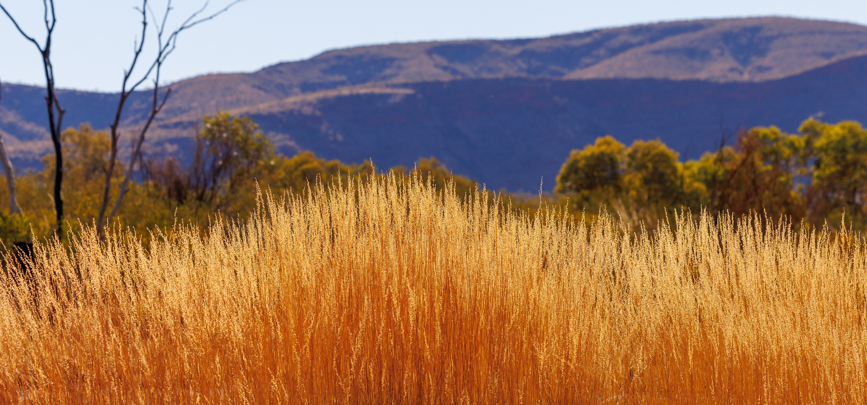

Section | Source | Date
Transmission Infrastructure Projects
Pilbara Green Link | Pilbara Green Linkc, Horizon Power | November 2024
NWIS Upgrades | $3 billion Rewiring the Nation deal to power WA jobs and growth, DCCEEW | August 2023
Employment
Average working age, median income, labour force participation | Census, ABS | 2021
Regional Labour Market Index | Regional Labour Market Indicator, Jobs and Skills Australia | March 2025
Unemployment rate:
- Pilbara  - WA | Small Area Labour Markets, Jobs and Skills Australia Labour Force, Australia, ABS | December 2024  December 2024
Demographics
All | Census, ABS | 2021
Housing
Homelessness, mortgage stress, rental stress | Census, ABS | 2021
Commonwealth Rental Assistance | Benefit and Payment Recipient Demographics - quarterly data, DSS | December 2024
Maps
All | Produced using data from Australian Bureau of Agricultural and Resource Economics and Sciences (ABARES), DAFF | December 2023
Note: All datasets maintained by third party providers listed above and date reflects most recent data available.

Data sourced using REMPLAN (incorporating ABS 2021 Census Place of Work Employment (Scaled); 2022 / 2023 National Input Output Tables; June 2024 Gross State Product figures)
Data by usual residence means only employees living in Pilbara region would be captured (regardless of whether or not they actually work in Pilbara).
Data by place of work means only employees working in Pilbara region would be captured (regardless of whether or not they actually reside in Pilbara).
Note, for purposes of calculating shares of workforce, total of 26,449 was used (total workforce minus those workers in ‘Industry of Employment’ categories listed as ‘inadequately described’ and ‘not stated’).
Note, for purposes of calculating shares of workforce, total of 53,592 was used (total workforce minus those workers in 1‘Industry of Employment’ categories listed as ‘inadequately described’ and ‘not stated’).
https://research.csiro.au/hyresource/australian-renewable-energy-hub/ (Access may be restricted on a secure network)
https://www.abc.net.au/news/2023-12-16/south-korean-green-steel-iron-ore-plans-port-hedland/103201750 (Access may be restricted on a secure network)
https://www.abc.net.au/news/2024-06-28/legacie-suez-ngarluma-pilbara-desalination-plant-balla-balla/104030948 (Access may be restricted on a secure network)
https://international.austrade.gov.au/en/news-and-analysis/success-stories/yindjibarndi-people-partner-with-acen-to- bring-clean-energy-to-western-australia
https://www.industry.gov.au/publications/resources-and-energy-major-projects-2024
https://reneweconomy.com.au/engineer-named-for-new-transmission-line-from-massive-renewable-hub-to-pilbara-iron-ore-mines/ (Access may be restricted on a secure network)
https://www.wa.gov.au/organisation/energy-policy-wa/pilbara-energy-transition-plan
Note, the Pilbara region falls within the ‘Western Australia – Outback North & South’ labour market region, where the Regional Labour Market Index (RMLI) is assessed as ‘Below average’. However, the unemployment rate is much higher across this region than it is in Pilbara, meaning using this as a proxy for Pilbara would be misleading.
Excludes ‘not stated’ and categories are not cumulative
Share of population
Share of population
Share of households where repayments are >30% of household income
Share of households where rent payments are >30% of household income
a Access may be restricted on a secure network: https://www.remplan.com.au
b Access may be restricted on a secure network: https://research.csiro.au/hyresource/projects/projects-spreadsheet/
c Access may be restricted on a secure network: https://infrastructurepipeline.org/project/pilbara-green-link

