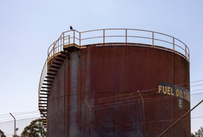




Regional Profiles
Hunter
Total Area: 33,851 sq. km Population: 1,119,685 (Hunter: 773,110; Central Coast: 346,575) Working Zones: Bulahdelah- Stroud; Central Coast & surrounds; Forster, Tuncurry & surrounds; Gloucester; Muswellbrook, Scone & surrounds; Nelson Bay Peninsula & Anna Bay; Newcastle, Lower Hunter & surrounds; Taree & surrounds (maps at end of profile)

Region Selection Rationale

Exposure to decarbonisation | Potential to harness economic opportunities from decarbonisation
- Carbon intensity: Large number of facilities (incl. 3 coal-fired power stations and 17 safeguards. As of 2023-24, safeguards in the region account for 39% of NSW safeguard scope 1 emissions); high carbon-intensive employment (Approx. 20,000 employees).  - Urgency: All coal-fired power stations projected to close by 2033.  - Adaptive capacity: Varying levels of adaptive capacity across the region, largely reflecting proximity to well-diversified economies in city centres and related education and skill level opportunities.  - Readiness: Moderate to strong position for energy transition opportunities – hydrogen hubs planned for Singleton & Newcastle, with government support flagged for Newcastle, Lower Hunter prospective projects. Several transition planning initiatives exist, but not joined up, reflecting different dynamics across Upper and Lower Hunter regions. However, the NSW Government is now establishing a Future Jobs and Investment Authority for NSW’s four coal mining regions, including the Hunter. | - Natural capital: Considerable green industry potential – including green aluminium, strong offshore wind energy resources  - Workforce compatibility: Moderate number of workers in the region are in jobs highly compatible with clean energy industries. Higher compatibility in the Muswellbrook, Scone and surrounds working zone.  - Enabling infrastructure: Strong position  - existing and proposed transport infrastructure, particularly its large regional airport and port (Newcastle Shipping  Port), will support labour mobility to meet workforce needs and connect the region’s output to global markets.

Carbon-Intensive Industries

Coal Fired Power Stations (CFPS)

Name | Owner | Public closure date | Supplying Coal Mine | S1 emiss. (tCO2-e) (23/24) | % of NSW S1 emiss. (23/24) | % of Aus S1 emiss. (23/24)
Bayswater Power Station | AGL | 2033 | Mangoola, Mt Arthur, Wilpinjong | 13,678,909 | 19% | 5%
Eraring Power Station | Origin | 2027 | Mandalong, Myuna, & three others | 13,535,335 | 19% | 4%
Vales Point Power Station | Delta | 2033 | Chain Valley (primary) | 7,043,816 | 10% | 2%
Total | 3 |  | 9+ | 34,258,060 | 47% | 11%

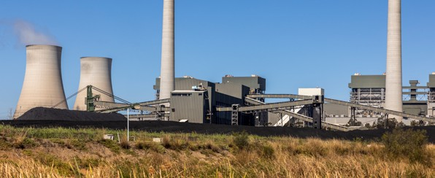

Metal Manufacturing / Refineries and Smelters

Name | Owner | PPA  expiry date | Power source | Scope 1 emissions (tCO2-e) (23/24) | % of NSW Scope 1 emissions (23/24) | % of Aus Scope 1 emissions (23/24)
Tomago Aluminium Smelter | Tomago Aluminium Company Ltd | 2028 | Bayswater CFPS | 1,159,663 | 1.6% | 0.4%

Gas Fired Power Stations

Name | Owner | Scope 1 emissions (tCO2-e) (23/24) | % of NSW Scope 1 emissions (23/24) | % of Aus Scope 1 emissions (23/24)
Colongra | Snowy Hydro Limited (Cwth gov) | 63,830 | 0.1% | 0.02%

Safeguard Facilities (Emit 100,000+ tonnes CO2 annually - power stations connected to grid are exempt)

Type | No. | Total scope 1 emissions (tCO2-e) (23/24) | % of NSW scope 1 safeguard emissions (23/24) | % of Aus scope 1 safeguard emissions (23/24)
Manufacturing | 2 | 1,642,734 | 7.3% | 1.3%
Coal mines | 15 | 7,129,811 | 31.9% | 5.6%
Total safeguards | 17 | 8,772,545 | 39.2% | 6.9%

Coal mines

Type | No.
Safeguards | 15
Non-safeguards | 5
Total | 20

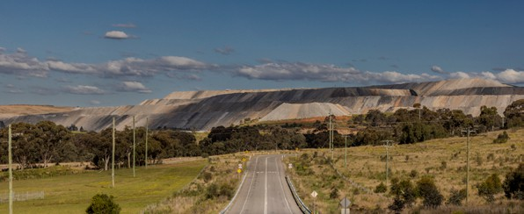

Major Industries

Gross Regional Product (GRP): $108.1 billion (14% of NSW’s Gross State Product)

Ranked Industries with most value | Value (m) | % of GRP
Mining | $31,509 | 29.2%
Rental, Hiring & Real Estate Services | $12,363 | 11.4%
Health Care & Social Assistance | $10,471 | 9.7%
Construction | $8,401 | 7.8%
Public Administration & Safety | $5,937 | 5.5%
Hunter

Ranked Employing Industries (by usual residence) | No. of employees (% of workforce) | Ranked Employing Industries (by place of work) | No. of employees (% of workforce)
Total labour force living in region | 336,495 | Total labour force working in region | 312,965
Health Care and Social Assistance | 61,190 (18%) | Health Care and Social Assistance | 57,879 (18%)
Retail & Wholesale Trade | 40,139 (12%) | Retail & Wholesale Trade | 38,741 (12%)
Construction | 33,132 (10%) | Education and Training | 28,616 (9%)
Education and Training | 29,995 (9%) | Construction | 26,970 (9%)
Accommodation and Food Services | 26,322 (8%) | Accommodation and Food Services | 25,590 (8%)

Central Coast

Ranked Employing Industries (by usual residence) | No. of employees (% of workforce) | Ranked Employing Industries (by place of work) | No. of employees (% of workforce)
Total labour force living in region | 144,753 | Total labour force working in region | 112,242
Health Care and Social Assistance | 26,792 (19%) | Health Care and Social Assistance | 24,006 (21%)
Retail & Wholesale Trade | 18,714 (13%) | Retail & Wholesale Trade | 16,010 (14%)
Construction | 17,370 (12%) | Construction | 10,626 (9%)
Education and Training | 12,413 (9%) | Education and Training | 10,224 (9%)
Accommodation and Food Services | 10,578 (7%) | Accommodation and Food Services | 9,986 (9%)

Major Investments

Clean energy and heavy industry projects (excluding cancelled and completed) (top projects by value)

Project | Description | Category | Status | Value
AGL Energy – Liddell Large Scale Battery with  advanced inverters | Project involves the construction and operation of a 500 MW / 1000 MWh battery with advanced inverters at the retired Liddell Power Station in Muswellbrook, New South Wales. | Battery storage | Under construction | $695 m
Bowmans Creek Wind Farm | Stage 1 involves 54 wind turbines, and scoping of stage 2 proposes an additional 21 wind turbines | Renewable energy | Announced | $569 m
Waratah Super Battery | Will allow network operators to move greater amounts of electricity over existing transmission lines and to ‘shock absorb’ during power surges | Infrastructure | Reached mechanical completion and will be fully operating later in 2025 | $500 m
Hunter Valley Hydrogen Hub | Project proponent is progressing large- scale renewables-based hydrogen project located in the Newcastle industrial and port precinct. | Hydrogen | Under development | $250 m
Liddell Solar Manufacturing Hub | Establishment of solar panel manufacturing plant in Upper Hunter at site of former Liddell Power Station | Renewable energy | Feasibility | Unknown

Transmission Infrastructure Projects

AEMO Final 2024 Integrated System Plan transmission infrastructure projects

Name | Description | Status (Draft 2024 ISP Status) | Timing  (Draft 2024 ISP Timing) | Costs
Hunter-Central Coast REZ Network Infrastructure Project | Substation upgrades to supply generation from the Hunter and Central Coast to Sydney, Newcastle and Wollongong load centres. | Actionable (previously listed as Future) | Dec 2027  (previously 2027-28) | $59 m (±50%)
Sydney Ring South | Switching station and modular power flow controllers to reinforce supply to Sydney, Newcastle and Wollongong load centres. | Actionable (previously listed as Future) | Sep 2028  (previously Dec 2027) | $221 m (±50%)
Sydney Ring North (Hunter Transmission Project) | High capacity 500 kV transmission network to reinforce supply to Sydney, Newcastle and Wollongong load centres. | Actionable (unchanged from Draft 2024 ISP) | Dec 2028  (previously Dec 2027) | $1,100 m (±50%)
New England REZ Network  Infrastructure project | Three separate projects to increase the transfer capability between central and northern NSW, enable more transfer capacity out of QLD-NSW Interconnector, and expand the New England REZ. | Actionable (unchanged from Draft 2024 ISP) | Part 1 Jun 2031  Part 2 Jun 2033 (previously Sep 2028) | $3,700 m (±50%)  (estimate includes the three separate projects

Employment
Hunter

Indicator (2021 Census unless otherwise stated) | Hunter | NSW
Average working age | 39 | 38
Median income (annual gross, exc. super) | $33.8K - $41.6K | $41.6K - $52.0K
Participation in workforce | 58% | 59%
Female participation in workforce | 55% | 56%
Unemployment rate (Dec 2024) | 3.4% | 3.8%
Regional Labour Market Index (Dec 2024) | Below average | N/A
Central Coast

Indicator (2021 Census unless otherwise stated) | Central Coast | NSW
Average working age | 40 | 38
Median income (annual gross, exc. super) | $33.8K - $41.6K | $41.6K - $52.0K
Participation in workforce | 56% | 59%
Female participation in workforce | 53% | 56%
Unemployment rate (Dec 2024) | 3.0% | 3.8%
Regional Labour Market Index (Dec 2024) | Above average | N/A

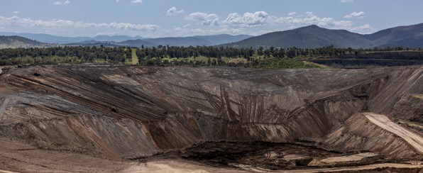

Demographics
Hunter

Indicator (2021 Census) | Hunter | NSW
Median age | 41 | 38
First Nations (% of population) | 6% | 3%
Population growth (2016-21) | 9% | 8%
Educational attainment (% of population aged 15 & above): | 54% | 39%
- Below Y12 | 54% | 39%
- Y12 or equivalent | 46% | 61%
- Cert III & IV | 22% | 16%
- Bachelor and above | 18% | 30%
Central Coast

Indicator (2021 Census) | Central Coast | NSW
Median age | 42 | 38
First Nations (% of population) | 5% | 3%
Population growth (2016-21) | 6% | 8%
Educational attainment (% of population aged 15 & above): | 51% | 39%
- Below Y12 | 51% | 39%
- Y12 or equivalent | 49% | 61%
- Cert III & IV | 21% | 16%
- Bachelor and above | 18% | 30%

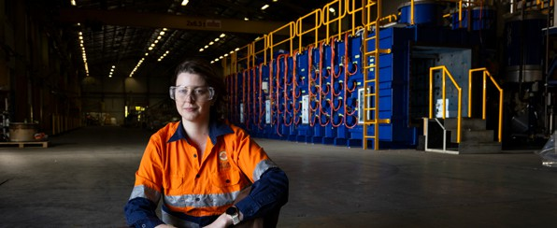

Housing
Hunter

Indicator (2021 Census unless otherwise stated) | Hunter | NSW
Homelessness | 0.3% | 0.4%
Commonwealth Rent Assistance (Dec 2024) | 7% | 6%
Mortgage stress | 12% | 17%
Rental stress | 37% | 36%
Central Coast

Indicator (2021 Census unless otherwise stated) | Central Coast | NSW
Homelessness | 0.2% | 0.4%
Commonwealth Rent Assistance (Dec 2024) | 8% | 6%
Mortgage stress | 15% | 17%
Rental stress | 42% | 36%

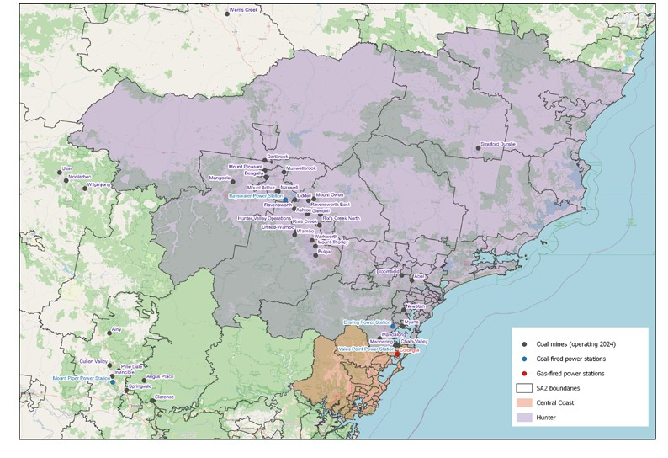
Map of Region – Power Stations and Mines

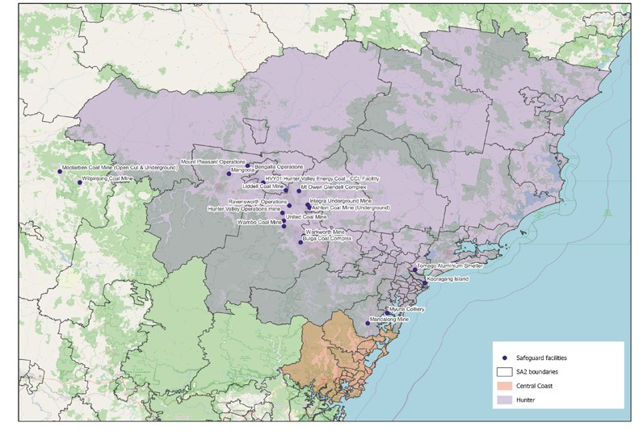
Map of Region – Safeguards

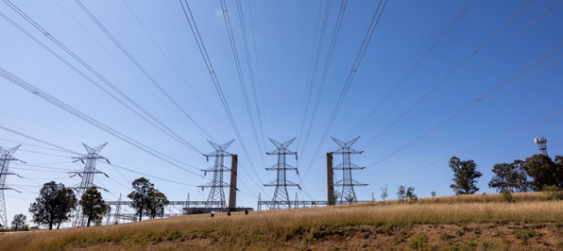

Data Sources

Section | Source | Date
Overview
Total Population | Census, ABS | 2021
Area | Mesh Blocks - SA2 Allocation Files, ABS | 2021
Priority Region Selection Rationale
All | Regional identification framework | February 2025
Emissions | Safeguard facilities data, CER | 2023-24
Carbon Intensive Industries
Coal Fired & Gas Fired Power Stations | Greenhouse and energy information by designated generation facility, CER (Hunter)  Greenhouse and energy information - published data highlights (NSW) | 2023-24
Coal mines | Safeguard facilities data, CER | 2023-24
Safeguard facilities | Safeguard facilities data, CER | 2023-24
Major Industries
Ranked Industries by most value | Economic dataa, REMPLAN | 2025
Ranked Employing Industries | Census, ABS | 2021
Major Investments
All | Funded projects, ARENA HyResourceb, CSIRO  Resources and Energy Major Projects, DISR | 2025  2025  2024

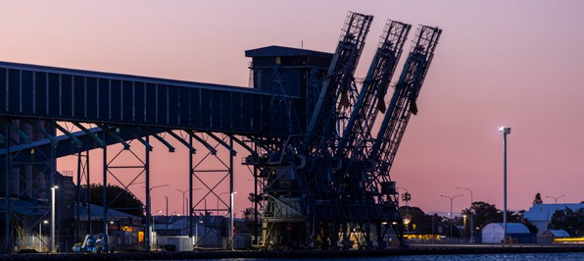

Section | Source | Date
Transmission Infrastructure Projects
All | Integrated System Planc, AEMO | June 2024
Employment
Average working age, median income, labour force participation | Census, ABS | 2021
Regional Labour Market Index | Regional Labour Market Indicator, Jobs Skills Australia | December 2024
Unemployment rate:  - Hunter  - NSW | Small Area Labour Markets, Jobs & Skills Australia Labour Force, Australia, ABS | December 2024  December 2024
Demographics
All | Census, ABS | 2021
Housing
Homelessness, mortgage stress, rental stress | Census, ABS | 2021
Commonwealth Rental Assistance | Benefit and Payment Recipient Demographics - quarterly data, DSS | December 2024
Maps
All | Produced using data from Australian Bureau of Agricultural and Resource Economics and Sciences (ABARES), DAFF | December 2023

Note: All datasets maintained by third party providers listed above and date reflects most recent data available.

S1 emiss. indicates Scope 1 Emissions (2023/24)
Note, NSW Scope 1 Emissions includes ACT Scope 1 Emissions
Note, NSW Scope 1 Emissions includes ACT Scope 1 Emissions
See above
See above
Mannering Colliery operates as part of an integrated mining operation with Chain Valley
Data sourced using REMPLAN (incorporating ABS 2021 Census Place of Work Employment (Scaled); 2022 / 2023 National Input Output Tables; June 2024 Gross State Product figures)
Note, this table has been produced looking at both Hunter and Central Coast regions (but does not include Forster, Tuncurry and Taree areas).
Data by usual residence means only employees living in Hunter region would be captured (regardless of whether or not they actually work in Hunter).
Data by place of work means only employees working in Hunter region would be captured (regardless of whether or not they actually reside in Hunter).
Note, for purposes of calculating shares of workforce, total of 454,135 was used (total workforce minus those workers in ‘Industry of Employment’ categories listed as ‘inadequately described’ and ‘not stated’).
Note, for purposes of calculating shares of workforce, total of 400,964 was used (total workforce minus those workers in ‘Industry of Employment’ categories listed as ‘inadequately described’ and ‘not stated’).
Data by usual residence means only employees living in Hunter region would be captured (regardless of whether or not they actually work in Hunter).
Data by place of work means only employees working in Hunter region would be captured (regardless of whether or not they actually reside in Hunter).
Note, for purposes of calculating shares of workforce, total of 454,135 was used (total workforce minus those workers in ‘Industry of Employment’ categories listed as ‘inadequately described’ and ‘not stated’).
Note, for purposes of calculating shares of workforce, total of 400,964 was used (total workforce minus those workers in ‘Industry of Employment’ categories listed as ‘inadequately described’ and ‘not stated’).
Note, this does not include Newcastle. The neighbouring SA4 of Newcastle and Lake Macquarie has an ‘Above average’ score.
Excludes ‘not stated’ and categories are not cumulative
Excludes ‘not stated’ and categories are not cumulative
Share of population
Share of population
Share of households where repayments are >30% of household income
Share of households where rent payments are >30% of household income
Share of population
Share of population
Share of households where repayments are >30% of household income
Share of households where rent payments are >30% of household income
a Access may be restricted on a secure network: https://www.remplan.com.au
b Access may be restricted on a secure network: https://research.csiro.au/hyresource/projects/projects-spreadsheet/
c Access may be restricted on a secure network: https://aemo.com.au/en/energy-systems/major-publications/integrated- system-plan-isp/2024-integrated-system-plan-isp

