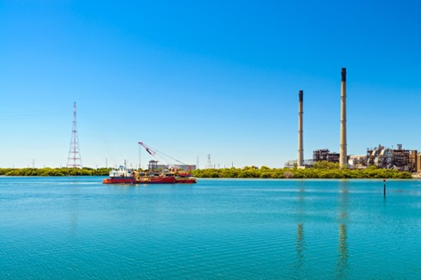



Adelaide

Regional Profiles

Overview
Adelaide is one of Australia’s largest gas-fired electricity producers, supplying electricity to the National Electricity Market (NEM). Gas-fired power stations in Adelaide contributes substantial benefits to the local economy; however, three power stations are expected to close over the next decade. This change represents challenges for some workers and the surrounding communities. However, the region is also well placed to benefit from changes associated with decarbonisation.
 | Population (2025)  - 1,217,212 persons  - 1.4% 5-year avg. annual Growth  - SA: 1.2% 5-year avg. annual Growth |  | Total Area  - 1,352.4 km²  - 0.1% of SA
 | Gross Regional Product (2022-23)  - $110.3 Billion  - 66.9% of SA |  | Employment (2022-23)  - 595,282 persons  - 71.3% of SA
Working Zones: Central and Hills, Adelaide – North, Adelaide – South, Adelaide – West (excluding Adelaide Hills and Onkaparinga Statistical Areas level 3 [SA3s]) (maps at end of profile).

Region Focus Rationale
Exposure to Decarbonisation | Economic Opportunities from Decarbonisation
- Carbon Intensity: Adelaide has 8 gas-fired power stations and 2 safeguard facilities. As of 2024-25, safeguards in the region account for 22.2% of South Australia’s safeguard scope 1 emissions. Approximately 1.4% of jobs in the region are potentially impacted by decarbonisation.  - Urgency: The region is heavily reliant on fossil fuels, particularly gas. Osborne power station is expected to close in 2027, Torrens Island is expected to close in 2028, and Dry Creek is expected to close in 2030. All other power stations are not expected to close until 2037 and beyond.  - Adaptive Capacity: Adaptive capacity to change is supported by high-levels of high school completion and economic diversity.  - Readiness: The legislative framework for the Energy Industry Jobs Plan (EIJP) commenced on 11 December 2024, with the commencement of the Net Zero Economy Authority Act 2024 (the Act). On 20 November 2025, the Fair Work Commission made a community of interest determination to formally establish the EIJP at Torrens Island B Power Station. The determination enlivens obligations under the EIJP requiring AGL to provide access to transition supports to its employees impacted by the closure. | - Natural Capital: Given its role as South Australia’s capital and metropolitan layout, Adelaide has limited capacity for large-scale renewable energy development compared to regional and rural areas.  - Workforce Compatibility: Approximately 8.9% of workers in Adelaide are employed in jobs highly compatible with clean energy industries.  - Enabling Infrastructure: Key infrastructure includes the Port of Adelaide and Adelaide Airport. This infrastructure supports global trade and labour mobility into and out of the region. The region is also connected by well-established road network and connecting freight and passenger railway connections.
Source: NZEA (2026).

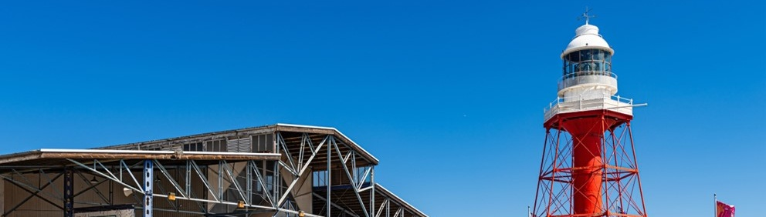
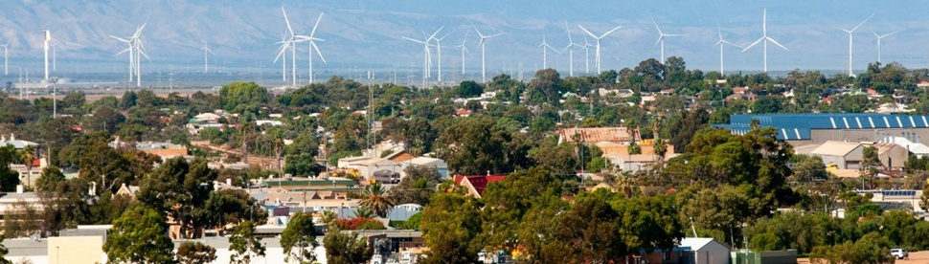
Carbon-Intensive Industries

Gas-Fired Power Stations
Facility | Owner | Public closure date | Employees | S1 emiss. (tCO2-e) (23/24) | % of SA S1 emiss. (23/24) | % of Aus S1 emiss. (23/24)
Barker Inlet | AGL | 2044 | Incl. In Torres Island PS | 163,814 | 0.6% | <0.1%
Bolivar | Iberdrola Australia Energy Markets Pty Ltd | 2045 | 5 | 23,494 | 0.1% | <0.1%
Dry Creek | ENGIE | 2030 | 2 | 12,596 | 0.0% | <0.1%
Osborne | ATCO and Origin Energy | 2027 | 24 | 156,932 | 0.6% | <0.1%
Pelican Point | ENGIE | 2037 | 30 | 677,090 | 2.7% | 0.1%
Quarantine | Origin Energy | 2044-55 | 7 | 72,916 | 0.3% | <0.1%
Snapper Point | Nexif and RATCH | 2046 | N/A | 26,704 | 0.1% | <0.1%
Torrens Island | AGL | 2028 | 200 | 370,328 | 1.5% | 0.1%
Total 8 | 7 | - | 268 | 1,503,874 | 5.9% | 0.2%
Note: S1 emiss. indicates Scope 1 Emissions. Further information on Scope 1 emissions can be found here.
Source: AEMO (2026a), DCCEEW (2025a, 2025b).

Safeguard Facilities (Emit 100,000+ tonnes CO2 annually – power stations connected to grid are exempt)
Facility | Employees | S1 emiss. (tCO2-e) (24/25) | % of SA Safeguard emiss. (24/25) | % of Aus Safeguard emiss. (24/25)
Birkenhead Operations (Cement, lime, plaster & concrete manufacturing) | 185 | 796,132 | 19.0% | 0.6%
Orora Glass Plant Gawler | 25 | 134,492 | 3.2% | 0.1%
Total 2 | 210 | 930,624 | 22.2% | 0.7%
Note: S1 emiss. indicates Scope 1 Emissions. Further information on Scope 1 emissions can be found here.
Source: CER (2026).

Major Commonwealth Funded Net Zero Projects (excluding cancelled and completed) (top projects by value)
This table reflects projects that have received Commonwealth funding (as of April 2026), identified through publicly available sources, consistent with the Net Zero Investment Map, including the programs below.
- Capacity Investment Scheme (CIS)
- Australia Renewable Energy Agency (ARENA)
- Clean Energy Finance Corporation (CEFC)
- Northern Australian Infrastructure Facility (NAIF)
- National Reconstruction Fund (NRF)
- Regional Hydrogen Hubs Program
Project | Description | Status | Cwth Govt Funding | Value
Tindo Mawson Lakes Facility Upgrade | Tindo will scale up the production of solar photovoltaic (PV) modules at its existing Mawson Lakes module manufacturing facility. Tindo will sell the solar PV modules produced in connection with this project to the domestic solar market with potential for export sales. | Concept | $34.5M ARENA | $35.8M
SA DEM Remote Area Energy Supply Project | This project involves deploying renewable energy microgrids in remote South Australian First Nations communities to improve the reliability and sustainability of energy supplies. | Concept | $13.0M ARENA | $27.7M
SA Power Networks - Electrification and Demand Flexibility | The project will recruit a minimum of 500 households in South Australia to demonstrate the customer and industry benefits of demand flexibility and smart electric homes and identify levers to support their deployment at scale. | Concept | $6.2M ARENA | $13.8M
SA Power Networks EV Charging & Resilience Community Batteries | This project involves deploying eight front-of-meter Community Batteries at network constrained regional locations within the SA Power Networks (SAPN) distribution network. | Concept | $5.4M ARENA | $10.8M
HILT CRC - upgrading iron ore for DRI production using seawater | HILT CRC will lead the development of a scalable hydrometallurgical caustic leaching process to upgrade iron ore using the reagents derived from seawater reverse osmosis (RO) brines. | Concept | $1.4M ARENA | $5.7M
Note: Information correct as of April 2026.
Source: Net Zero Investment Map (2026).

Regional Renewable Energy Projects (aggregated)
The aggregated tables below draw on RenewMap’s energy project database which contains information on the location and size of public and privately funded energy generation projects. Results are shown in aggregated form to illustrate the breadth and depth of projects in the region.

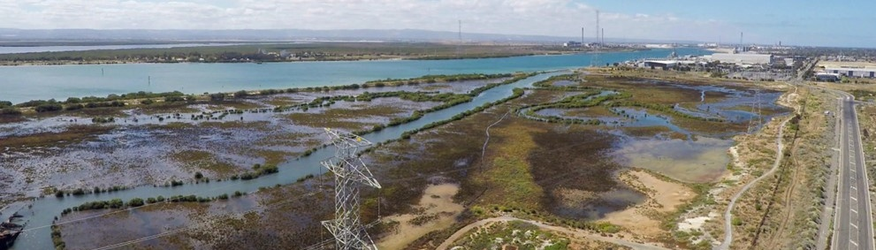
Operational
Type | Projects (No.) | Total Project Size (MW) | Total Storage Size (MWh)
Battery | 4 | 263 | 265
Biogas | 3 | 18 | N/A
Hydrogen | 2 | 1 | N/A
Solar PV | 1 | 8 | N/A
Total | 10 | 290 | 265 (Known Storage)
Note:
- RenewMap is a commercial subscription and is not publicly available.
- MW = Megawatt. A unit that measures capacity of energy systems.
- MWh = Megawatt hour. In battery technology, this unit measures the total amount of energy the system can store.
- Information correct as of April 2026.
Source: RenewMap (2026).

Under Development and Proposed
Type | Projects (No.) | Total Project Size (MW) | Total Storage Size (MWh)
Battery | 4 | 785 | 510
Hydrogen | 1 | 60 | N/A
Total | 5 | 845 | 510 (Known Storage)
Note:
- RenewMap is a commercial subscription and is not publicly available.
- MW = Megawatt. A unit that measures capacity of energy systems.
- MWh = Megawatt hour. In battery technology, this unit measures the total amount of energy the system can store.
- Information correct as of April 2026.
Source: RenewMap (2026).

Transmission Infrastructure Projects

Australian Energy Market Operator (AEMO) Draft 2026 Integrated System Plan (ISP)
Project | Description | Status | Timing | Cost
Northern Transmission Project | New 275 kV and 132 kV transmission lines to connect renewable generation to Adelaide and to supply increasing industrial load. | Actionable | Jul 2029 | $620.0M (±50%)
Note: ± indicates the cost uncertainty range.
Source: AEMO (2026b).

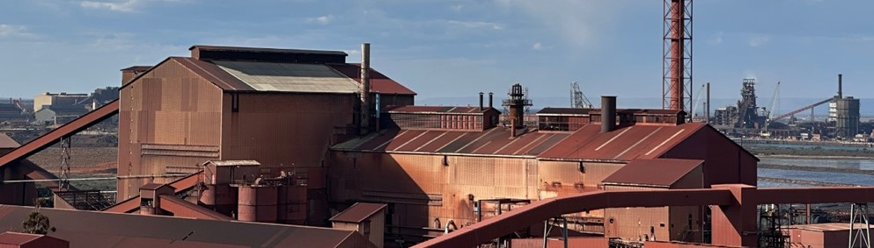
Major Industries

Gross Value Add (2022-23)
Ranked Industries (Top Five) | Value ($M) | % of GVA
Rental, Hiring & Real Estate Services | $13,412.8 | 12.9%
Health Care & Social Assistance | $11,982.5 | 11.6%
Public Administration & Safety | $9,362.6 | 9.0%
Financial & Insurance Services | $8,838.9 | 8.5%
Construction | $8,306.9 | 8.0%
Note: Gross Value Add estimates are sourced from REMPLAN (2026), incorporating Australia Bureau of Statistics (ABS) 2021 Census (PoW), ABS 2024 Estimated Resident Population, ABS 2022–23 National Input–Output Tables, and ABS June 2025 Gross State Product into its modelling. Gross Value Add (GVA) measures the value of goods and services produced, minus the cost inputs used in production. Further information on GVA can be found here.
Source: REMPLAN (2026).

Employment

Place of Work (2022-23)
Ranked Industries (Top Five) | Employees (No.) | % of Employment
Health Care and Social Assistance | 107,871 | 18.1%
Retail Trade | 57,940 | 9.7%
Education and Training | 55,103 | 9.3%
Construction | 50,293 | 8.4%
Public Administration and Safety | 46,809 | 7.9%
Note: Employment by Place of Work (PoW) estimates are sourced from REMPLAN (2026), incorporating Australia Bureau of Statistics (ABS) 2021 Census by PoW, ABS 2024 Estimated Resident Population, ABS 2022–23 National Input–Output Tables, and ABS June 2025 Gross State Product into its modelling.
Source: REMPLAN (2026).

Place of Usual Residence (2021)
Ranked Industries (Top Five) | Employees (No.) | % of Employment
Health Care and Social Assistance | 93,374 | 17.7%
Retail Trade | 52,343 | 9.9%
Manufacturing | 49,493 | 9.4%
Education and Training | 43,623 | 8.2%
Agriculture, Forestry and Fishing | 40,294 | 7.6%
Source: ABS (2021).

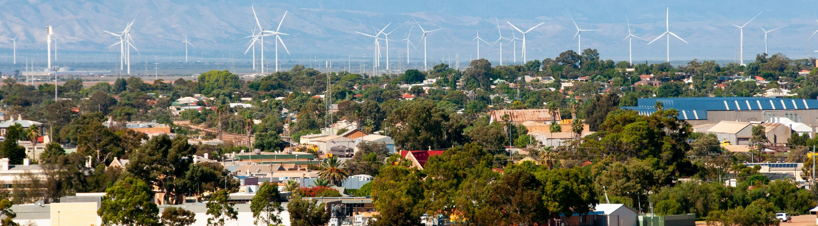
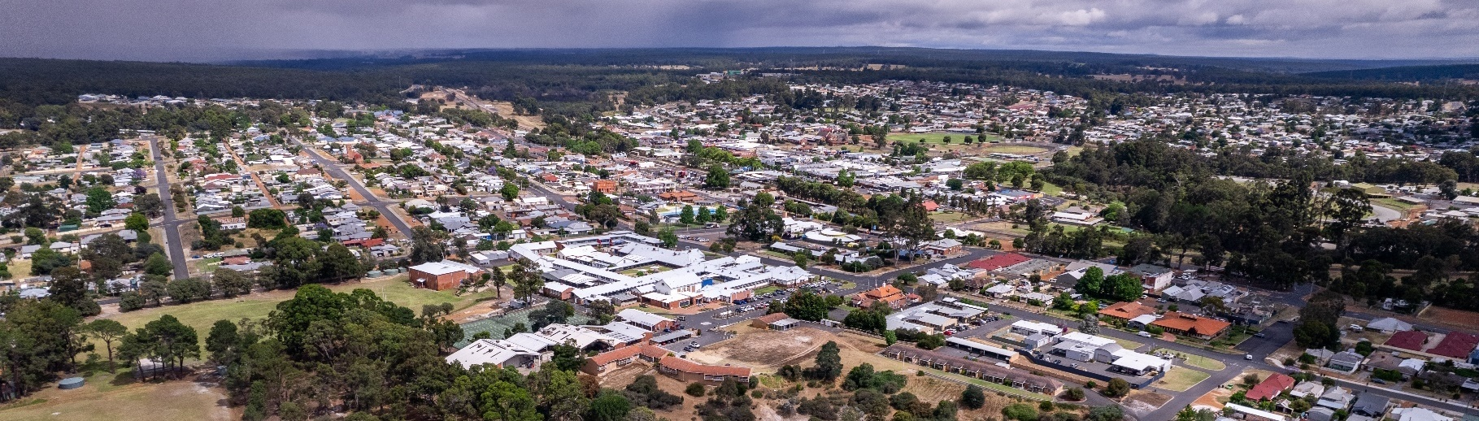
Key Economic and Social Indicators

Employment
Indicator (2021 Census unless otherwise stated) | Adelaide | South Australia
Median working age | 39 | 40
Median income (annual gross, exc. super) | $41,600 – $51,999 | $41,600 – $51,999
Participation in workforce | 61.7% | 60.0%
Female participation in workforce | 58.1% | 56.8%
Workforce Self-Sufficiency (% of Workforce) | 87.2% | N/A
Unemployment rate (Dec 2025) | 3.8% | 4.2%
Regional Labour Market Index (Sep 2025) | Average | N/A
Source: ABS (2021), DEWR (2026), JSA (2026).

Demographics
Indicator (2021 Census) | Adelaide | South Australia
Median age | 39 | 41
First Nations (% of population) | 1.8% | 2.5%
Educational attainment (% of population aged 15 and above):
- Below Year 12 | 39.2% | 44.3%
- Year 12 or equivalent | 60.8% | 55.7%
- Certificate III and IV | 16.5% | 18.9%
- Bachelor and above | 29.0% | 24.4%
Source: ABS (2021).

Housing
Indicator (2021 Census) | Adelaide | South Australia
Homelessness (% of population) | 0.4% | 0.4%
Commonwealth Rent Assistance (% of population) (Sep 2025) | 5.3% | 5.4%
Mortgage stress | 12.3% | 12.0%
Rental stress | 30.6% | 30.1%
Source: ABS (2021), DSS (2025).

Power Stations and Safeguard Facilities Map
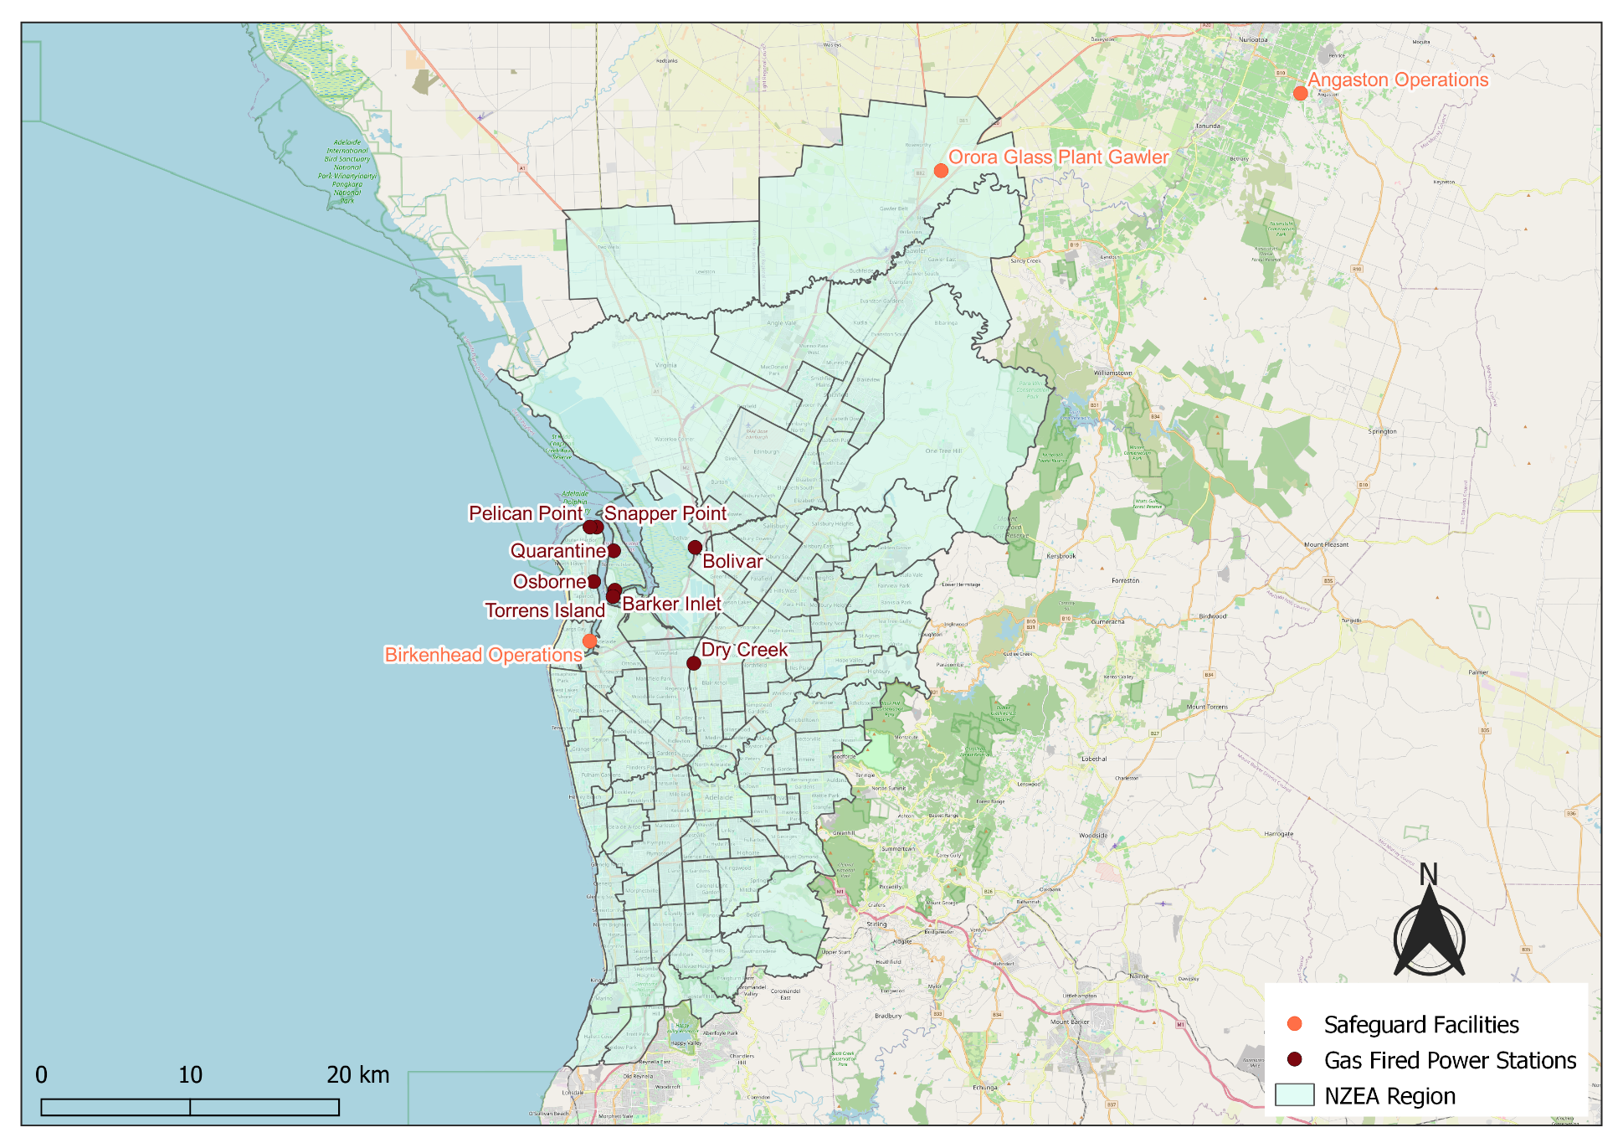
Source: DCCEEW (2025b).

Commonwealth Funded Net Zero Projects Map (Current & Proposed) (2020 Onwards)
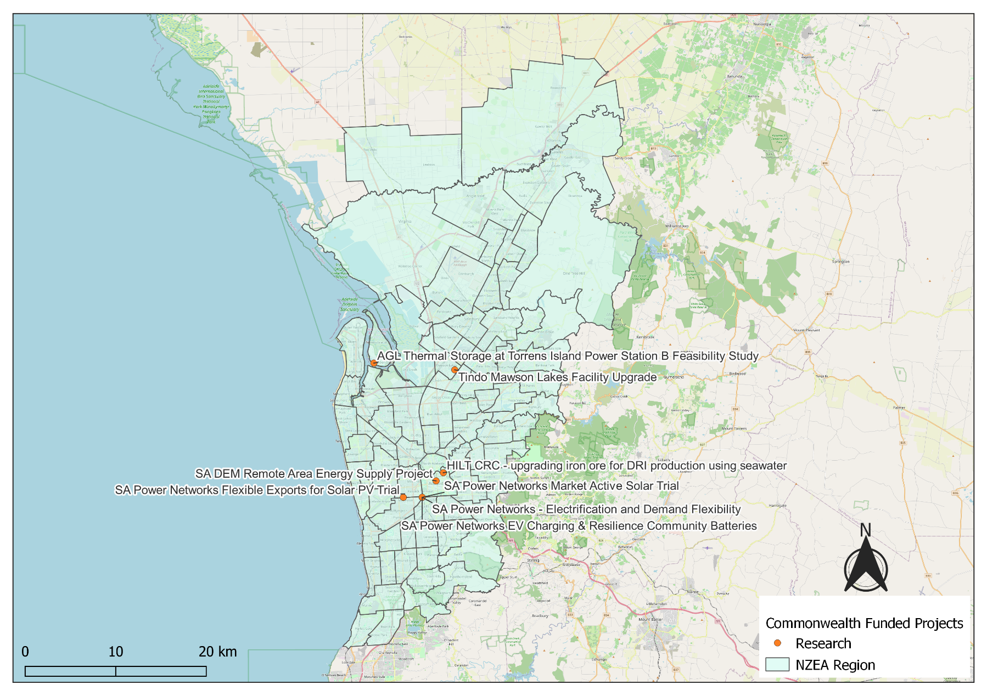
Note:
- Commonwealth funded projects include projects from the following schemes, Capacity Investment Scheme. Australian Renewable Energy Agency, Clean Energy Finance Corporation, Northern Australia Infrastructure Facility, National Reconstruction Fund, Regional Hydrogen Hubs Program.
- Information correct as of April 2026.
Source: NZIM (2026).

References
ABS (Australian Bureau of Statistics) (2021) Census of Population and Housing, abs.gov.au, accessed 10 February 2026.
ABS (Australian Bureau of Statistics) (2026) Regional population, abs.gov.au, accessed 1 April 2026.
AEMO (Australian Energy Market Operator) (2026a) Generation information, aemo.com.au, accessed 10 February 2026.
AEMO (Australian Energy Market Operator) (2026b) Draft 2026 Integrated System Plan (ISP), aemo.com.au, accessed 10 March 2026.
CER (Clean Energy Regulator) (2026) Safeguard facility covered emissions data 2024–25, cer.gov.au, accessed 20 April 2026.
DCCEEW (Department of Climate Change, Energy, the Environment and Water) (2025a) National Pollutant Inventory – Reports, data.gov.au, accessed 10 February 2026.
DCCEEW (Department of Climate Change, Energy, the Environment and Water) (2025b) Australia’s National Greenhouse Accounts, Emissions by State and Territory, greenhouseaccounts.climatechange.gov.au, accessed 10 February 2026.
DEWR (Department of Employment and Workplace Relations) (2026) Small Area Labour Market, dewr.gov.au, accessed 10 February 2026.
DSS (Department of Social Services) (2025) DSS Benefit and Payment Recipient Demographics – quarterly data, data.gov.au, accessed 10 February 2026.
JSA (Jobs and Skills Australia) (2026) Regional Labour Market Indicator, jobsandskills.gov.au, accessed 10 February 2026.
NZEA (Net Zero Economy Authority) (2026). Regional Identification Framework and Profiles, netzero.gov.au, accessed 8 May 2026.
NZIM (Net Zero Investment Map) (2026). Net Zero Investment Map, netzeromap.au, accessed 10 February 2026.
REMPLAN (REMPLAN Pty Ltd) (2026) Economy, remplan.com.au, accessed 10 February 2026.
RenewMap (RenewMap Pty Ltd) (2026) Visualising Australia’s Energy Future, renewmap.com.au, accessed 10 February 2026.

