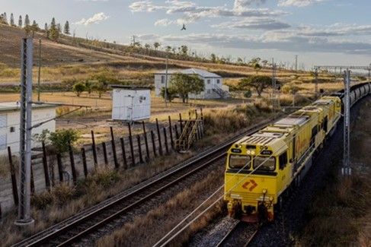



Central Queensland

Regional Profiles

Overview
Central Queensland is one of Australia’s largest coal mining and electricity producing regions. As Australia transitions to a decarbonised future, the region faces a significant adjustment. All four coal‑fired power stations expected to progressively close over the coming decades, alongside longer‑term changes across the coal mining industry.
While some parts of the region have a lower adaptive capacity due to heavy reliance on coal‑related employment, strong potential for clean industry, established industrial capability, and enabling infrastructure position Central Queensland to manage impacts over time and capitalise on new economic opportunities.
 | Population (2025)  - 235,953 persons  - 1.1% 5-year avg. annual growth  - QLD: 1.9% 5-year avg. annual growth |  | Total Area  - 113,815.2 km²  - 6.6% of QLD
 | Gross Regional Product (2022-23)  - $37.3 Billion  - 7.0% of QLD |  | Employment (2022-23)  - 106,335 persons  - 4.4% of QLD
Working Zones: Banana, Biloela, Central Highlands-East, Emerald and Central Highlands-West, Gladstone and surrounds, Rockhampton and surrounds, Yeppoon and surrounds (maps at end).

Region Selection Rationale
Exposure to Decarbonisation |  | Economic Opportunities from Decarbonisation
- Carbon Intensity: Large number of carbon-intensive facilities, including 4 coal-fired power stations and 25 safeguard facilities. As of 2024-25, safeguard facilities account for 54.8% of Queensland’s Safeguard Mechanism direct (scope 1) emissions.  - Urgency: 2 of the region’s 4 coal-fired power stations are projected to close by 2031.  - Adaptive Capacity: Adaptive capacity across Central Queensland is moderate but unevenly distributed. Communities with a high concentration of coal mining and coal-fired electricity generation face greater exposure. Reflecting strong workforce concentration in these industries and, in some areas, limited diversification opportunities.  - Readiness: Gladstone demonstrates more advanced planning and coordination, while broader regional planning is still developing in parts of Central Queensland. Queensland’s revised Energy Roadmap and legislative settings now extend the operational lifespan of the State’s coal-fired generation fleet to at least 2046, reversing previous commitments to close units by 2035. | - Natural Capital: Considerable potential for green industry, including green aluminium and alumina. This is underpinned by high‑quality solar and wind resources and proximity to existing industrial precincts.  - Workforce Compatibility: High proportion of workers in Central Highlands, the Banana shire and Gladstone in roles compatible with forecast clean energy occupations. Medium compatibility in Capricorn Coast and Rockhampton.  - Enabling Infrastructure: Central Queensland benefits from well-established transport, energy and export infrastructure. The region has widespread 5G coverage, commercial airports at Gladstone and Rockhampton, and access to the Port of Gladstone, one of Australia’s largest multicommodity ports. The port is progressing plans to support future hydrogen exports. Curtis Island is home to the LNG export terminals, the only such facilities on Australia’s east coast.

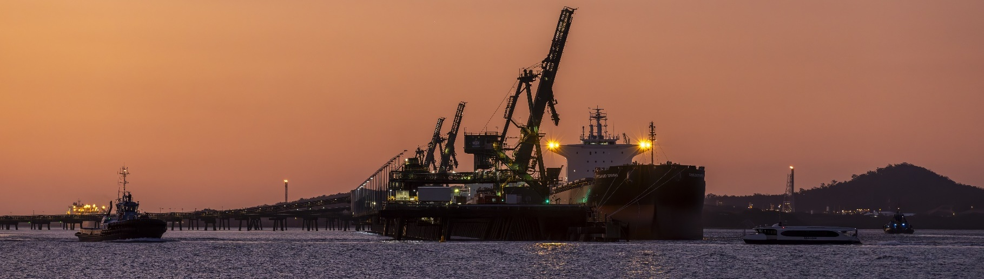
Carbon-Intensive Industries

Coal-Fired Power Stations
Facility | Owner | Public closure date | Employees | Supplying Coal Mine | S1 emiss. (tCO2-e) (23/24) | % of QLD S1 emiss. (23/24) | % of Aus S1 emiss. (23/24)
Callide Power Station B | CS Energy | 2031 | 263 | Callide | 4,004,358 | 2.8% | 0.8%
Callide Power Station C | IG Power and CS Energy | Unknown | 263 | Callide | 675,798 | 0.5% | 0.1%
Gladstone Power Station | Rio Tinto, NRG Energy, and others | 2029 | 50 | Rolleston (primary), Callide, and Ensham | 6,492,467 | 4.5% | 1.2%
Stanwell Power Station | Stanwell | 2046 | 553 | Curragh | 6,975,068 | 4.8% | 1.3%
Total 4 | 5+ | - | 866 | - | 18,147,691 | 12.6% | 3.4%
Note: S1 emiss. indicates Scope 1 Emissions. Further information on Scope 1 emissions can be found here.
Source: AEMO (2026a), DCCEEW (2025a, 2025b).

Safeguard Facilities (Emit 100,000+ tonnes CO2 annually – power stations connected to grid are exempt)
Facility | No. | S1 emiss. (tCO2-e) (24/25) | % of QLD Safeguard emiss. (24/25) | % of Aus Safeguard emiss. (24/25)
Manufacturing | 9 | 8,197,250 | 22.2% | 6.1%
Coal mines | 12 | 6,181,706 | 16.7% | 4.6%
Oil and gas extraction | 4 | 5,879,987 | 15.9% | 4.4%
Total | 25 | 20,258,943 | 54.8% | 15.1%
Note:
- S1 emiss. indicates Scope 1 Emissions. Further information on Scope 1 emissions can be found here.
- Not all coal mines qualify as a safeguard facility. The total number of coal mines in the region is 14 facilities.
- Fisherman’s Landing manufacturing facilities, Clinker and Cement, and Lime, have been aggregated together in this table.
Source: CER (2026).

Coal Mines
No. of Coal Mines | Mines Supplying Domestic Market | Mines Supplying Export Market | Thermal Coal Mines | Metallurgical Coal Mines
14 | 5 | 14 | 12 | 9
Note: Individual coal mines may produce both thermal and metallurgical coal and may therefore be counted in both categories. Similarly, some mines may supply both domestic and export markets and may be counted in both market categories.
Source: Geoscience Australia (2026), Wood MacKenzie (2026).

Major Commonwealth Funded Net Zero Projects (excluding cancelled and completed) (top projects by value)
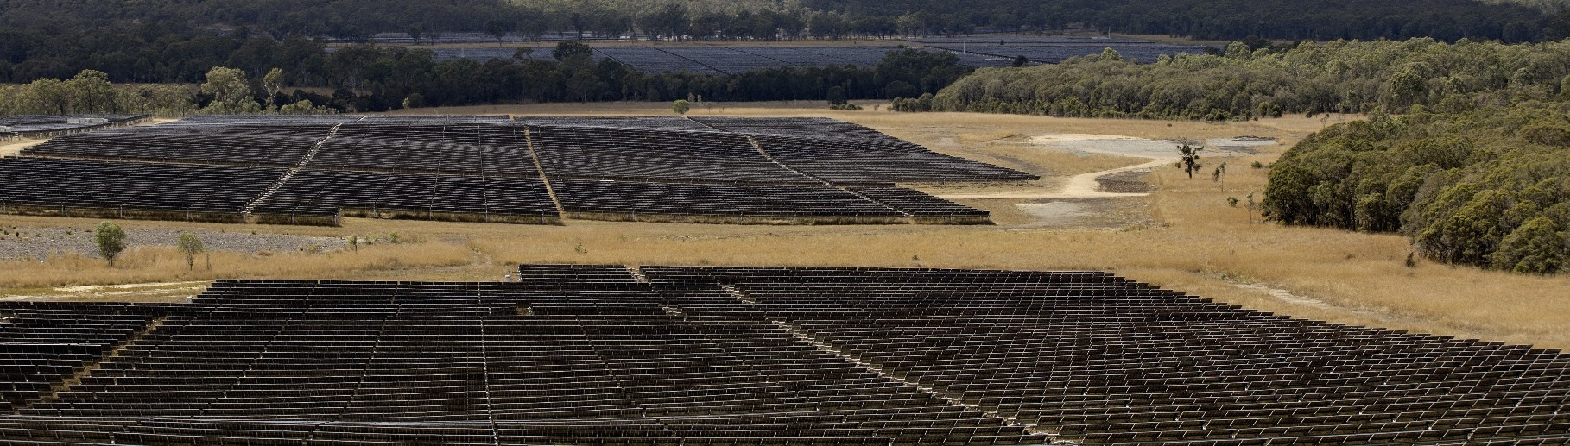
This table reflects projects that have received Commonwealth funding (as of April 2026), identified through publicly available sources, consistent with the Net Zero Investment Map, including the programs below.
- Capacity Investment Scheme (CIS)
- Australia Renewable Energy Agency (ARENA)
- Clean Energy Finance Corporation (CEFC)
- Northern Australian Infrastructure Facility (NAIF)
- National Reconstruction Fund (NRF)
- Regional Hydrogen Hubs Program
Project | Description | Status | Cwth Govt Funding | Value
Alpha HPA (High Purity Aluminium) First Project | Based in Gladstone area, this facility will leverage modern process control systems and automation and will be capable of producing over 10,000 tonnes of HPA per year. The site intends to run on 100% renewable energy. | Development | $200.0M  NAIF Loan  $75.0M  NRF | $647.4M
Yarwun Hydrogen Calcination | Yarwun Hydrogen Calcination aims to use hydrogen in the calcination process at the Yarwun Alumina Refinery | Construction | $32.1M ARENA | $111.1M
Queensland Alumina Refinery (QAL) double digestion | In the double digestion process, bauxite is processed in two stages of low temperature and higher temperature which significantly reduces energy use and emissions. | Development | $94.0M  ARENA | $188.0M
Iberdrola Australia – Moura Dawson Renewable Hydrogen Hub FEED Study | The project comprises:  - Pre‑FEED study for a new renewable hydrogen plant;  - FEED study for the hydrogen production facility (HPF FEED);  - Permitting and approvals study for the hydrogen plant; and  - FEED study for integrating renewable hydrogen into QNP’s existing facility (QNP FEED). | Development | $2.7M ARENA | $7.3M
Note: Information correct as of April 2026.
Source: DCCEEW (2024), NZIM (2026).

Regional Renewable Energy Projects (aggregated)
The aggregated tables below draw on RenewMap’s energy project database which contains information on the location and size of public and privately funded energy generation projects. Results are shown in aggregated form to illustrate the breadth and depth of projects in the region.

Operational
Type | Projects (No.) | Total Project Size (MW) | Total Storage Size (MWh)
Battery | 5 | 66 | 132
Biogas | 1 | 1 | N/A
Hydrogen | 2 | <1 | N/A
Onshore Wind | 1 | 450 | N/A
Solar Photovoltaic (Solar PV) | 4 | 658 | N/A
Total | 13 | 1,175 | 132 (Known Storage)
Note:
- RenewMap is a commercial subscription and is not publicly available.
- MW = Megawatt. A unit that measures capacity of energy systems.
- MWh = Megawatt hour. In battery technology, this unit measures the total amount of energy the system can store.
- Information correct as of April 2026.
Source: RenewMap (2026).

Under Development and Proposed
Type | Projects (No.) | Total Project Size (MW) | Total Storage Size (MWh)
Battery | 53 | 16,119 | 53,502
Biogas | 1 | 1 | N/A
Hydrogen | 6 | 870 | N/A
Onshore Wind | 21 | 11,340 | N/A
Pumped Hydro | 2 | 2,200 | 20,600
Solar Photovoltaic (Solar PV) | 30 | 10,208 | N/A
Total | 113 | 40,738 | 74,102 (Known Storage)
Note:
- RenewMap is a commercial subscription and is not publicly available.
- MW = Megawatt. A unit that measures capacity of energy systems.
- MWh = Megawatt hour. In battery technology, this unit measures the total amount of energy the system can store.
- Information correct as of April 2026.
Source: RenewMap (2026).
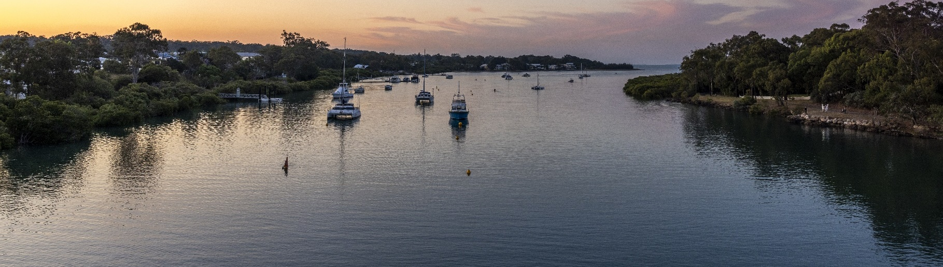

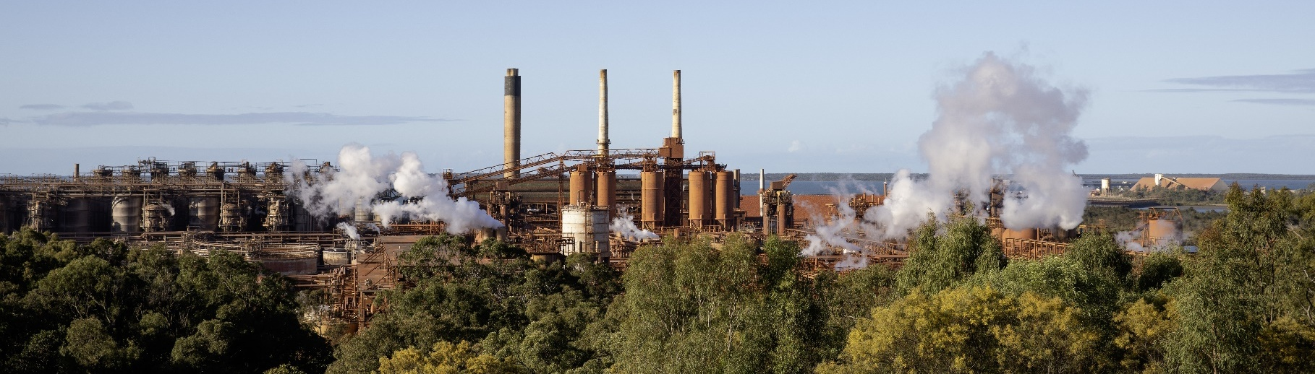
Transmission Infrastructure Projects

Australian Energy Market Operator (AEMO) Draft 2026 Integrated System Plan (ISP)
Project | Description | Status | Timing | Cost
Gladstone Project | Increase network capacity from Central Queensland into Gladstone area to support the area’s industry once Gladstone Power Station retires and add capacity between North and South Queensland. | Actionable | Mar 2029 | $2.4B  (-20% to +30%)
Note: ± indicates the cost uncertainty range.
Source: AEMO (2026b).

Major Industries

Gross Value Add (2022-23)
Ranked Industries (Top Five) | Value ($M) | % of GVA
Mining | $18,733.1 | 52.1%
Rental, Hiring and Real Estate Services | $2,556.9 | 7.1%
Construction | $2,026.9 | 5.6%
Health Care and Social Assistance | $1,656.6 | 4.6%
Manufacturing | $1,531.7 | 4.3%
Note: Gross Value Add estimates are sourced from REMPLAN (2026), incorporating Australia Bureau of Statistics (ABS) 2021 Census (PoW), ABS 2024 Estimated Resident Population, ABS 2022–23 National Input–Output Tables, and ABS June 2025 Gross State Product into its modelling. Gross Value Add (GVA) measures the value of goods and services produced, minus the cost inputs used in production. Further information on GVA can be found here.
Source: REMPLAN (2026).

Employment

Place of Work (2022-23)
Ranked Industries (Top Five) | Employees (No.) | % of Employment
Health Care and Social Assistance | 14,075 | 13.2%
Mining | 10,170 | 9.6%
Construction | 9,924 | 9.3%
Education and Training | 9,913 | 9.3%
Retail Trade | 9,832 | 9.2%
Note: Employment by Place of Work (PoW) estimates are sourced from REMPLAN (2026), incorporating Australia Bureau of Statistics (ABS) 2021 Census by PoW, ABS 2024 Estimated Resident Population, ABS 2022–23 National Input–Output Tables, and ABS June 2025 Gross State Product into its modelling.
Source: REMPLAN (2026).

Place of Usual Residence (2021)
Ranked Industries (Top Five) | Employees (No.) | % of Employment
Health Care and Social Assistance | 13,144 | 13.4%
Education and Training | 9,344 | 9.5%
Retail Trade | 9,036 | 9.2%
Construction | 8,764 | 8.9%
Mining | 8,691 | 8.9%
Source: ABS (2021).

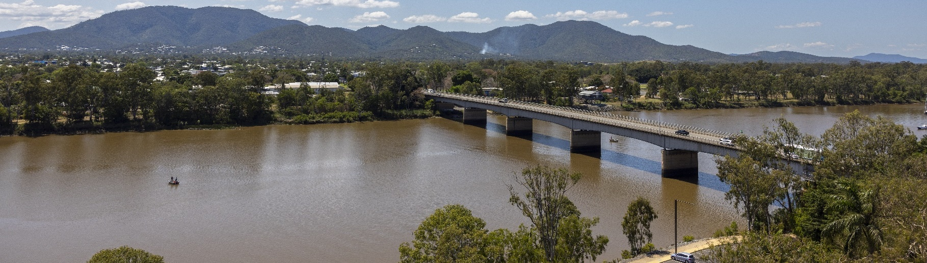
Key Economic and Social Indicators

Employment
Indicator (2021 Census unless otherwise stated) | Central Queensland | Queensland
Median working age | 40 | 40
Median income (annual gross, exc. super) | $33,800 – $41,599 | $33,800 – $41,599
Participation in workforce | 61.7% | 61.6%
Female participation in workforce | 59.1% | 58.9%
Workforce Self-Sufficiency (% of Workforce) | 94.6% | N/A
Unemployment rate (Dec 2025) | 3.9% | 4.1%
Regional Labour Market Index (Sep 2025) | Average | N/A
Source: ABS (2021), DEWR (2026), JSA (2026)

Demographics
Indicator (2021 Census) | Central Queensland | Queensland
Median age | 37 | 38
First Nations (% of population) | 7.9% | 4.9%
Educational attainment (% of population aged 15 and above):
- Below Year 12 | 51.1% | 40.8%
- Year 12 or equivalent | 48.9% | 59.2%
- Certificate III and IV | 25.9% | 20.7%
- Bachelor and above | 14.5% | 24.0%
Source: ABS (2021).

Housing
Indicator (2021 Census) | Central Queensland | Queensland
Homelessness (% of population) | 0.5% | 0.4%
Commonwealth Rent Assistance (% of population) (Sep 2025) | 6.0% | 6.2%
Mortgage stress | 9.6% | 11.9%
Rental stress | 26.8% | 32.4%
Source: ABS (2021), DSS (2025).

Power Stations and Coal Mines Map
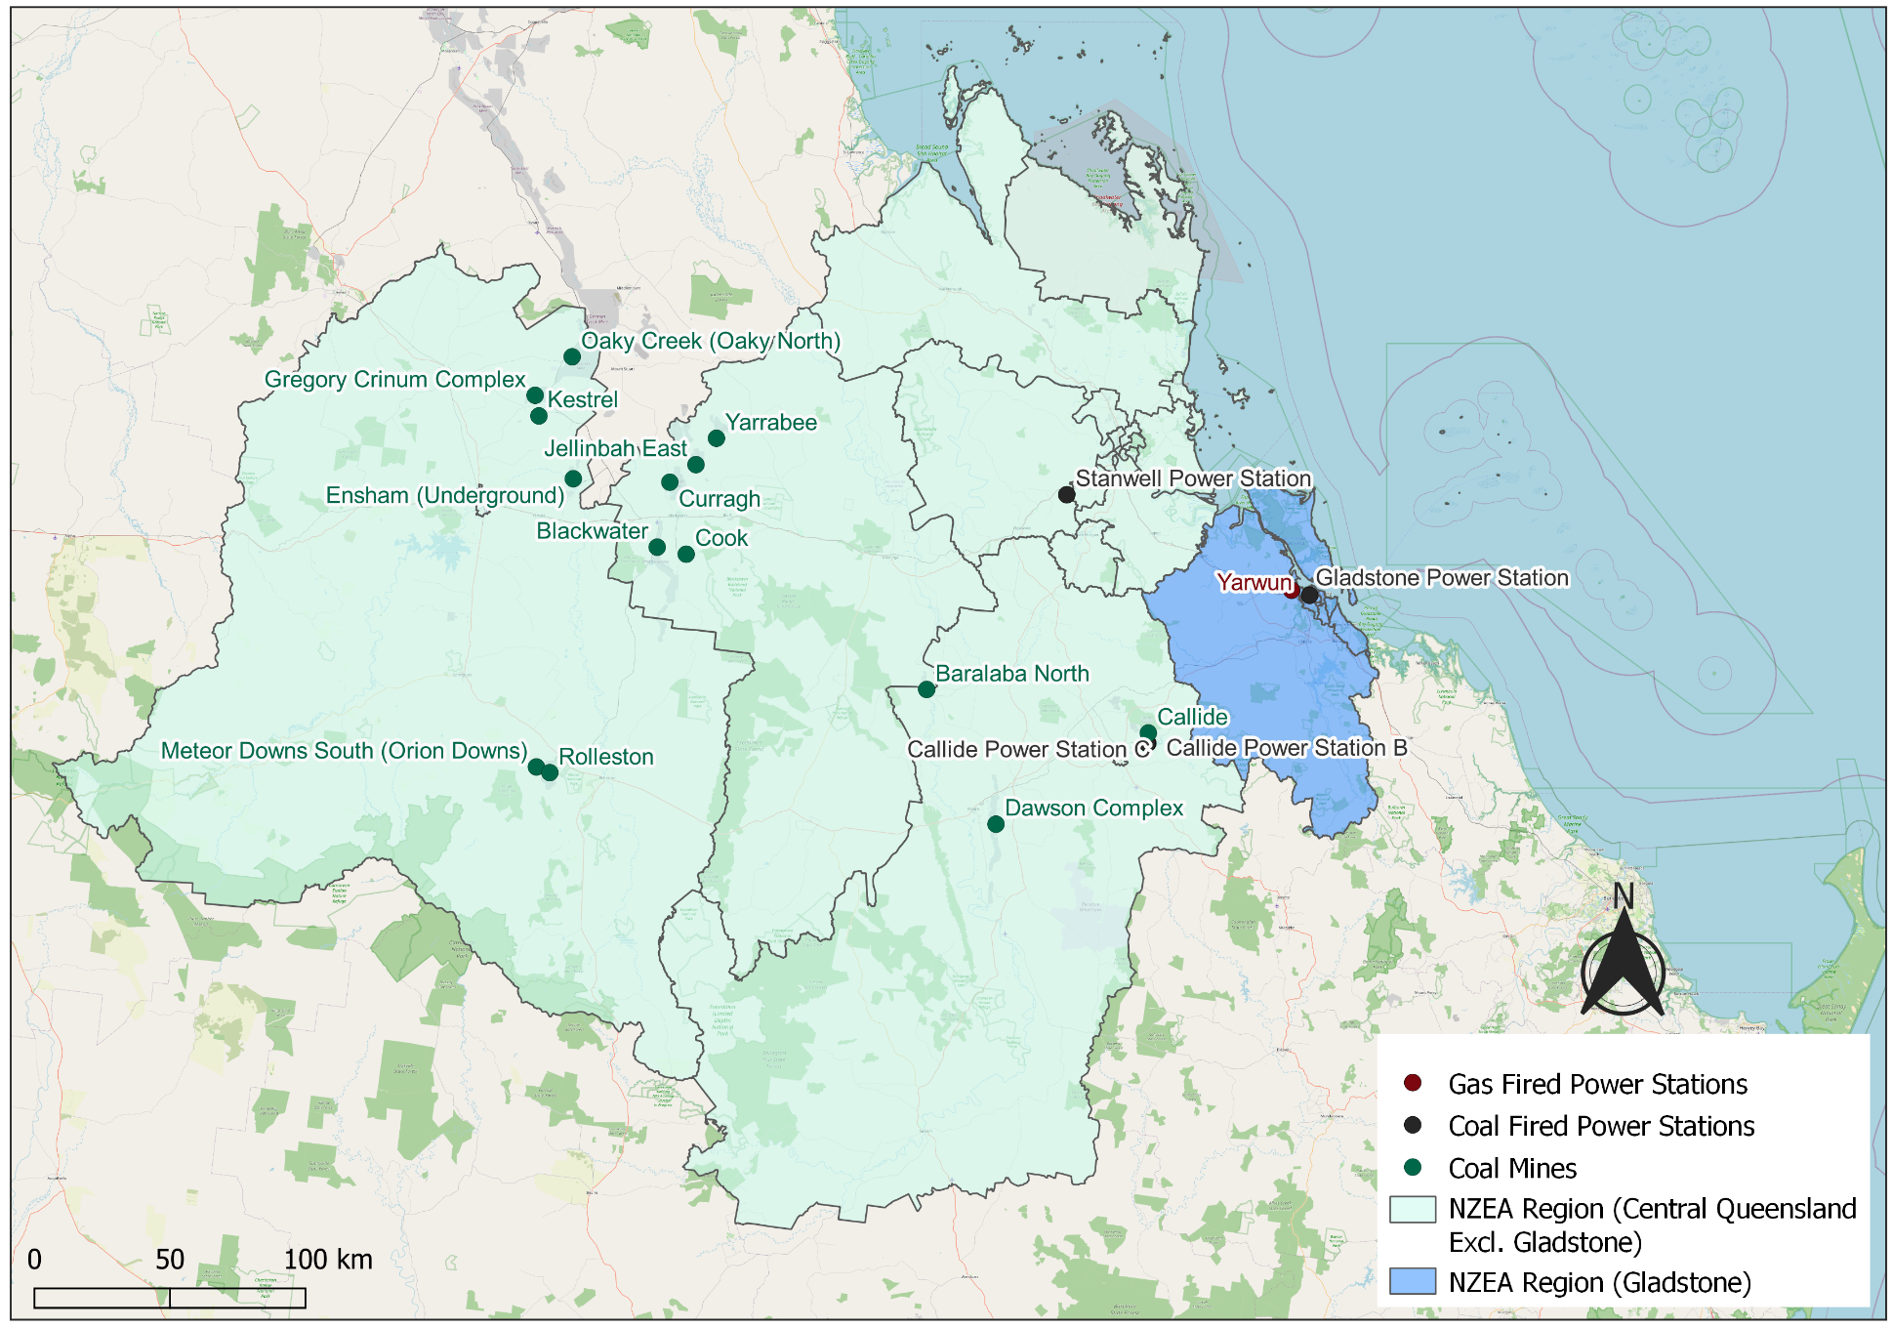
Source: DCCEEW (2025b).

Safeguard Facilities Map
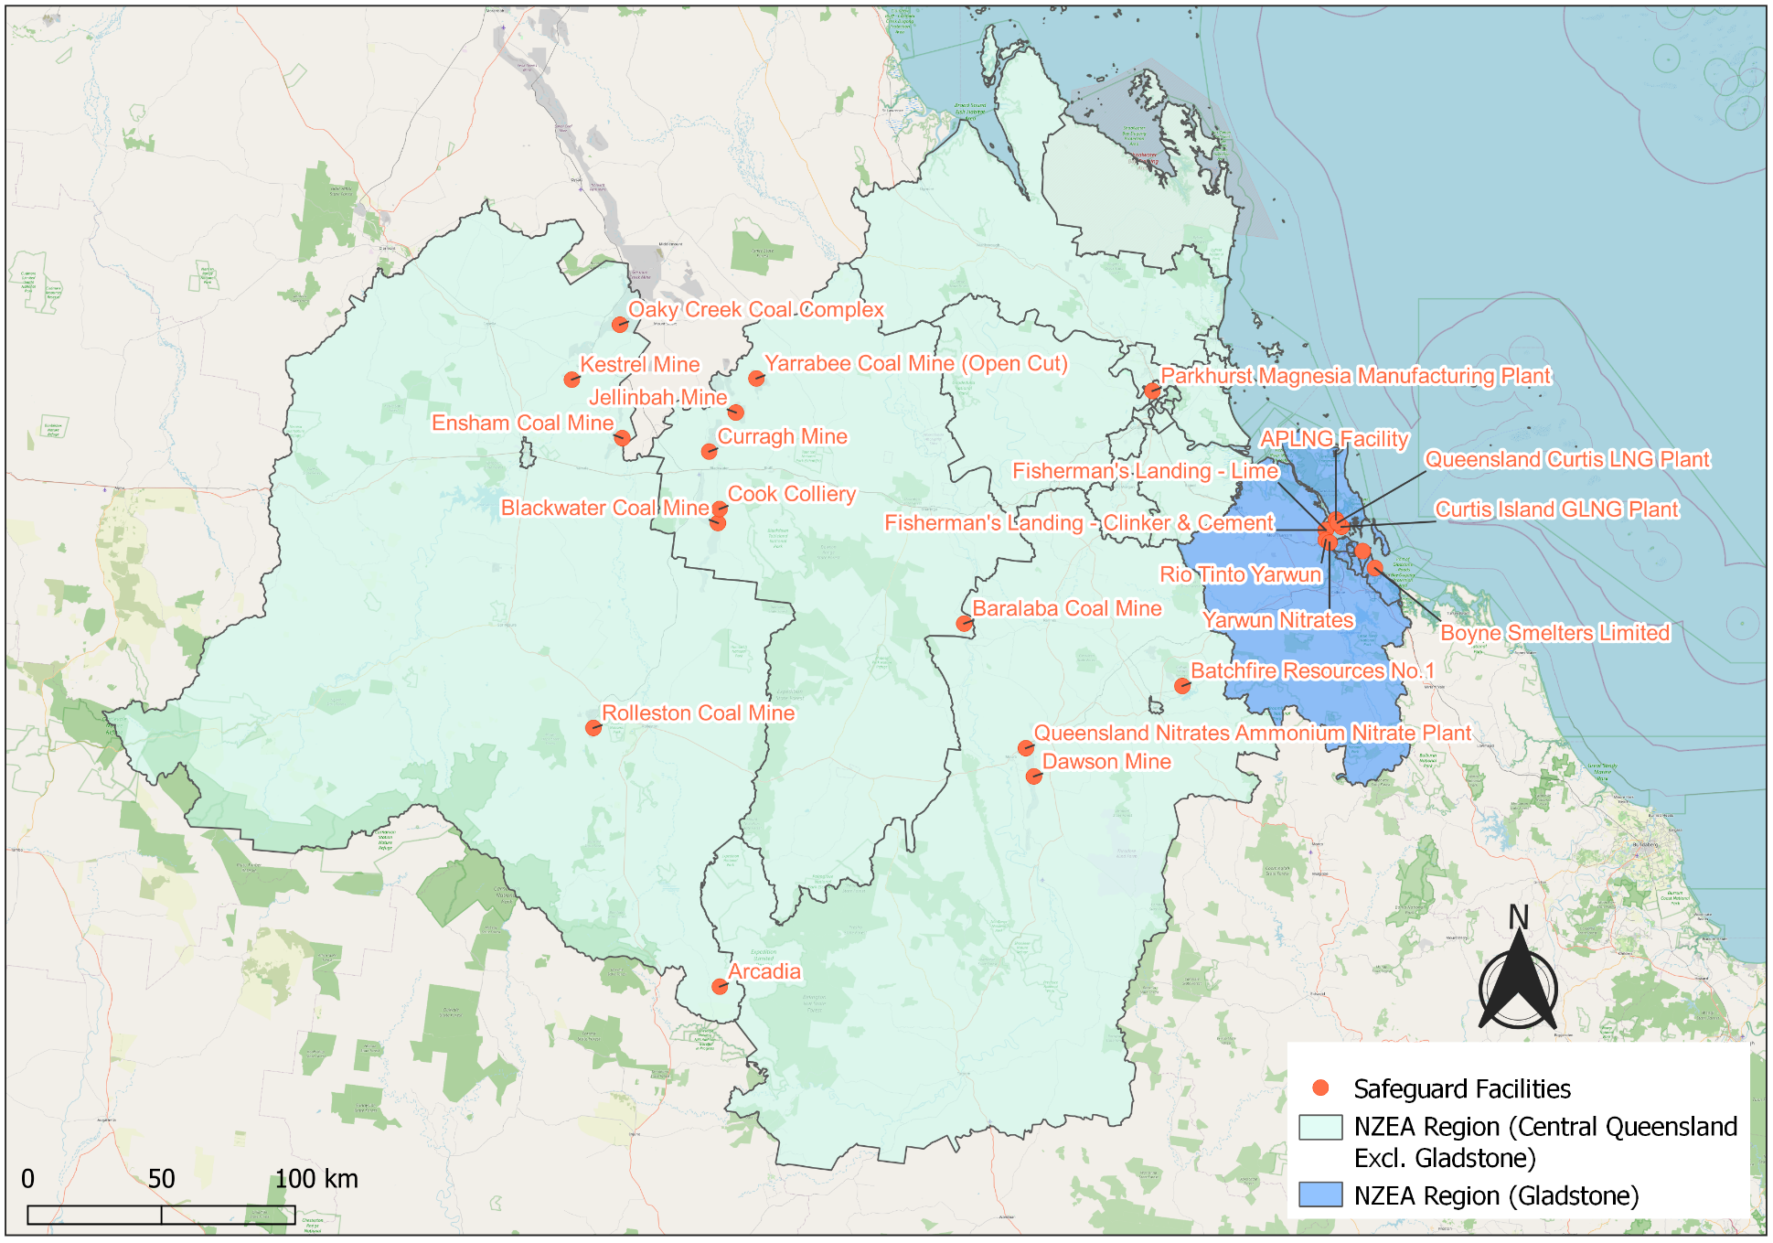
Source: DCCEEW (2025b).
Commonwealth-Funded Net Zero Projects Map (Current and Proposed)
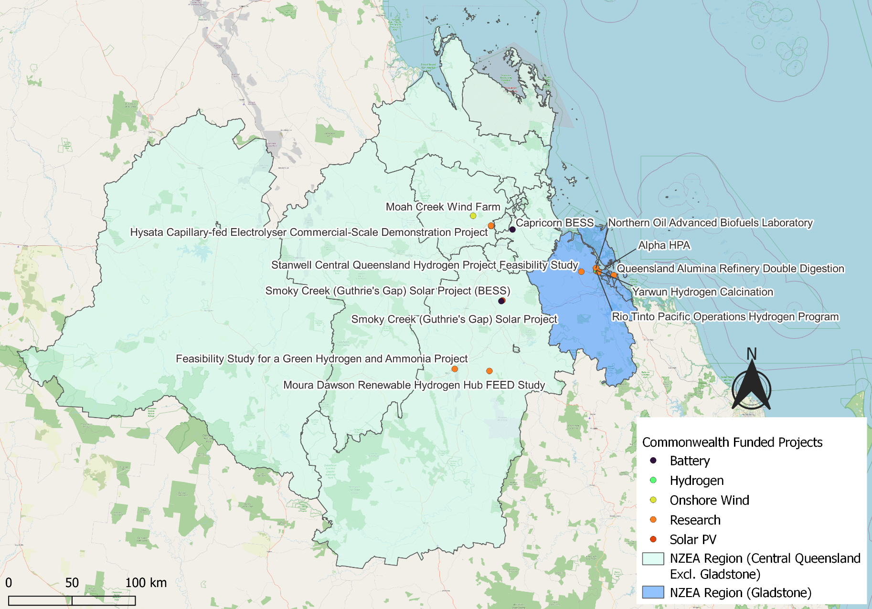
Note:
- Commonwealth funded projects include projects from the following schemes, Capacity Investment Scheme. Australian Renewable Energy Agency, Clean Energy Finance Corporation, Northern Australia Infrastructure Facility, National Reconstruction Fund, Regional Hydrogen Hubs Program.
- Information correct as of April 2026.
Source: NZIM (2026).

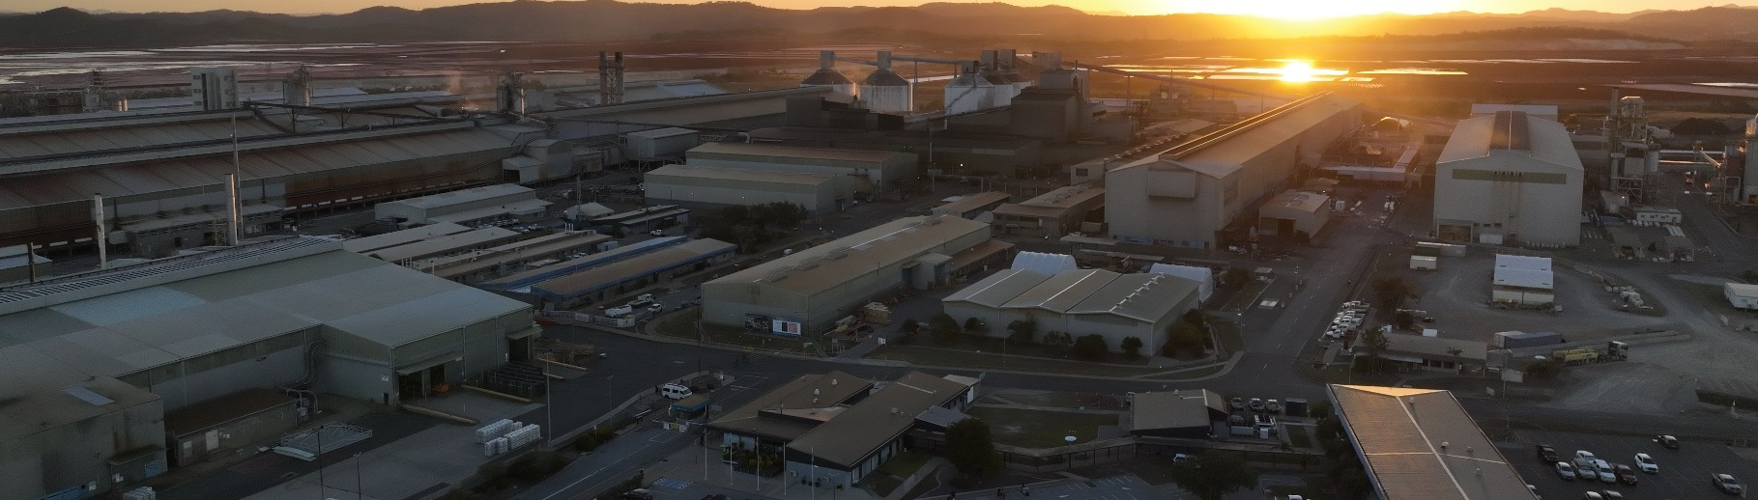
References
ABS (Australian Bureau of Statistics) (2021) Census of Population and Housing, abs.gov.au, accessed 10 February 2026.
ABS (Australian Bureau of Statistics) (2026) Regional population, abs.gov.au, accessed 1 April 2026.
AEMO (Australian Energy Market Operator) (2026a) Generation information, aemo.com.au, accessed 10 February 2026.
AEMO (Australian Energy Market Operator) (2026b) Draft 2026 Integrated System Plan (ISP), aemo.com.au, accessed 10 March 2026.
CER (Clean Energy Regulator) (2026) Safeguard facility covered emissions data 2024–25, cer.gov.au, accessed 20 April 2026.
DCCEEW (Department of Climate Change, Energy, the Environment and Water) (2024) Press conference, Queensland Alumina, Gladstone, minister.dccew.gov.au, accessed 5 May 2026.
DCCEEW (Department of Climate Change, Energy, the Environment and Water) (2025a) National Pollutant Inventory – Reports, data.gov.au, accessed 10 February 2026.
DCCEEW (Department of Climate Change, Energy, the Environment and Water) (2025b) Australia’s National Greenhouse Accounts, Emissions by State and Territory, greenhouseaccounts.climatechange.gov.au, accessed 10 February 2026.
DEWR (Department of Employment and Workplace Relations) (2026) Small Area Labour Market, dewr.gov.au, accessed 10 February 2026.
DSS (Department of Social Services) (2025) DSS Benefit and Payment Recipient Demographics – quarterly data, data.gov.au, accessed 10 February 2026.
Geoscience Australia (2026). Australian Mines Atlas, ga.gov.au, accessed 3 September 2026.
JSA (Jobs and Skills Australia) (2025) Regional Labour Market Indicator, jobsandskills.gov.au, accessed 10 February 2026.
NZEA (Net Zero Economy Authority) (2026). Regional Identification Framework and Profiles, netzero.gov.au, accessed 8 May 2026.
NZIM (Net Zero Investment Map) (2026). Net Zero Investment Map, netzeromap.au, accessed 10 February 2026.
REMPLAN (REMPLAN Pty Ltd) (2026) Economy, remplan.com.au, accessed 10 February 2026.
RenewMap (RenewMap Pty Ltd) (2026) Visualising Australia’s Energy Future, renewmap.com.au, accessed 10 February 2026.
Wood Mackenzie (2026) Coal Supply Data, woodmac.com. Last accessed 27 February 2026.

