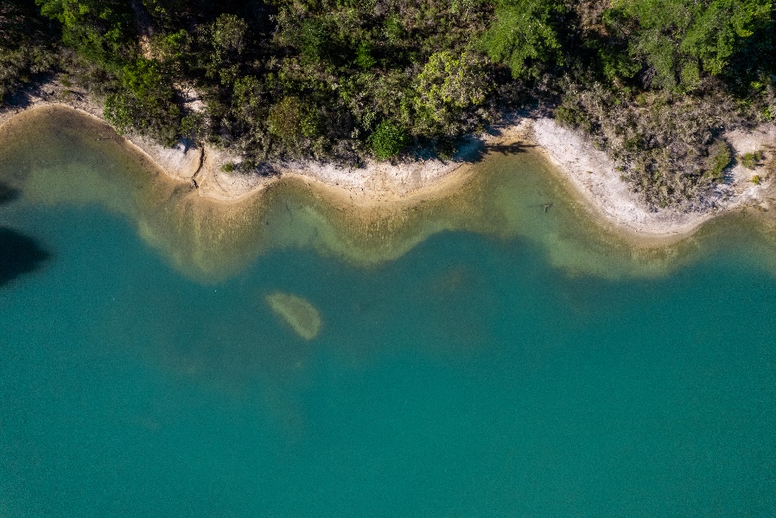



Collie

Regional Profiles

Overview
Collie plays a central role in Western Australia’s electricity generation and is one of the state’s premier coal mining regions. As Australia transitions to a decarbonised future, coal‑fired power generation and coal mining in the region will change significantly. This will present challenges for the local economy and workforce.
At the same time, Collie is proactively preparing for this transition. A skilled industrial workforce, established infrastructure, and strong government support are enabling early planning and investment. Together, these foundations are driving the region’s shift toward new industries and positioning Collie for long-term economic diversification.
 | Population (2025)  - 9,561 persons  - 1.3% 5-year avg. annual growth  - WA: 2.3% 5-year avg. annual growth |  | Total Area  - 1,709.8 km²  - 0.1% of WA
 | Gross Regional Product (2022-23)  - $2.8 Billion  - 0.6% of WA |  | Employment (2022-23)  - 4,994 persons  - 0.4% of WA
Working Zones: Collie (maps at end of profile)

Region Selection Rationale
Exposure to Decarbonisation | Economic Opportunities from Decarbonisation
- Carbon Intensity: 3 coal-fired power stations and 2 safeguard facilities (accounting for 7.0% of Western Australia’s safeguard scope 1 emissions in 2024-25). Collie has a high concentration of employment in electricity generation, coal mining and a large alumina refinery.  - Urgency: 2 of the 3 remaining power stations are expected to close by 2029.  - Adaptive Capacity: Adaptive capacity is limited by low transferable workforce skills, low educational attainment and a comparatively low workforce self-sufficiency rate (% of workforce who live and work in Collie (55.0% in 2021)).  - Readiness: Strong planning, funding and governance arrangements are in place, including a dedicated working group and the Collie Just Transition program. The Western Australia Government has announced $692 million in funding, including the $230 million Collie Industrial Transition Fund, to attract new industries and support economic diversification. | - Natural Capital: Above-average wind potential and average solar potential, which can support green manufacturing (e.g. proposed green steel mill and net zero magnesium refinery).  - Workforce Compatibility: High proportion of workers in the region are employed in jobs highly compatible with clean energy industries.  - Enabling Infrastructure: Collie is well connected by major highway and railway infrastructure and is located approximately 50 kilometres from Bunbury Port, although outside the Collie catchment. This infrastructure supports vital connectivity, logistics and trade. The region is not serviced by a commercial airport.
Source: NZEA (2026).

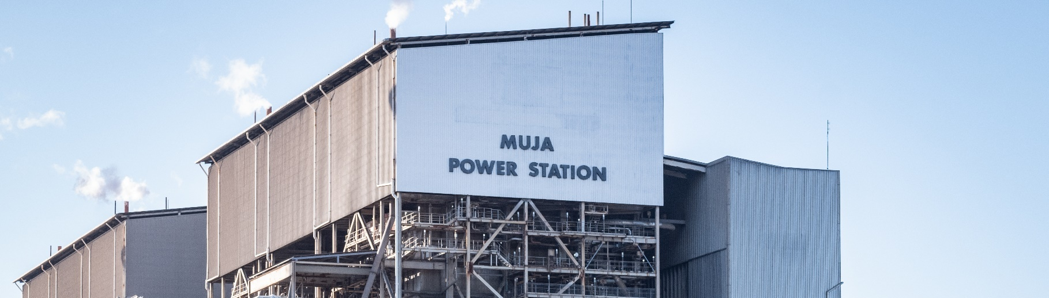
Carbon-Intensive Industries

Coal-Fired Power Stations
Facility | Owner |  | Public closure date | Employees | Supplying Coal Mine | S1 emiss. (tCO2-e) (23/24) | % of WA S1 emiss. (23/24) | % of Aus S1 emiss. (23/24)
Bluewaters Power Station | Kansai Electric & Sumitomo |  | Not reported | 55 | Ewington | 2,590,563 | 3.7% | 0.9%
Collie Power Station | Synergy (WA gov) |  | 2027 | 49 | Ewington and Premier | 920,053 | 1.3% | 0.3%
Muja Power Station C & D | Synergy (WA gov) |  | 2024 (C) and 2029 (D) | 270 | Ewington and Premier | 3,091,936 | 4.5% | 1.0%
Total 3 | 3 |  | - | 374 | - | 6,602,552 | 9.5% | 1.2%
Note:
- S1 emiss. indicates Scope 1 Emissions. Further information on Scope 1 emissions can be found here.
- Muja C closed in 2024, however generated emissions in the 2023/24 FY.
Source: AEMO (2026), Bluewaters Power (2024), DCCEEW (2025a, 2025b).

Metal Manufacturing/ Refineries and Smelters
Facility | Owner | Employees | Power Source | S1 emiss. (tCO2-e) (23/24) | % of WA S1 emiss. (23/24) | % of Aus S1 emiss. (23/24)
Worsley Alumina | South32 Worsley Alumina Pty Ltd | 1,450 | Worsley Refinery PS | 3,177,815 | 3.6% | 0.7%
Note:
- S1 emiss. indicates Scope 1 Emissions. Further information on Scope 1 emissions can be found here.
- Emissions data is based on the 2023-24 FY, compared to the safeguards data which is based on the 2024-25 FY due to data availability from the national and state total emissions estimates.
Source: CER (2026), DCCEEW (2025a, 2025b).

Safeguard Facilities (Emit 100,000+ tonnes CO2 annually - power stations connected to grid are exempt)
Facility | S1 emiss. (tCO2-e) (24/25) | % of WA Safeguard emiss. (24/25) | % of Aus Safeguard emiss. (24/25)
South32 Worsley Alumina Pty Ltd | 3,218,588 | 6.8% | 2.4%
Premier Coal Pty Ltd | 106,030 | 0.2% | 0.1%
Total | 3,324,618 | 7.0% | 2.5%
Note: S1 emiss. indicates Scope 1 Emissions. Further information on Scope 1 emissions can be found here.
Source: CER (2026).

Coal Mines
No. of Coal Mines | Mines Supplying Domestic Market | Mines Supplying Export Market | Thermal Coal Mines | Metallurgical Coal Mines
2 | 2 | 0 | 2 | 0
Source: Geoscience Australia (2026), Wood MacKenzie (2026).

Major Commonwealth Funded Net Zero Projects (excluding cancelled) (top projects by value)
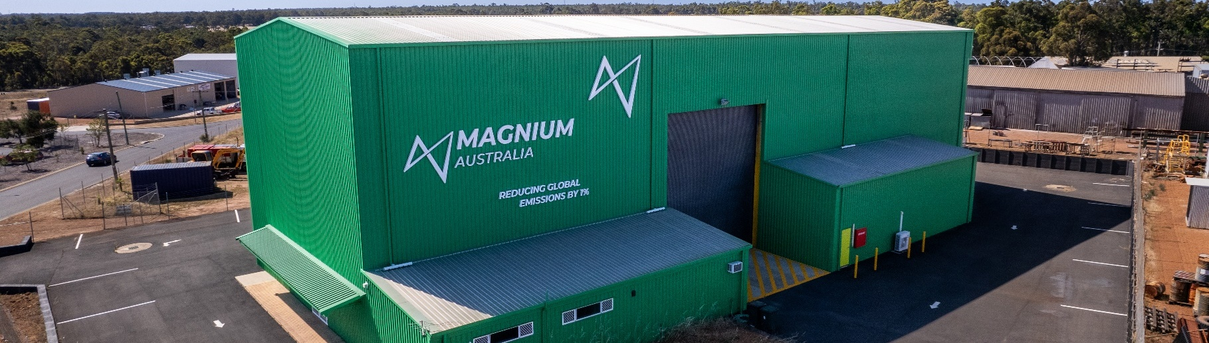
This table reflects projects that have received Commonwealth funding (as of April 2026), identified through publicly available sources, consistent with the Net Zero Investment Map, including the programs below.
- Capacity Investment Scheme (CIS)
- Australia Renewable Energy Agency (ARENA)
- Clean Energy Finance Corporation (CEFC)
- Northern Australian Infrastructure Facility (NAIF)
- National Reconstruction Fund (NRF)
- Regional Hydrogen Hubs Program
Project | Description | Status | Funding | Value
Collie Battery Stage 1 and 2 | The Collie Battery, Stage 1 and 2, have a combined capacity of 560 MW for four hours. The Collie Battery will provide short-duration storage in peak times and deliver grid reliability services. Altogether, the Collie Battery will have the ability to charge and discharge 20.0% of the average demand placed on Western Australia’s transmission network. | Stage 1: Operational  Stage 2: Operational | $155.0M  CEFC | $1.6B
Energy from Waste Through Pyrolysis | The project involves the design, build and operation of a 1.5 tonne/ hour pre-commercial demonstration energy-from-waste (EfW) plant located in the Shire of Collie in Western Australia. | Completed | $4.3M ARENA | $9.8M
South32 Steam Electrification | Prefeasibility study of options for partial steam electrification at Worsley Alumina refinery using electric boilers (E-Boiler) and mechanical vapour recompression. | Concept | $4.4M ARENA | $8.7M
Collie Solar Project (BESS) | The Collie Solar Project is a solar and battery project located in the Shire of Collie. The project will develop a 66 MW Solar PV farm matched with a 200 MW battery facility. | Planned | CIS | Unknown
Note: Information correct as of April 2026.
Source: APA (2025), NZIM (2026).

Regional Renewable Energy Projects (aggregated)
The aggregated tables below draw on RenewMap’s energy project database which contains information on the location and size of public and privately funded energy generation projects. Results are shown in aggregated form to illustrate the breadth and depth of projects in the region.

Operational
Type | Projects (No.) | Total Project Size (MW) | Total Storage Size (MWh)
Battery | 2 | 560 | 2,240
Note:
- RenewMap is a commercial subscription and is not publicly available.
- MW = Megawatt. A unit that measures capacity of energy systems.
- MWh = Megawatt hour. In battery technology, this unit measures the total amount of energy the system can store.
- Information correct as of April 2026.
Source: RenewMap (2026).

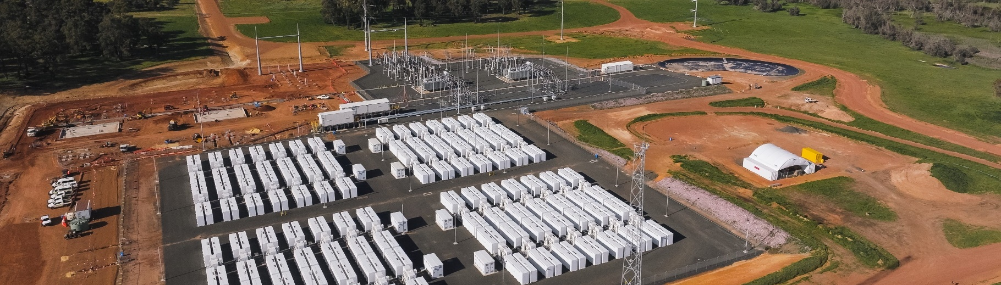
Under Development and Proposed
Type | Projects (No.) | Total Project Size (MW) | Total Storage Size (MWh)
Battery | 3 | 1,200 | 4,000
Onshore Wind | 1 | 500 | N/A
Solar Photovoltaic (Solar PV) | 2 | 86 | N/A
Total | 6 | 1,786 | 4,000 (Known Storage)
Note:
- RenewMap is a commercial subscription and is not publicly available.
- MW = Megawatt. A unit that measures capacity of energy systems.
- MWh = Megawatt hour. In battery technology, this unit measures the total amount of energy the system can store.
- Information correct as of April 2026.
Source: RenewMap (2026).

Transmission Infrastructure Projects

South West Interconnected Grid System (SWIS) Transmission Planning Update
Project | Description | Status | Timing | Cost
Clean Energy Link – East | Aims to optimise existing infrastructure and prepare the regional electricity network in Western Australia for a clean energy future. Link focuses on expanding Western Australia’s main electricity network to enable more renewable energy connections, support industry growth and electrification of processes. | In Planning Stage | Stage 1: 2029  Stage 2 and 3: N/A | N/A
Clean Energy Link – Collie | New circuits to Wells, Guildford and Shotts Terminals will improve import/ export transfer capacity between industrial loads in the north metropolitan region and Kwinana and renewable generation connections in the southwest.  Link will enable additional capacity to be released from Clean Energy Link East Stage Three. | In Planning Stage | N/A | N/A
Source: WA Govt (2025).

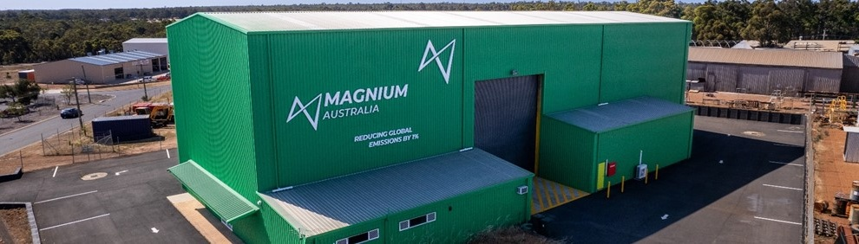
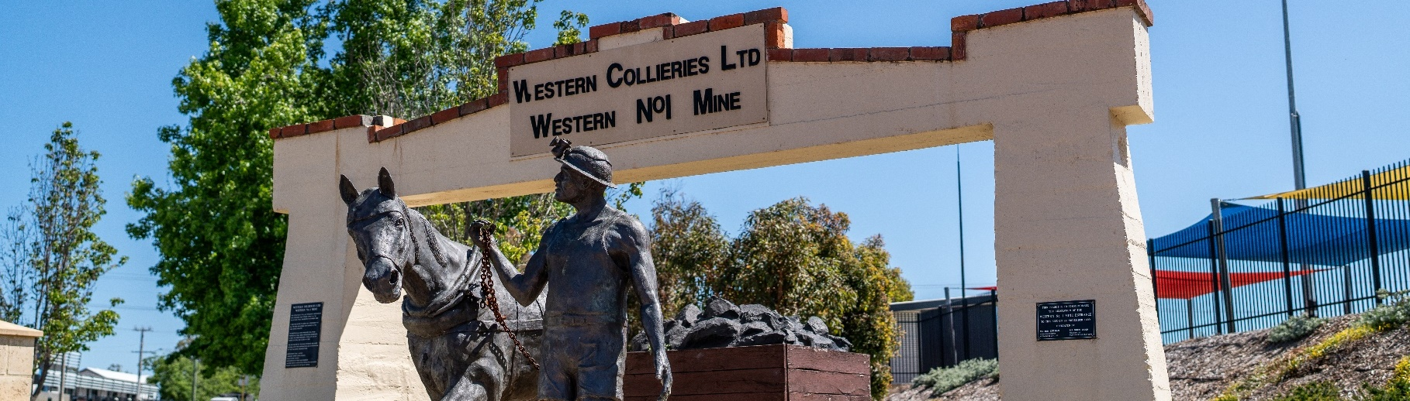
Major Industries

Gross Value Add (2022-23)
Ranked Industries (Top Five) | Value ($M) | % of GVA
Mining | $1,766.7 | 63.9%
Manufacturing | $271.2 | 9.8%
Electricity, Gas, Water and Waste Services | $258.2 | 9.3%
Rental, Hiring and Real Estate Services | $113.3 | 4.1%
Construction | $88.9 | 3.2%
Note: Gross Value Add estimates are sourced from REMPLAN (2026), incorporating Australia Bureau of Statistics (ABS) 2021 Census (PoW), ABS 2024 Estimated Resident Population, ABS 2022–23 National Input–Output Tables, and ABS June 2025 Gross State Product into its modelling. Gross Value Add (GVA) measures the value of goods and services produced, minus the cost inputs used in production. Further information on GVA can be found here.
Source: REMPLAN (2026).

Employment

Place of Work (2022-23)
Ranked Industries (Top Five) | Employees (No.) | % of Employment
Manufacturing | 1,245 | 24.9%
Mining | 839 | 16.8%
Electricity, Gas, Water and Waste Services | 550 | 11.0%
Health Care and Social Assistance | 368 | 7.4%
Construction | 360 | 7.2%
Note: Employment by Place of Work (PoW) estimates are sourced from REMPLAN (2026), incorporating Australia Bureau of Statistics (ABS) 2021 Census by PoW, ABS 2024 Estimated Resident Population, ABS 2022–23 National Input–Output Tables, and ABS June 2025 Gross State Product into its modelling.
Source: REMPLAN (2026).

Place of Usual Residence (2021)
Ranked Industries (Top Five) | Employees (No.) | % of Employment
Mining | 608 | 18.6%
Health Care and Social Assistance | 352 | 10.8%
Retail Trade | 302 | 9.2%
Education and Training | 283 | 8.7%
Accommodation and Food Services | 266 | 8.1%
Source: ABS (2021).

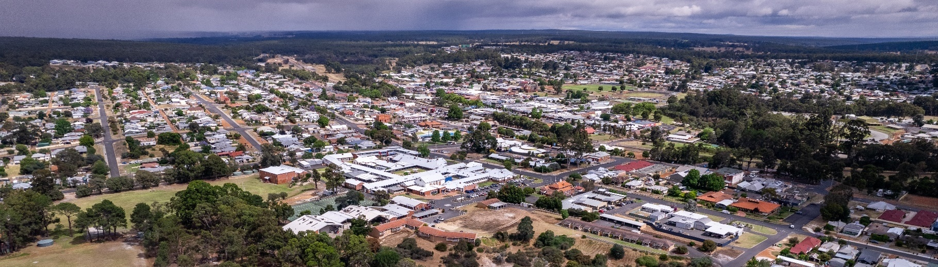
Key Economic and Social Indicators

Employment
Indicator (2021 Census unless otherwise stated) | Collie | Western Australia
Median working age | 42 | 40
Median income (annual gross, exc. super) | $26,000 – $33,799 | $33,800 – $41,599
Participation in workforce | 51.3% | 63.9%
Female participation in workforce | 48.4% | 60.3%
Workforce Self-Sufficiency (% of Workforce) | 55.0% | N/A
Unemployment rate (Dec 2025) | 5.5% | 4.0%
Regional Labour Market Index (Sep 2025) | Above Average | N/A
Source: ABS (2021), DEWR (2026), JSA (2026).

Demographics
Indicator (2021 Census) | Collie | Western Australia
Median age | 44 | 38
First Nations (% of population) | 4.6% | 3.5%
Educational attainment (% of population aged 15 and above):
- Below Year 12 | 67.7% | 39.7%
- Year 12 or equivalent | 32.3% | 60.3%
- Certificate III and IV | 29.0% | 19.4%
- Bachelor and above | 6.5% | 26.1%
Source: ABS (2021).

Housing
Indicator (2021 Census) | Collie | Western Australia
Estimated Homelessness (% of population) | 0.3% | 0.4%
Commonwealth Rent Assistance (% of population) (Sep 2025) | 4.9% | 3.9%
Mortgage stress | 12.4% | 12.9%
Rental stress | 26.4% | 28.4%
Source: ABS (2021), DSS (2025).

Power Stations, Coal Mines and Safeguard Facilities Map
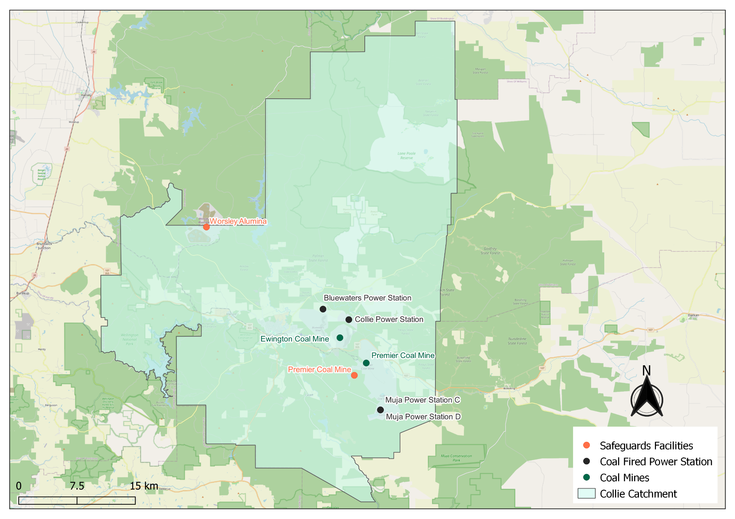

Source: AEMO (2026), DCCEEW (2025b), Wood Mackenzie (2026).

Commonwealth-Funded Net Zero Projects Map (Current and Proposed)

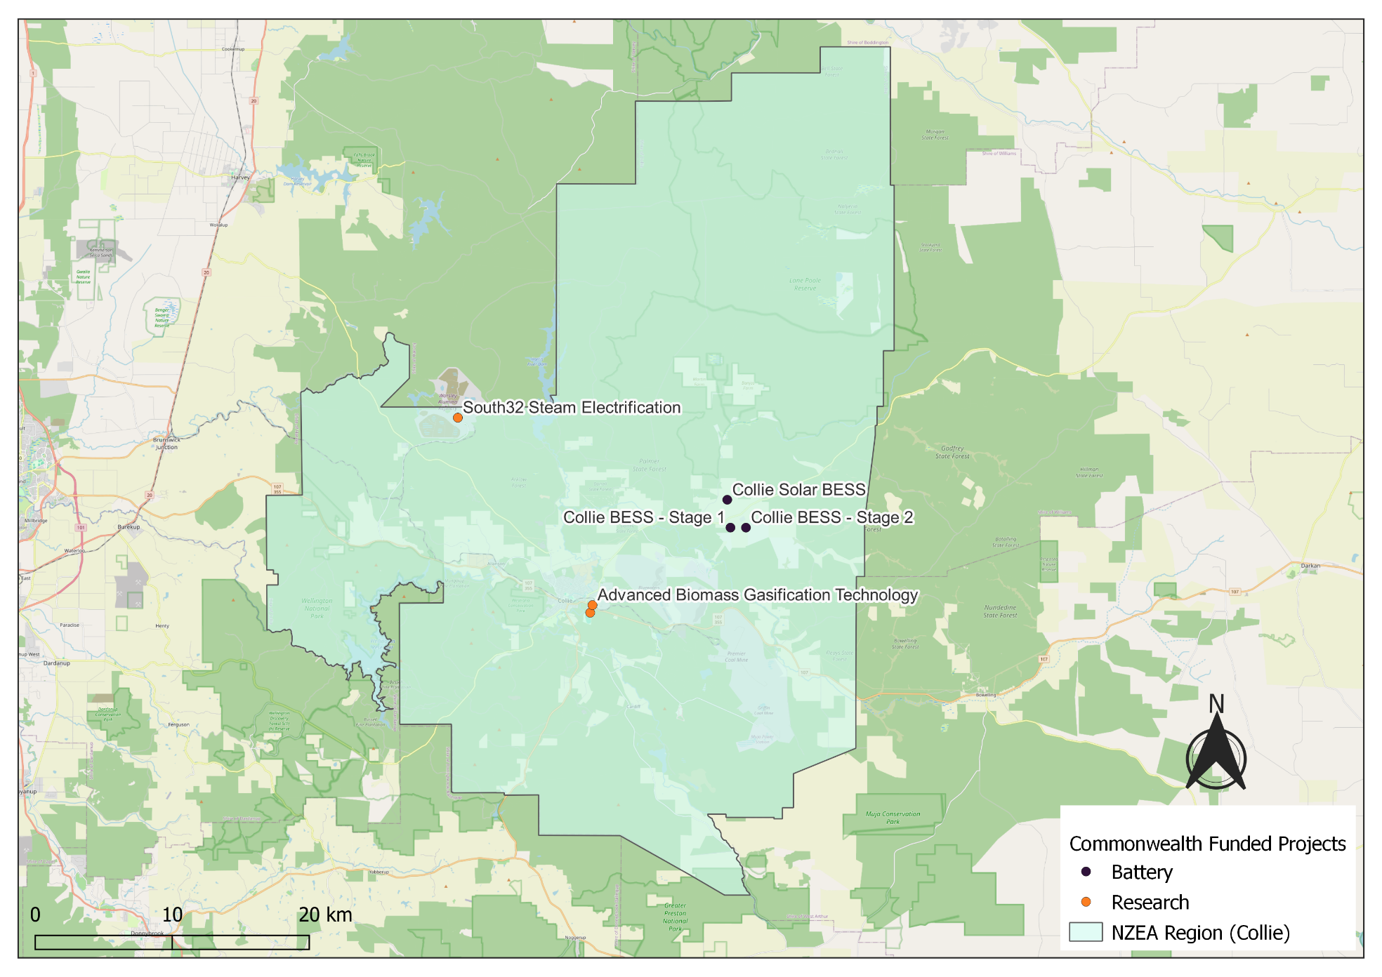
Note:
- Commonwealth funded projects include projects from the following schemes, Capacity Investment Scheme. Australian Renewable Energy Agency, Clean Energy Finance Corporation, Northern Australia Infrastructure Facility, National Reconstruction Fund, Regional Hydrogen Hubs Program.
- Information correct as of April 2026.
Source: NZIM (2026)
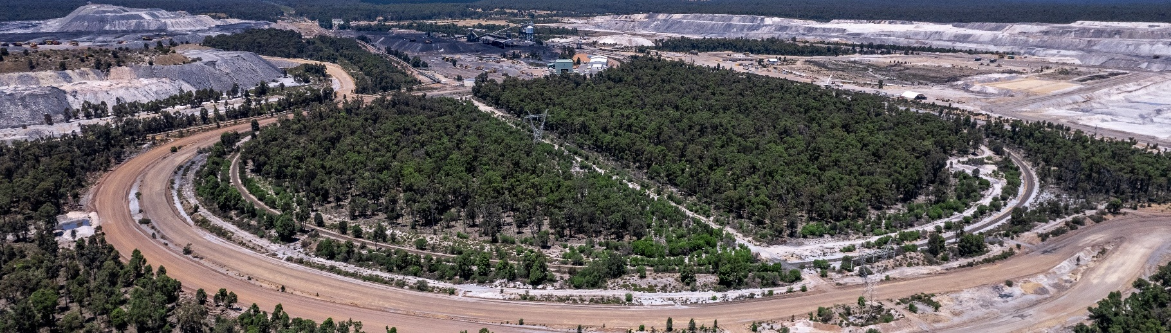
References
ABS (Australian Bureau of Statistics) (2021) Census of Population and Housing, abs.gov.au, accessed 10 February 2026.
ABS (Australian Bureau of Statistics) (2026) Regional population, abs.gov.au, accessed 1 April 2026.
AEMO (Australian Energy Market Operator) (2026) Generation information, aemo.com.au, accessed 10 February 2026.
APA (APA Group Limited) (2025) Big Batteries in Collie are not Western Australia’s only energy insurance policy, apa.com.au, accessed 9 April 2026.
Bluewaters Power (Bluewaters Power Group) (2024) Modern Slavery Statement FY2024, modernslaveryregister.gov.au, accessed 10 February 2026.
CER (Clean Energy Regulator) (2026) Safeguard facility covered emissions data 2024–25, cer.gov.au, accessed 20 April 2026.
DCCEEW (Department of Climate Change, Energy, the Environment and Water) (2025a) National Pollutant Inventory – Reports, data.gov.au, accessed 10 February 2026.
DCCEEW (Department of Climate Change, Energy, the Environment and Water) (2025b) Australia’s National Greenhouse Accounts, Emissions by State and Territory, greenhouseaccounts.climatechange.gov.au, accessed 10 February 2026.
DEWR (Department of Employment and Workplace Relations) (2026) Small Area Labour Market, dewr.gov.au, accessed 10 February 2026.
DSS (Department of Social Services) (2025) DSS Benefit and Payment Recipient Demographics – quarterly data, data.gov.au, accessed 10 February 2026.
Geoscience Australia (2026). Australian Mines Atlas, ga.gov.au, accessed 3 September 2026.
JSA (Jobs and Skills Australia) (2026) Regional Labour Market Indicator, jobsandskills.gov.au, accessed 10 February 2026.
NZEA (Net Zero Economy Authority) (2026). Regional Identification Framework and Profiles, netzero.gov.au, accessed 8 May 2026.
NZIM (Net Zero Investment Map) (2026). Net Zero Investment Map, netzeromap.au, accessed 10 February 2026.
REMPLAN (REMPLAN Pty Ltd) (2026) Economy, remplan.com.au, accessed 10 February 2026.
RenewMap (RenewMap Pty Ltd) (2026) Visualising Australia’s Energy Future, renewmap.com.au, accessed 10 February 2026.
Western Australia Government (WA Govt) (2025). The South West Interconnected System Transmission Plan: A Future-Ready Transmission Network for WA’s Main Electricity System, wa.gov.au, accessed 10 February 2026.
Wood Mackenzie (2026) Coal Supply Data, woodmac.com. Last accessed 27 February 2026.

