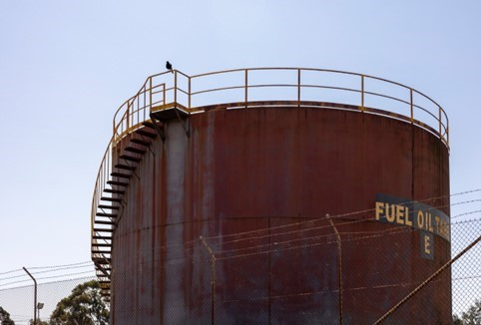



Hunter – Central Coast

Regional Profiles

Overview
The Hunter and Central Coast regions are at the centre of Australia’s economic transformation. Coal mining and coal-fired power generation remain a significant share of the local economy, and both industries are changing. This change presents challenges for some workers and communities, but the region is also well placed to benefit. The region has strong natural assets, existing infrastructure, and a skilled workforce that can support new industries.
  1 | Population (2025)  - 1,179,899 persons  - 1.2% 5-Yr Avg. Annual Growth  - NSW: 1.2% 5-Yr Avg. Annual Growth |  | Total Area  - 33,851.0 km²  - 4.2% of NSW
 | Gross Regional Product (2022-23)  - $119.8 Billion  - 14.0% of NSW |  | Employment (2022-23)  - 466,418 persons  - 12.7% of NSW
Working Zones: Bulahdelah-Stroud, Central Coast and surrounds, Forster, Tuncurry and surrounds, Gloucester; Muswellbrook, Scone and surrounds; Nelson Bay Peninsula and Anna Bay; Newcastle, Lower Hunter and surrounds; Taree and surrounds (maps at end of profile).

Region Selection Rationale

Exposure to Decarbonisation | Economic Opportunities from Decarbonisation
- Carbon Intensity: There are 3 coal-fired power stations along with 18 safeguard facilities in the region. As of 2024-25, safeguard facilities account for 39.6% of New South Wales (NSW) Safeguard Mechanism direct (scope 1) emissions. Approximately 20,000 employees are in roles exposed to change from decarbonisation.  - Urgency: All coal-fired power stations in the region are projected to close by 2033.  - Adaptive Capacity: Adaptive capacity varies across metropolitan and rural areas. City centres have diversified economies with related education opportunities and higher skill levels.  - Readiness: The Hunter-Central Coast is in a moderate to strong position to capitalise on energy transition opportunities. The NSW Government has announced the Future Jobs and Investment Authority for NSW’s four coal mining regions, including the Hunter. | - Natural Assets: Considerable potential for green industry, including green aluminium production and strong offshore wind energy resources. Several renewable energy projects have been proposed for the region, particularly in battery storage and solar photovoltaic (PV) electricity generation.  - Workforce Compatibility: A moderate number of workers in the region are employed in jobs highly compatible with clean energy industries. Higher levels of compatibility are experienced in Muswellbrook, Scone, Newcastle and the Lower Hunter.  - Enabling Infrastructure: Existing infrastructure, particularly the Newcastle Airport and the Port of Newcastle, supports the movement of workers, connect the region’s exports to global markets and support economic diversification.
Source: NZEA (2026).

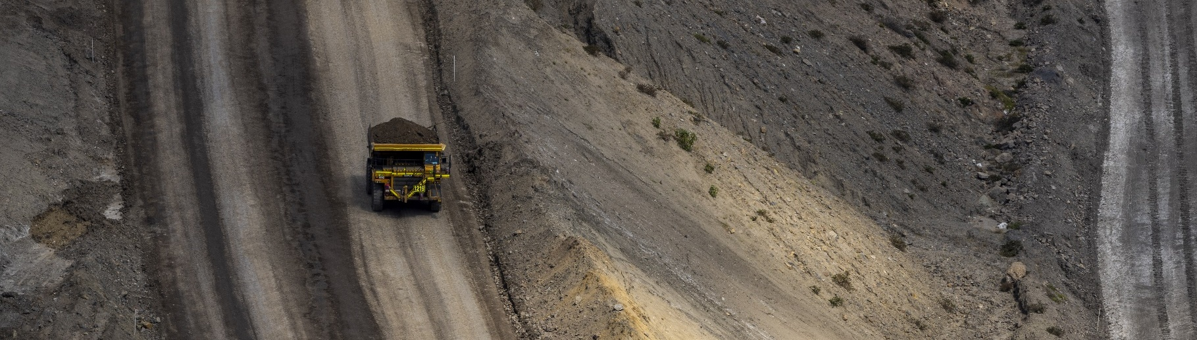
Carbon-Intensive Industries

Coal-Fired Power Stations
Facility | Owner | Public closure date | Employees | Supplying Coal Mine | S1 emiss. (tCO2-e) (23/24) | % of NSW S1 emiss. (23/24) | % of Aus S1 emiss. (23/24)
Bayswater Power Station | AGL | 2033 | 500 | Mangoola, and  Wilpinjong | 13,678,909 | 19.0% | 4.5%
Eraring Power Station | Origin | 2029 | 200+ | Mandalong, Myuna,  and three others | 13,535,335 | 18.8% | 4.5%
Vales Point Power Station | Delta | 2033 | 280 | Chain Valley (primary) | 7,043,816 | 9.8% | 2.3%
Total 3 | 3 | - | 980+ | - | 34,258,060 | 47.6% | 11.3%
Note: S1 emiss. indicates Scope 1 Emissions. Further information on Scope 1 emissions can be found here.
Source: AEMO (2026a), AGL (2026a) DCCEEW (2025a, 2025b), Origin (2024).

Gas-Fired Power Stations
Facility | Owner | Public closure date | Employees | S1 emiss. (tCO2-e) (23/24) | % of NSW S1 emiss. (23/24) | % of Aus S1 emiss. (23/24)
Colongra | Snowy Hydro Limited (Cwth gov) | 2070 | 10 | 63,830 | 0.1% | <0.1%
Note: S1 emiss. indicates Scope 1 Emissions. Further information on Scope 1 emissions can be found here.
Source: AEMO (2026a), DCCEEW (2025b).

Safeguard Facilities (Emit 100,000+ tonnes CO2 annually - power stations connected to grid are exempt)
Facility | No. | S1 emiss. (tCO2-e) (24/25) | % of NSW Safeguard emiss. (24/25) | % of Aus Safeguard emiss. (24/25)
Coal mining | 16* | 7,318,650 | 32.2% | 5.5%
Manufacturing | 2 | 1,669,870 | 7.4% | 1.2%
Total | 18 | 8,988,520 | 39.6% | 6.7%
Note:
- Mannering Colliery, included in the safeguard numbers, operates as part of an integrated mining operation with Chain Valley.
- Integra coal mine is included in the safeguard facilities number. However, this facility is no longer operational.
- Data is based on coal mines that emitted emissions in the 2023/24 FY, which includes mines that have since closed.
Source: CER (2026).

Coal Mines
No. of Coal Mines | Mines Supplying Domestic Market | Mines Supplying Export Market | Thermal Coal Mines | Metallurgical Coal Mines
21 | 10 | 19 | 20 | 12
Note: Individual coal mines may produce both thermal and metallurgical coal and may therefore be counted in both categories. Similarly, some mines may supply both domestic and export markets and may be counted in both market categories.
Source: Geoscience Australia (2026), Wood MacKenzie (2026).

Major Commonwealth Funded Net Zero Projects (excluding cancelled and completed) (top projects by value)
This table reflects projects that have received Commonwealth funding (as of April 2026), identified through publicly available sources, consistent with the Net Zero Investment Map, including the programs below.
- Capacity Investment Scheme (CIS)
- Australia Renewable Energy Agency (ARENA)
- Clean Energy Finance Corporation (CEFC)
- Northern Australian Infrastructure Facility (NAIF)
- National Reconstruction Fund (NRF)
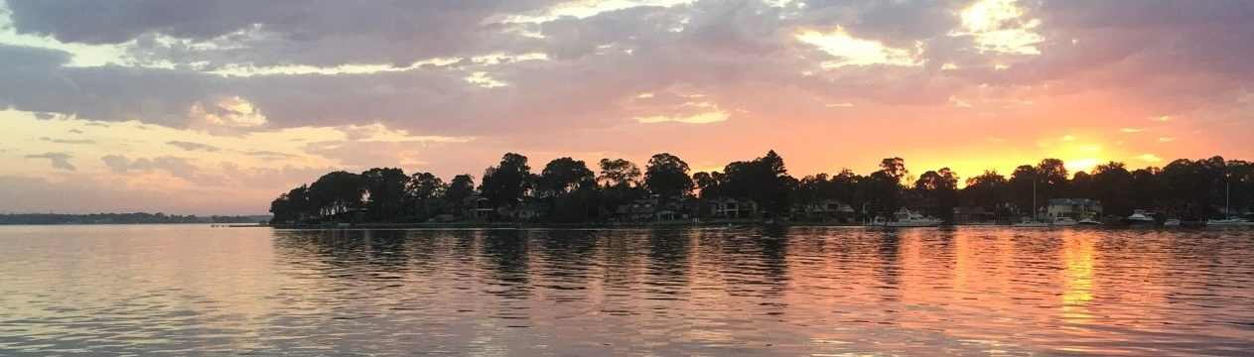
- Regional Hydrogen Hubs Program
Project | Description | Status | Cwth Govt Funding | Value
Liddell Battery Energy Storage System (BESS) | The Liddell Battery is a 500MW, two-hour duration, grid scale battery located at the former Liddell Power station site. Construction of the battery is complete with full commercial operations expected by June 2026. | Commissioning | $35.0M ARENA | $694.7M
Hunter Valley Hydrogen Hub | The Hunter Valley Hydrogen Hub project located in Kooragang Island, delivering green hydrogen to the Newcastle industrial area and port precinct. The project is designed to support decarbonisation of existing industrial operations in the Hunter region. | Development | $432.0M ARENA  $70.0M (Regional Hydrogen Hub Program) | $200.0M
ASTRI Australian Solar Thermal Research Institute | Consortium of leading Australian research institutions collaborating on Concentrating Solar Thermal (CST) power research projects. The main objective is to facilitate the commercial uptake of more efficient, higher temperature solar thermal technologies and CST systems. | Concept | $50.0M ARENA | $102.2M
Ethtec Cellulosic Ethanol Pilot Plant | The Ethtec Cellulosic Ethanol Pilot Plant is expected to have a production capacity of 270,000 litres per annum. | Planning | $12.0M  ARENA | $32.0M
Hunter Valley Solar Foundry Project | The Hunter Valley Solar Foundry Project is a solar manufacturing facility, producing modules for local and export markets. The facility aims to utilise local materials and suppliers and provide production capability to other manufacturers. | Planning | $171.0M ARENA  $34.4M CEFC | Unknown
Source: AGL (2026b) ARENA (2026), NZIM (2026), Orica (2026).

Regional Renewable Energy Projects (aggregated)
The aggregated tables below draw on RenewMap’s energy project database which contains information on the location and size of public and privately funded energy generation projects. Results are shown in aggregated form to illustrate the breadth and depth of projects in the region.

Operational
Type | Projects (No.) | Total Project Size (MW) | Total Storage Size (MWh)
Battery | 3 | 475 | 1,070
Biogas | 4 | 6 | N/A
Hydro | 1 | 6 | N/A
Solar Photovoltaic (Solar PV) | 4 | 15 | N/A
Total | 12 | 502 | 1,070 (Known Storage)
Note:
- RenewMap is a commercial subscription and is not publicly available.
- MW = Megawatt. A unit that measures capacity of energy systems.
- MWh = Megawatt hour. In battery technology, this unit measures the total amount of energy the system can store.
- Information correct as of April 2026.
Source: RenewMap (2026).

Under Development and Proposed
Type | Projects (No.) | Total Project Size (MW) | Total Storage Size (MWh)
Battery | 52 | 12,989 | 32,986
Biomass | 1 | 128 | N/A
Hydrogen | 2 | 1,650 | N/A
Onshore Wind | 5 | 2,451 | N/A
Pumped Hydro | 5 | 2,090 | 20,700
Solar Photovoltaic (Solar PV) | 15 | 2,244 | N/A
Solar Thermal | 1 | 5 | 90
Total | 81 | 21,557 | 53,776 (Known Storage)
Note:
- RenewMap is a commercial subscription and is not publicly available.
- MW = Megawatt. A unit that measures capacity of energy systems.
- MWh = Megawatt hour. In battery technology, this unit measures the total amount of energy the system can store.
- Information correct as of April 2026.
Source: RenewMap (2026).

Transmission Infrastructure Projects

Australian Energy Market Operator (AEMO) Draft 2026 Integrated System Plan (ISP)
Project | Description | Status | Timing | Cost
Hunter-Central Coast Renewable Energy Zone (REZ) Network Infrastructure Project | Substation upgrades to supply electricity generation from the Hunter and Central Coast to Sydney, Newcastle and Wollongong load | Committed | Jul-2028 | $604.2M
Sydney Ring North (Hunter Transmission Project) | High capacity 500 kV transmission network to reinforce supply to Sydney, Newcastle and Wollongong load centres. | Actionable | Nov-2029 | $1,364M (±50%)
Sydney Ring South | A new double-circuit 500 kV line to supply the Sydney, Newcastle and Wollongong load centres. | Actionable | Jul-2030 | $2,360M (±50%)
New England REZ Network Infrastructure project | Three separate projects to increase the transfer capability between central and northern NSW, enable more transfer capacity out of QLD-NSW Interconnector, and expand the New England REZ. | Anticipated | Jul-2034 | $3,700M
Note: ± indicates the cost uncertainty range.
Source: AEMO (2026b). AER (2025), Infrastructure Pipeline (2026).

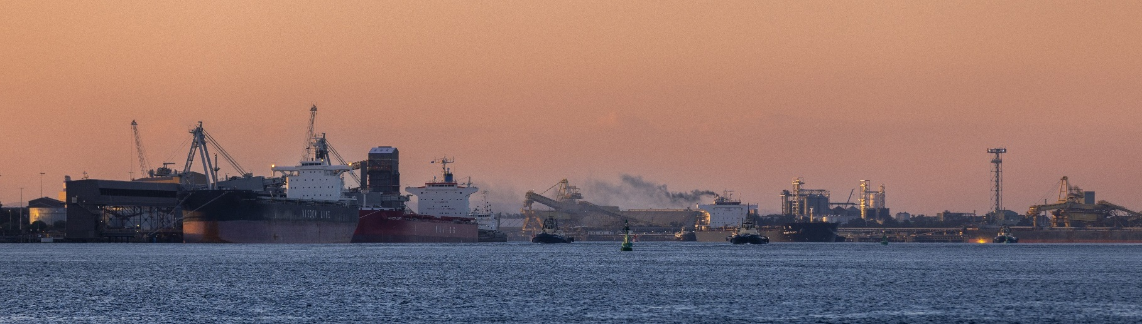
Major Industries (Hunter – Central Coast)

Gross Value Add (GVA) (2022-23)
Ranked Industries (Top five by value) | Value ($M) | % of GVA
Mining | $31,587.2 | 28.0%
Rental, Hiring and Real Estate Services | $13,250.5 | 11.8%
Health Care and Social Assistance | $11,241.7 | 10.0%
Construction | $8,850.4 | 7.9%
Public Administration and Safety | $6,187.6 | 5.5%
Note: Gross Value Add estimates are sourced from REMPLAN (2026), incorporating Australia Bureau of Statistics (ABS) 2021 Census (PoW), ABS 2024 Estimated Resident Population, ABS 2022–23 National Input–Output Tables, and ABS June 2025 Gross State Product into its modelling. Gross Value Add (GVA) measures the value of goods and services produced, minus the cost inputs used in production. Further information on GVA can be found here.
Source: REMPLAN (2026).

Employment (Hunter – Central Coast)

Place of Work (2022-23)
Ranked Industries (Top Five) | Employees (No.) | % of Employment
Health Care and Social Assistance | 88,943 | 19.1%
Retail Trade | 48,638 | 10.4%
Construction | 47,976 | 10.3%
Education and Training | 41,433 | 8.9%
Accommodation and Food Services | 38,122 | 8.2%
Note: Employment by Place of Work (PoW) estimates are sourced from REMPLAN (2026), incorporating Australia Bureau of Statistics (ABS) 2021 Census by PoW, ABS 2024 Estimated Resident Population, ABS 2022–23 National Input–Output Tables, and ABS June 2025 Gross State Product into its modelling.
Source: REMPLAN (2026).

Place of Usual Residence (2021)
Ranked Industries (Top Five) | Employees (No.) | % of Employment
Health Care and Social Assistance | 87,982 | 18.3%
Construction | 50,502 | 10.5%
Retail Trade | 48,192 | 10.0%
Education and Training | 42,408 | 8.8%
Accommodation and Food Services | 36,900 | 7.7%
Source: ABS (2021).

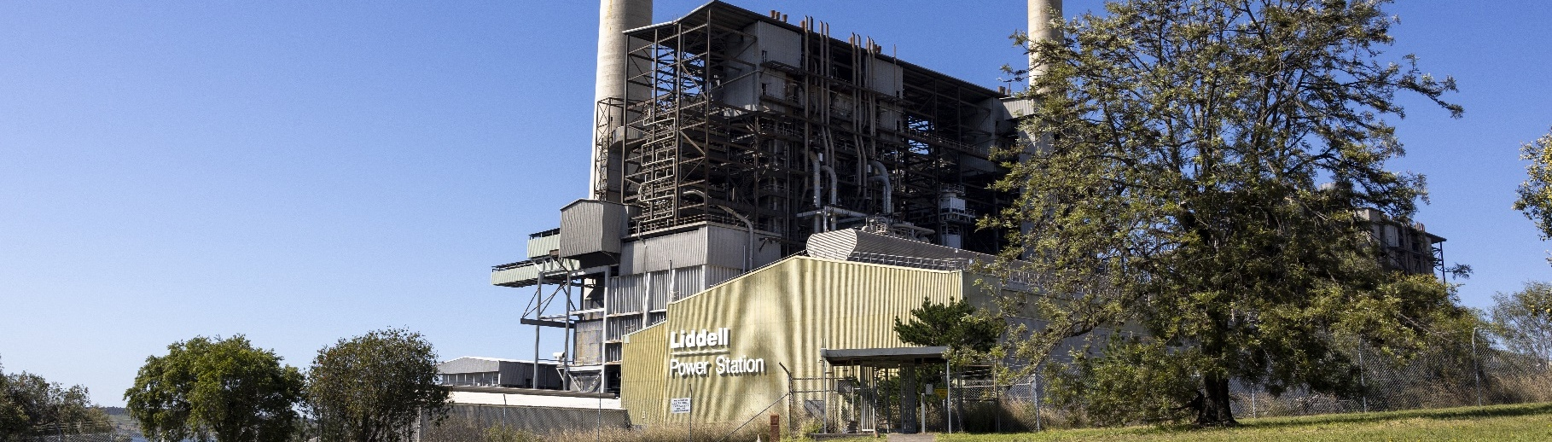
Key Economic and Social Indicators (Hunter)

Employment
Indicator (2021 Census unless otherwise stated) | Hunter | New South Wales
Median working age | 39 | 40
Median income (annual gross, exc. super) | $33,800 – $41,559 | $41,600 – $51,999
Participation in workforce | 59.5% | 58.7%
Female participation in workforce | 56.8% | 55.5%
Workforce Self-Sufficiency (% of Workforce) | 96.5% | N/A
Unemployment rate (Dec 2025) | 4.3% | 4.1%
Regional Labour Market Index (Sep 2025) | Average | N/A
Note: The regional labour market index does not include Newcastle. The neighbouring SA4 of Newcastle and Lake Macquarie has an ‘Above Average’ score
Source: ABS (2021), DEWR (2026), JSA (2026).

Demographics
Indicator (2021 Census) | Hunter | New South Wales
Median age | 40 | 39
First Nations (% of population) | 6.6% | 3.6%
Educational attainment (% of population aged 15 and above):
- Below Year 12 | 53.0% | 39.0%
- Year 12 or equivalent | 47.0% | 61.0%
- Certificate III and IV | 24.0% | 16.3%
- Bachelor and above | 20.2% | 30.4%
Source: ABS (2021).

Housing
Indicator (2021 Census) | Hunter | New South Wales
Estimated Homelessness (% of population) | 0.3% | 0.4%
Commonwealth Rent Assistance (% of population) (Sep 2025) | 6.9% | 5.4%
Mortgage stress | 12.0% | 17.3%
Rental stress | 35.8% | 35.5%
Source: ABS (2021), DSS (2025).

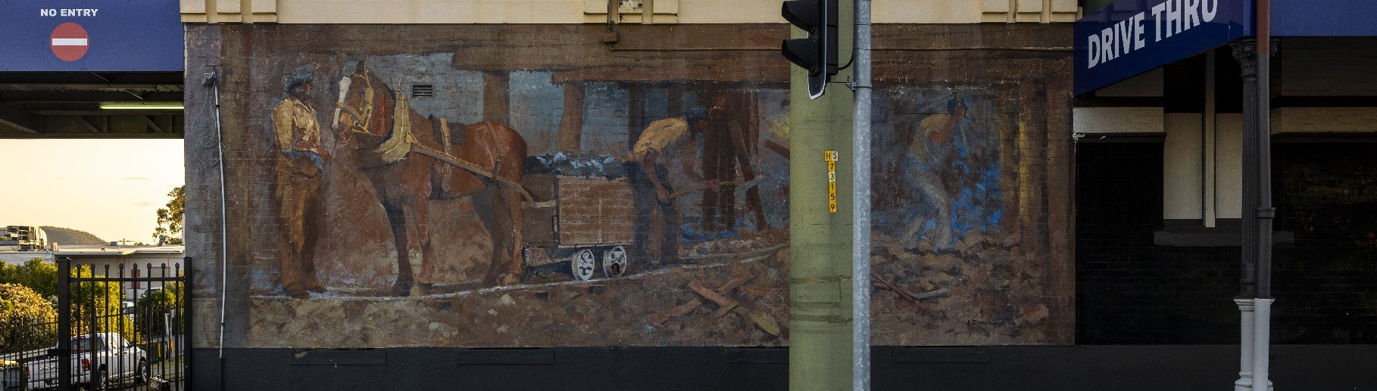
Key Economic and Social Indicators (Central Coast)

Employment
Indicator (2021 Census unless otherwise stated) | Central Coast | New South Wales
Median working age | 42 | 40
Median income (annual gross, exc. super) | $33,800 – $41,559 | $41,600 – $51,999
Participation in workforce | 55.6% | 58.7%
Female participation in workforce | 52.5% | 55.5%
Workforce Self-Sufficiency (% of Workforce) | 91.9% | N/A
Unemployment rate (Sep 2025) | 3.7% | 4.1%
Regional Labour Market Index (Sep 2025) | Average | N/A
Source: ABS (2021), DEWR (2026), JSA (2026).

Demographics
Indicator (2021 Census) | Central Coast | New South Wales
Median age | 43 | 39
First Nations (% of population) | 5.1% | 3.6%
Educational attainment (% of population aged 15 and above):
- Below Year 12 | 51.4% | 39.0%
- Year 12 or equivalent | 48.6% | 61.0%
- Certificate III and IV | 22.9% | 16.3%
- Bachelor and above | 19.5% | 30.4%
Source: ABS (2021).

Housing
Indicator (2021 Census) | Central Coast | New South Wales
Homelessness (% of population) | 0.2% | 0.4%
Commonwealth Rent Assistance (% of population) (Sep 2025) | 7.7% | 5.4%
Mortgage stress | 14.7% | 17.3%
Rental stress | 42.0% | 35.5%
Source: ABS (2021), DSS (2025).

Power Stations and Coal Mines Map
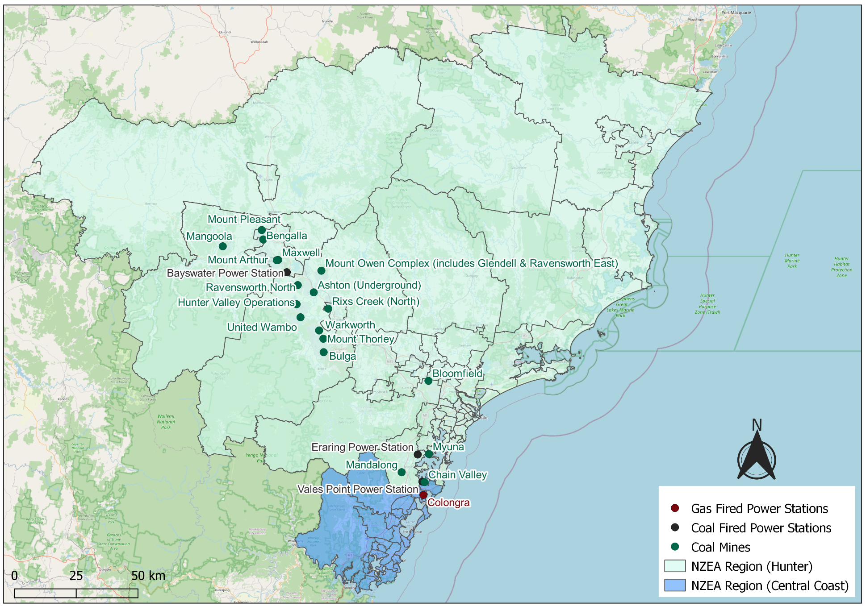
Source: AEMO (2026a).

Safeguard Facilities Map
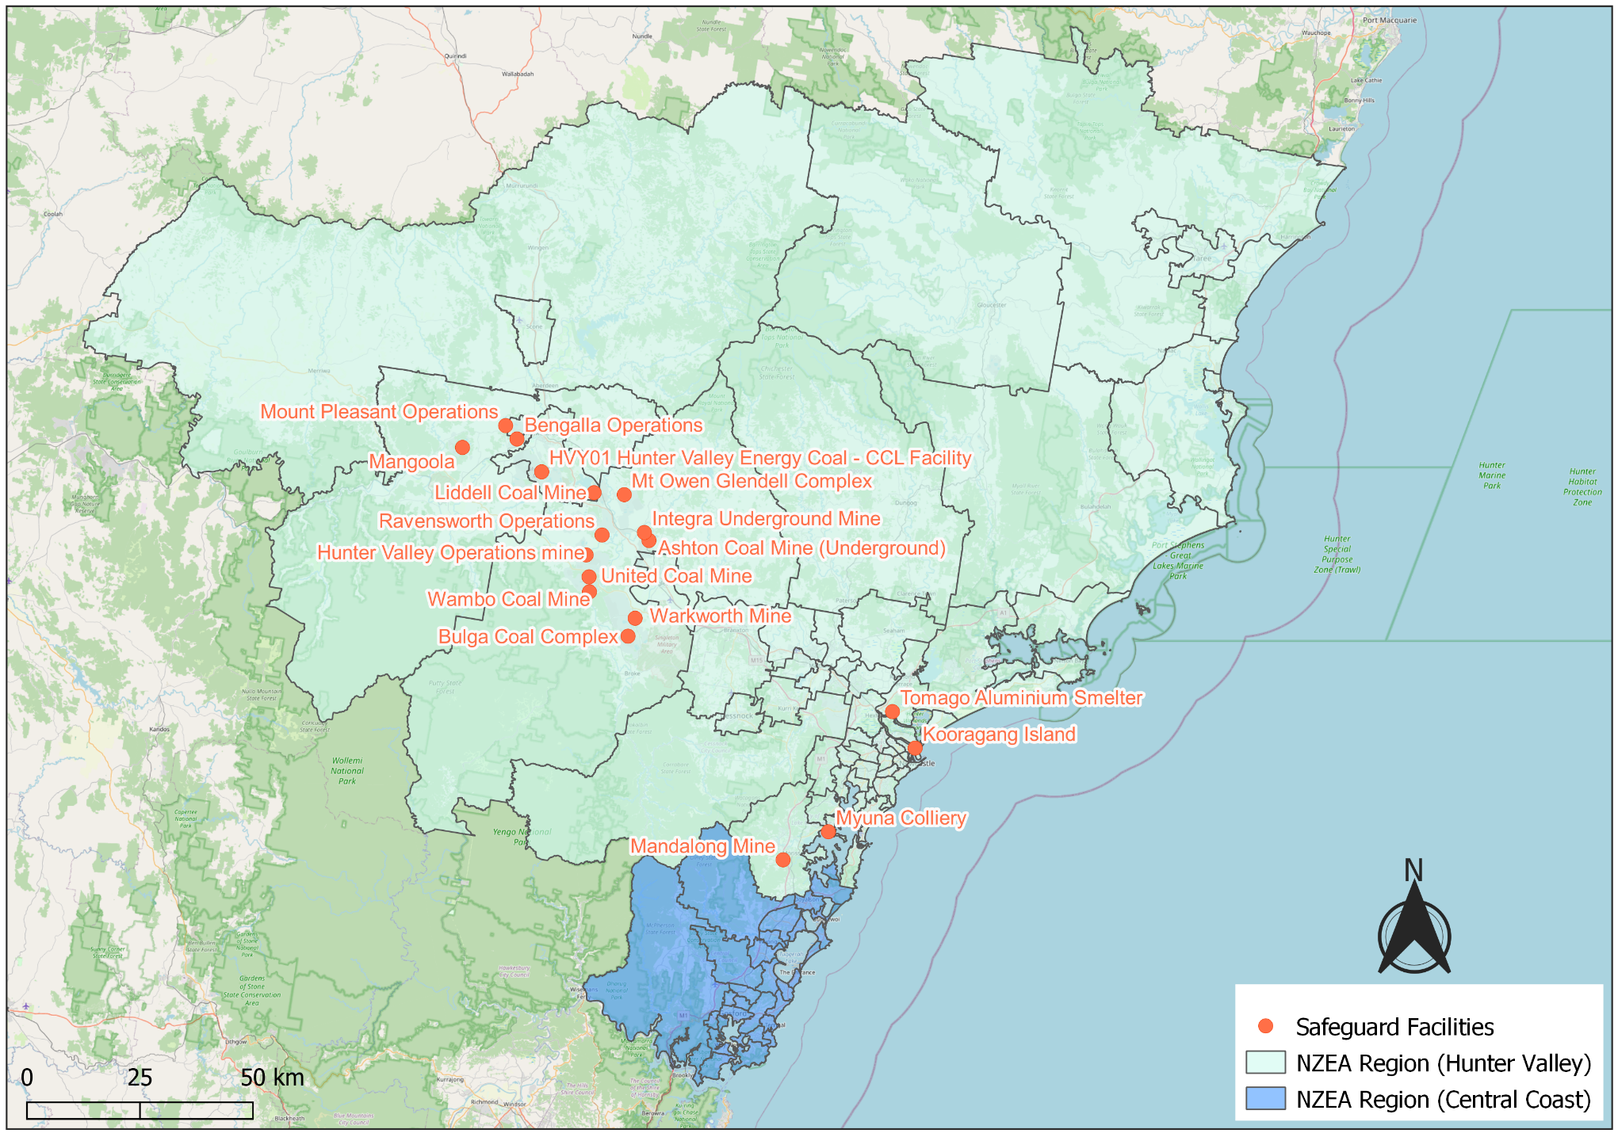
Source: DCCEEW (2025b).

Commonwealth-Funded Net Zero Projects Map (Current & Proposed)
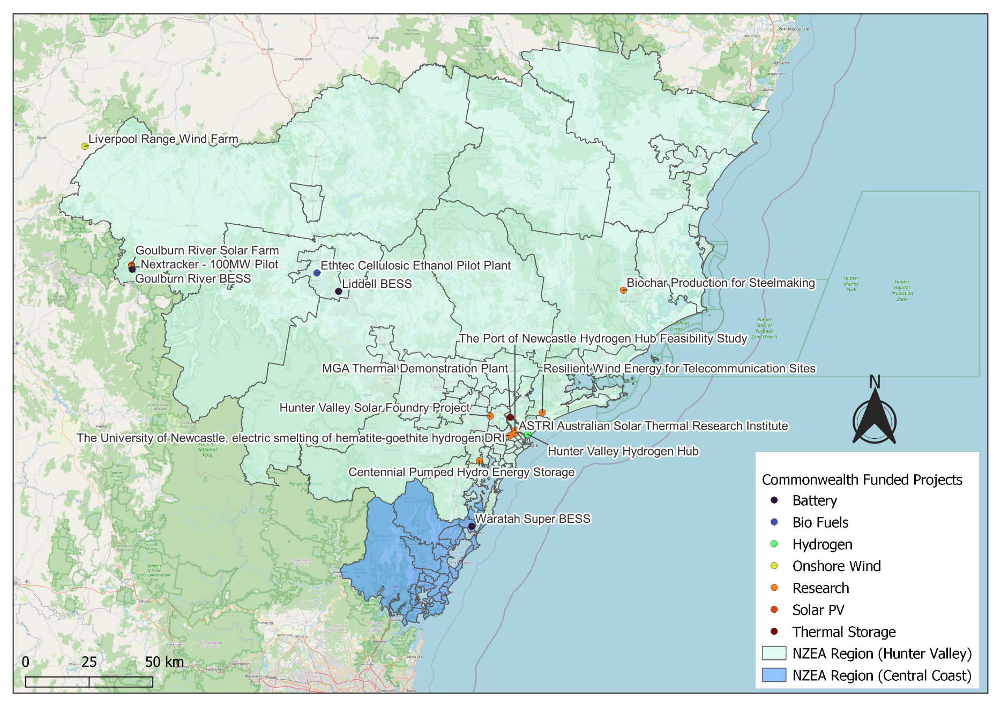
Note:
- Commonwealth funded projects include projects from the following schemes, Capacity Investment Scheme. Australian Renewable Energy Agency, Clean Energy Finance Corporation, Northern Australia Infrastructure Facility, National Reconstruction Fund, Regional Hydrogen Hubs Program.
- Information correct as of April 2026.
Source: NZIM (2026)

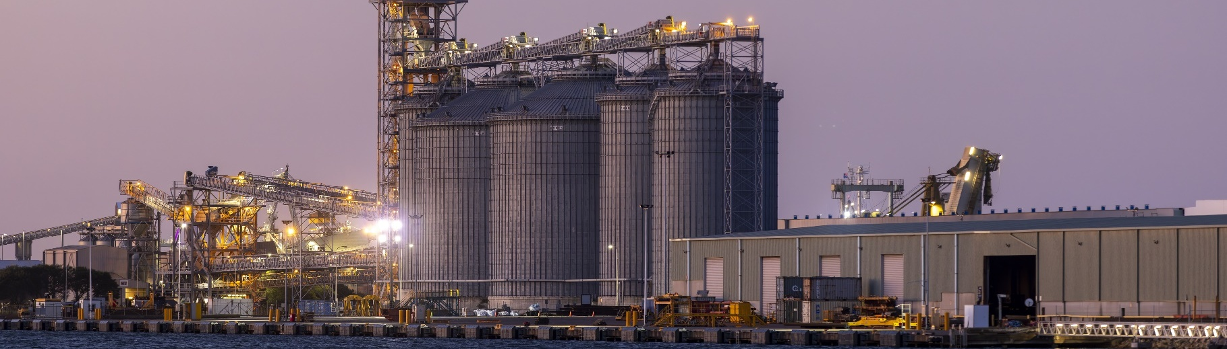
References
ABS (Australian Bureau of Statistics) (2021) Census of Population and Housing, abs.gov.au, accessed 10 February 2026.
ABS (Australian Bureau of Statistics) (2026) Regional population, abs.gov.au, accessed 1 April 2026.
AEMO (Australian Energy Market Operator) (2026a) Generation information, aemo.com.au, accessed 10 February 2026.
AEMO (Australian Energy Market Operator) (2026b) Draft 2026 Integrated System Plan (ISP), aemo.com.au, accessed 10 March 2026.
AER (Australian Energy Regulator) (2026) Final Decision – Hunter‑Central Coast REZ Network Infrastructure Project (Non‑contestable), aer.gov.au, accessed 10 March 2026.
AGL (AGL Energy) (2026a) AGL in the Hunter Region, agl.com.au, accessed 25 February 2026.
AGL (AGL Energy) (2026a) Liddell Battery, agl.com.au, accessed 5 May 2026.
ARENA (Australian Renewable Energy Agency) (2026). Ethtec Cellulosic Ethanol Pilot Plant, arena.gov.au, accessed 5 May 2026.
CER (Clean Energy Regulator) (2026) Safeguard facility covered emissions data 2024–25, cer.gov.au, accessed 20 April 2026.
DCCEEW (Department of Climate Change, Energy, the Environment and Water) (2025a) National Pollutant Inventory – Reports, data.gov.au, accessed 10 February 2026.
DCCEEW (Department of Climate Change, Energy, the Environment and Water) (2025b) Australia’s National Greenhouse Accounts, Emissions by State and Territory, greenhouseaccounts.climatechange.gov.au, accessed 10 February 2026.
DEWR (Department of Employment and Workplace Relations) (2026) Small Area Labour Market, dewr.gov.au, accessed 10 February 2026.
DSS (Department of Social Services) (2025) DSS Benefit and Payment Recipient Demographics – quarterly data, data.gov.au, accessed 10 February 2026.
Infrastructure Pipeline (2026) NSW New England REZ Transmission Project - Network Operator, infrastructurepipeline.org, accessed 2 July 2026.
Geoscience Australia (2026). Australian Mines Atlas, ga.gov.au, accessed 3 September 2026.
JSA (Jobs and Skills Australia) (2026) Regional Labour Market Indicator, jobsandskills.gov.au, accessed 10 February 2026.
NZEA (Net Zero Economy Authority) (2026). Regional Identification Framework and Profiles, netzero.gov.au, accessed 8 May 2026.
NZIM (Net Zero Investment Map) (2026). Net Zero Investment Map, netzeromap.au, accessed 10 February 2026.
Orica (Orica Limited) (2026) Hunter Valley Hydrogen Hub, orica.com, accessed 5 May 2026.
Origin (Origin Energy Limited) (2024) Eraring workers share their Future Directions journeys, originenergy.com.au, accessed 25 February 2026.
REMPLAN (REMPLAN Pty Ltd) (2026) Economy, remplan.com.au, accessed 10 February 2026.
RenewMap (RenewMap Pty Ltd) (2026) Visualising Australia’s Energy Future, renewmap.com.au, accessed 10 February 2026.
Wood Mackenzie (2026) Coal Supply Data, woodmac.com. Last accessed 27 February 2026.

