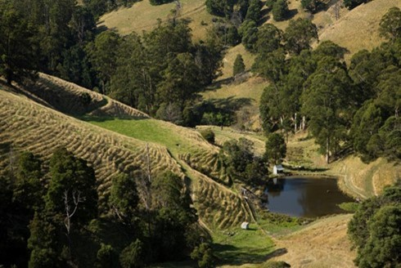



Latrobe – Gippsland

Regional Profiles

Overview
Latrobe – Gippsland plays a significant role in Australia’s electricity generation and has long been shaped by coal and gas‑fired power generation, which has driven the regional economy for decades. The region is at a critical transition point, with planned coal-fired power station closures as well as broader economic transitions occurring across Gippsland, presenting challenges for the region and its workforce.
At the same time, the region has strong underlying advantages that positions it well for future growth with coordinated planning, investment, and support.
 | Population (2025)  - 313,600 persons  - 1.3% 5-year avg. annual growth  - VIC: 1.4% 5-year avg. annual growth |  | Total Area  - 41,289.0 km²  - 18.1% of VIC
 | Gross Regional Product (2022-23)  - $26.3 Billion  - 4.1% of VIC |  | Employment (2022-23)  - 119,242 persons  - 3.8% of VIC
Working Zones: Drouin, Warragul and surrounds; La Trobe Valley Orbost and Alps-East; Bairnsdale, Lakes Entrance and surrounds; Leongatha and surrounds; Wonthaggi – Inverloch and Phillip Island; Sale and surrounds; Yarram (maps at end of profile).

Region Selection Rationale
Exposure to Decarbonisation | Economic Opportunities from Decarbonisation
- Carbon Intensity: 3 coal-fired power stations, 5 gas-fired power stations and 2 safeguard facilities. As of 2024-25, safeguard facilities accounted for 35.6% of Victoria’s Safeguard Mechanism direct (scope 1) emissions. Approximately 2.4% of regional jobs are in roles exposed to change from decarbonisation.  - Urgency: 2 of 3 coal-fired power stations, and 1 gas-fired power stations are expected to close by 2035.  - Adaptive Capacity: Adaptive capacity is supported by a large share of working age residents, meaning new industries can be more readily accommodated. However, higher reliance on government income support and lower labour force participation indicates some vulnerability to additional economic stress and a potential mismatch between workforce skills and available jobs.  - Readiness: Some planning, funding and governance arrangements are in place, including development of the Latrobe Valley and Gippsland Transition Plan, designed in conjunction with businesses, industries, and local communities. | - Natural Capital: Latrobe – Gippsland has high offshore wind potential, with projects proposed or under development in the region.  - Workforce Compatibility: Approximately 9.9% of the region’s workers are in roles compatible with forecasted clean energy occupations, which is largely consistent across townships in the region.  - Enabling Infrastructure: The region has strong road and telecommunication connectivity supporting trade and labour mobility. The region also has extensive high voltage transmission infrastructure supporting energy projects in the region.
Source: NZEA (2026).

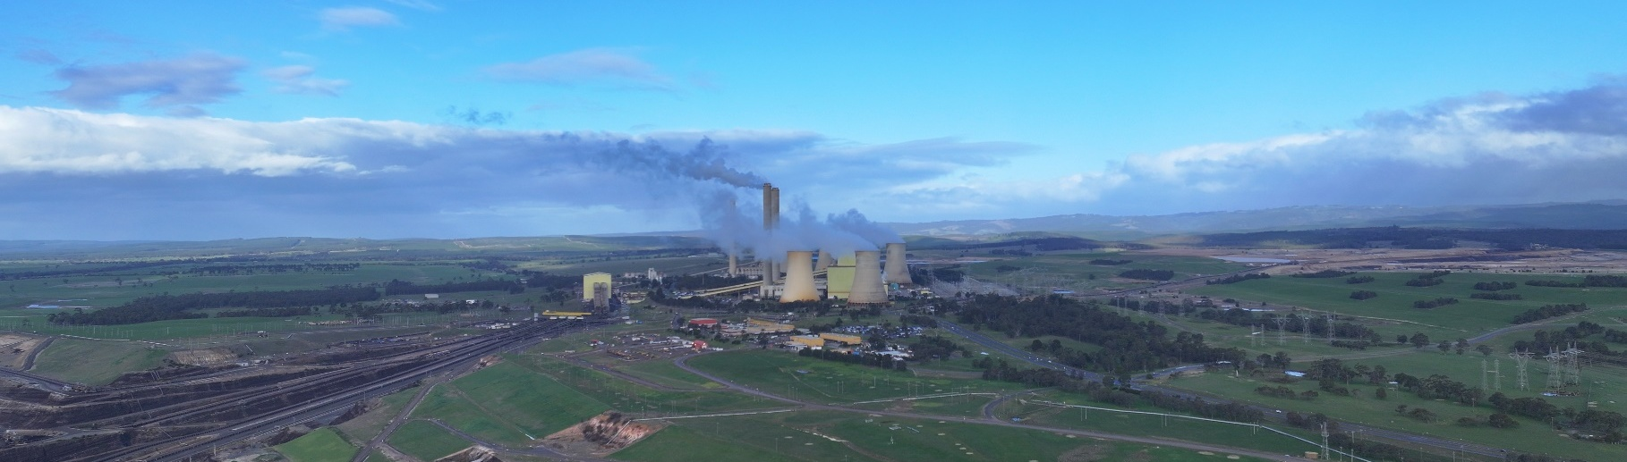
Carbon-Intensive Industries

Coal-Fired Power Stations
Facility | Owner | Public closure date | Employees | Supplying Coal Mine | S1 emiss. (tCO2-e) (23/24) | % of VIC S1 emiss. (23/24) | % of Aus S1 emiss. (23/24)
Yallourn | Energy Australia | 2028 | 50 | Yallourn | 10,344,727 | 10.4% | 2.0%
Loy Yang A | AGL | 2035 | 600 (and 300 contractors) | Loy Yang | 18,531,075 | 18.7% | 3.5%
Loy Yang B | Alinta Energy | 2047 | 152 (and 40 contractors) | Loy Yang | 9,642,473 | 9.7% | 1.8%
Total 3 | 3 | - | 1,142 | - | 38,518,275 | 38.8% | 7.3%
Note: S1 emiss. indicates Scope 1 Emissions. Further information on Scope 1 emissions can be found here.
Source: AEMO (2026a), AGL (2026), DCCEEW (2025a, 2025b), Energy Australia (2025).

Gas-Fired Power Stations
Facility | Owner | Public closure date | Employees | S1 emiss. (tCO2-e) (23/24) | % of VIC S1 emiss. (23/24) | % of Aus S1 emiss. (23/24)
Longford | Exxon Mobil | 2024-2032 | Unknown | Unknown | Unknown | Unknown
Jeeralang A & Jeeralang B | Energy Australia | 2039 | 11 (across A & B) | 34,838 (across A & B) | <0.1% | <0.1%
Valley Aking/Power | Snowy Hydro Ltd (Cwth gov.) | 2070 | 9 | 17,317 | <0.1% | <0.1%
Bairnsdale | Alinta Energy | 2042 | 5 | 33,601 | <0.1% | <0.1%
Total 5 | 4 | - | 25 | 85,756 | 0.1% | <0.1%
Note: S1 emiss. indicates Scope 1 Emissions. Further information on Scope 1 emissions can be found here.
Source: AEMO (2026a), DCCEEW (2025a, 2025b).

Safeguard Facilities (Emit 100,000+ tonnes CO2 annually - power stations connected to grid are exempt)
Facility | Owner | Employees | S1 emiss. (tCO2-e) (24/25) | % of VIC Safeguard emiss. (24/25) | % of Aus Safeguard emiss. (24/25)
Gippsland Basin facility | ESSO Australia Resources Pty Ltd | 126 | 1,634,475 | 32.2% | 1.2%
Opal Australian Paper Maryvale Mill | Paper Australia Ltd | 535 | 173,712 | 3.4% | 0.1%
Total 2 | 2 | 661 | 1,808,187 | 35.6% | 1.3%
Source: CER (2026), Cooper Energy (2024), DCCEEW (2025a).

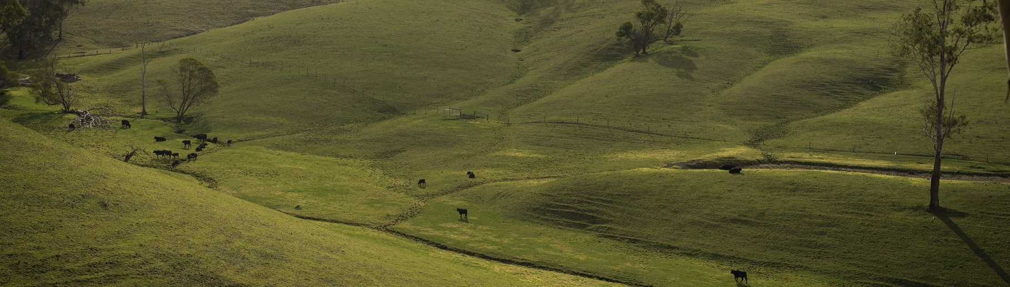
Major Commonwealth Funded Net Zero Projects (excluding cancelled and completed) (top projects by value)
This table reflects projects that have received Commonwealth funding (as of April 2026), identified through publicly available sources, consistent with the Net Zero Investment Map, including the programs below.
- Capacity Investment Scheme (CIS)
- Australia Renewable Energy Agency (ARENA)
- Clean Energy Finance Corporation (CEFC)
- Northern Australian Infrastructure Facility (NAIF)
- National Reconstruction Fund (NRF)
- Regional Hydrogen Hubs Program

Project | Description | Status | Cwth Govt Funding | Value
Wooreen Battery Energy Storage System (BESS) | Energy Australia has committed to building the Wooreen Energy Storage System scheduled to be operational prior to the end of 2026. The project will support Victoria’s energy supply, enable additional renewable energy capacity, and carry on the Latrobe Valley’s proud history of powering industry and communities. | Construction | CIS | $700.0M
Alinta ' Loy Yang B 'Stage 1' Synchronous Condenser Project | First of a kind project that aims to repurpose LYB’s spare generator stator and rotor, and spare generator transformer to provide essential system services as the percentage of inverter-based resources increases and synchronous generation reduces in the National Electricity Market (NEM). | Concept | $2.2M ARENA | $5.4M
Latrobe Valley Microgrid Feasibility Study | The Latrobe Valley Microgrid Feasibility Study will assess the viability of creating a local energy marketplace for dairy farms, residential participants and commercial/ industrial customers in the Latrobe Valley. | Concept | $0.4M ARENA | $0.8M
Latrobe Valley Aquaculture Geothermal Heating Study | Opal Australia Paper will complete a feasibility study for the use of a closed loop geothermal heating system to provide process heat at a proposed Recirculating Aquaculture System barramundi grow-out facility. This facility will be located adjacent to the Maryvale Paper Mill in the Latrobe Valley, Victoria. | Concept | $0.1M ARENA | $0.2M
Note: Information correct as of April 2026.
Source: NZIM (2026), RenewEconomy (2025).

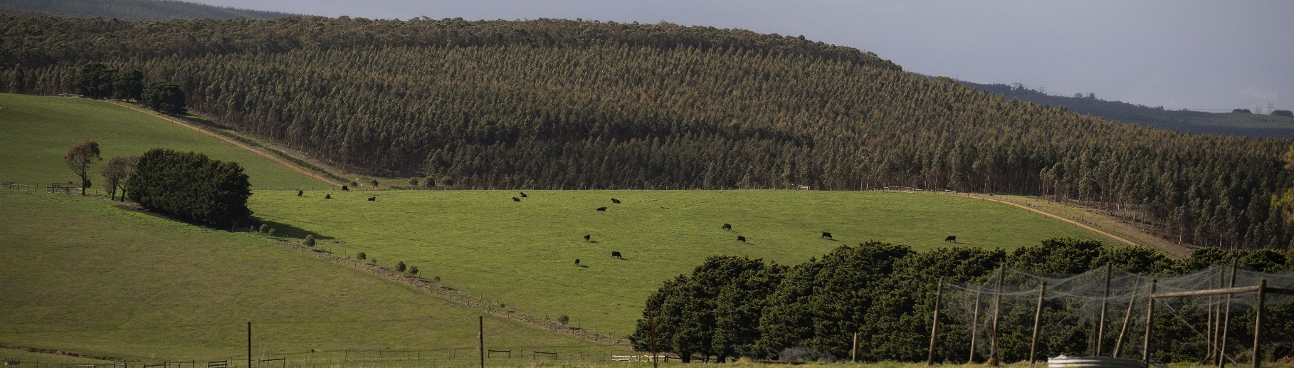
Regional Renewable Energy Projects (aggregated)
The aggregated tables below draw on RenewMap’s energy project database which contains information on the location and size of public and privately funded energy generation projects. Results are shown in aggregated form to illustrate the breadth and depth of projects in the region.

Operational
Type | Projects (No.) | Total Project Size (MW) | Total Storage Size (MWh)
Battery | 4 | 260 | 368
Onshore Wind | 3 | 140 | N/A
Hydro | 1 | 4 | N/A
Total | 8 | 404 | 368 (Known Storage)
Note:
- RenewMap is a commercial subscription and is not publicly available.
- MW = Megawatt. A unit that measures capacity of energy systems.
- MWh = Megawatt hour. In battery technology, this unit measures the total amount of energy the system can store.
- Information correct as of April 2026.
Source: RenewMap (2026).

Under Development and Proposed
Type | Projects (No.) | Total Project Size (MW) | Total Storage Size (MWh)
Battery | 28 | 5,444 | 17,681
Biomass | 1 | 25 | N/A
Offshore Wind | 9 | 16,980 | N/A
Onshore Wind | 3 | 702 | N/A
Solar Photovoltaic (Solar PV) | 13 | 1,198 | N/A
Total | 54 | 24,349 | 17,681 (Known Storage)
Note:
- RenewMap is a commercial subscription and is not publicly available.
- MW = Megawatt. A unit that measures capacity of energy systems.
- MWh = Megawatt hour. In battery technology, this unit measures the total amount of energy the system can store.
- Information correct as of April 2026.
Source: RenewMap (2026).

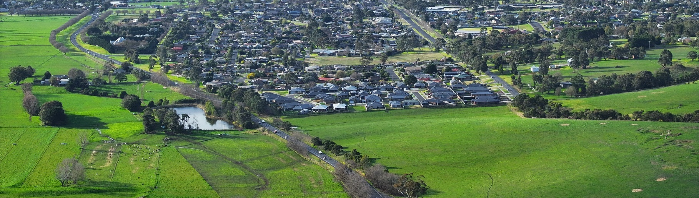
Transmission Infrastructure Projects

Australian Energy Market Operator (AEMO) Draft 2026 Integrated System Plan (ISP)
Project | Description | Status | Timing | Cost
Project Marinus | - Two new high-voltage direct current cables connecting Victoria (inc. Latrobe) and Tasmania, each with 750 MW of transfer capacity, alongside associated AC transmission infrastructure to enable efficient power sharing between regions.  - HVAC network assets in Tasmania for REZs under Transmission Developments project. | Stage 1: Committed  Stage 2: Actionable | Stage 1: 2030  Stage 2: 2034 | Stage 1: $3.4B  Stage 2: $2.5b (±30%)
Gippsland Offshore Wind Connection | - Gippsland Offshore Wind Transmission is required to integrate offshore wind into the existing Latrobe Valley infrastructure.  - Stage 1 is a 500 kV double-circuit radial line from Loy Yang to Giffard.  - Stage 2 (Phase 1) is a 500 kV double-circuit radial line from near Woodside to near Hazelwood.  - Stage 2 (Phase 2) is a 500 kV double-circuit line linking the two Gippsland radial lines | Actionable | Stage 1: 2031  Stage 2: 2038 | Stage 1: $1.5B  (-50% to +100%)  Stage 2: $1.2B  (-50% to +100%)
Eastern Victoria Reinforcement | - Additional transfer capacity between Latrobe Valley and Melbourne to accommodate increased onshore and new offshore wind power generation. | Future | 2033-34 | $70.0M  (-50% to +100%)
Note: ± indicates the cost uncertainty range.
Source: AEMO (2026b), Renew Economy (2026).

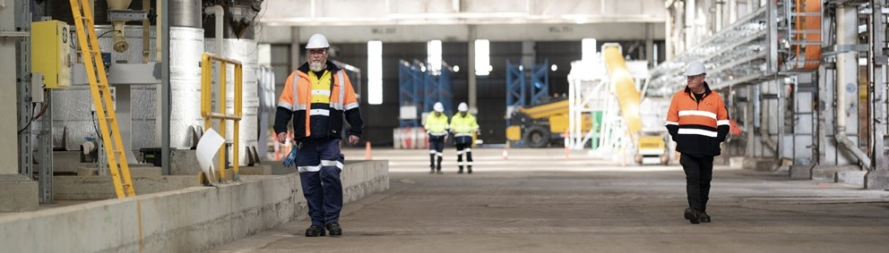
Major Industries

Gross Value Add (GVA) (2022-23)
Ranked Industries (Top Five) | Value ($M) | % of GVA
Rental, Hiring and Real Estate Services | $3,328.3 | 13.6%
Mining | $2,587.6 | 10.6%
Health Care and Social Assistance | $2,457.8 | 10.0%
Agriculture, Forestry and Fishing | $2,408.7 | 9.8%
Construction | $2,316.5 | 9.5%
Note: Gross Value Add estimates are sourced from REMPLAN (2026), incorporating Australia Bureau of Statistics (ABS) 2021 Census (PoW), ABS 2024 Estimated Resident Population, ABS 2022–23 National Input–Output Tables, and ABS June 2025 Gross State Product into its modelling. Gross Value Add (GVA) measures the value of goods and services produced, minus the cost inputs used in production. Further information on GVA can be found here.
Source: REMPLAN (2026).

Employment

Place of Work (2022-23)
Ranked Industries (Top Five) | Employees (No.) | % of Employment
Health Care and Social Assistance | 20,290 | 17.0%
Construction | 12,497 | 10.5%
Retail Trade | 12,053 | 10.1%
Education and Training | 10,807 | 9.1%
Agriculture, Forestry and Fishing | 10,046 | 8.4%
Note: Employment by Place of Work (PoW) estimates are sourced from REMPLAN (2026), incorporating Australia Bureau of Statistics (ABS) 2021 Census by PoW, ABS 2024 Estimated Resident Population, ABS 2022–23 National Input–Output Tables, and ABS June 2025 Gross State Product into its modelling.
Source: REMPLAN (2026).

Place of Usual Residence (2021)
Ranked Industries (Top Five) | Employees (No.) | % of Employment
Health Care and Social Assistance | 19,698 | 16.1%
Construction | 13,861 | 11.3%
Retail Trade | 12,012 | 9.8%
Education and Training | 10,942 | 9.0%
Agriculture, Forestry and Fishing | 9,580 | 7.8%
Source: ABS (2021).

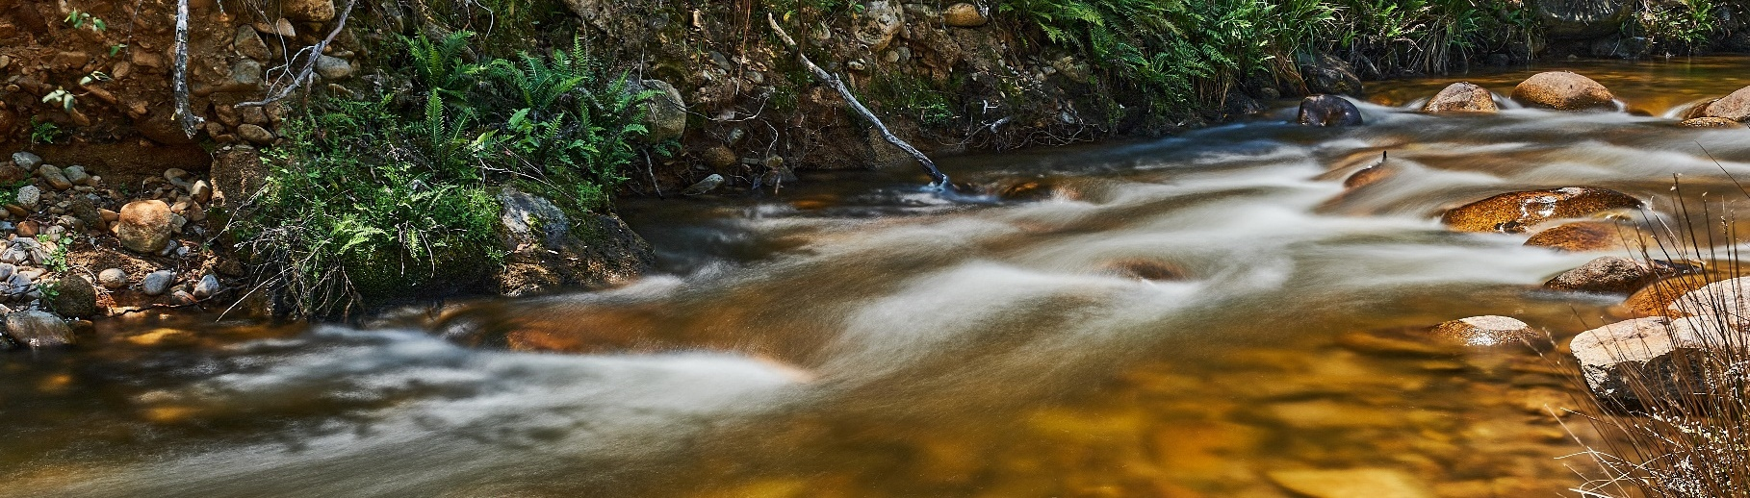
Key Economic and Social Indicators

Employment
Indicator (2021 Census unless otherwise stated) | Latrobe-Gippsland | Victoria
Median working age | 43 | 39
Median income (annual gross, exc. super) | $33,800 – $41,559 | $41,600 – $51,999
Participation in workforce | 53.5% | 62.4%
Female participation in workforce | 50.9% | 58.6%
Workforce Self-Sufficiency (% of Workforce) | 95.6% | N/A
Unemployment rate (Dec 2025) | 4.2% | 4.5%
Regional Labour Market Index (Sep 2025) | Below Average | N/A
Source: ABS (2021), DEWR (2026), JSA (2026).

Demographics
Indicator (2021 Census) | Latrobe-Gippsland | Victoria
Median age | 46 | 38
First Nations (% of population) | 2.1% | 1.1%
Educational attainment (% of population aged 15 and above):
- Below Year 12 | 56.1% | 36.7%
- Year 12 or equivalent | 43.9% | 63.3%
- Certificate III and IV | 24.3% | 15.4%
- Bachelor and above | 16.6% | 31.6%
Source: ABS (2021).

Housing
Indicator (2021 Census) | Latrobe-Gippsland | Victoria
Homelessness (% of population) | 0.3% | 0.5%
Commonwealth Rent Assistance (% of population) (Sep 2025) | 6.4% | 4.6%
Mortgage stress | 11.4% | 15.5%
Rental stress | 32.4% | 30.9%
Source: ABS (2021), DSS (2025).

Power Stations, Coal Mines and Safeguard Facilities Map
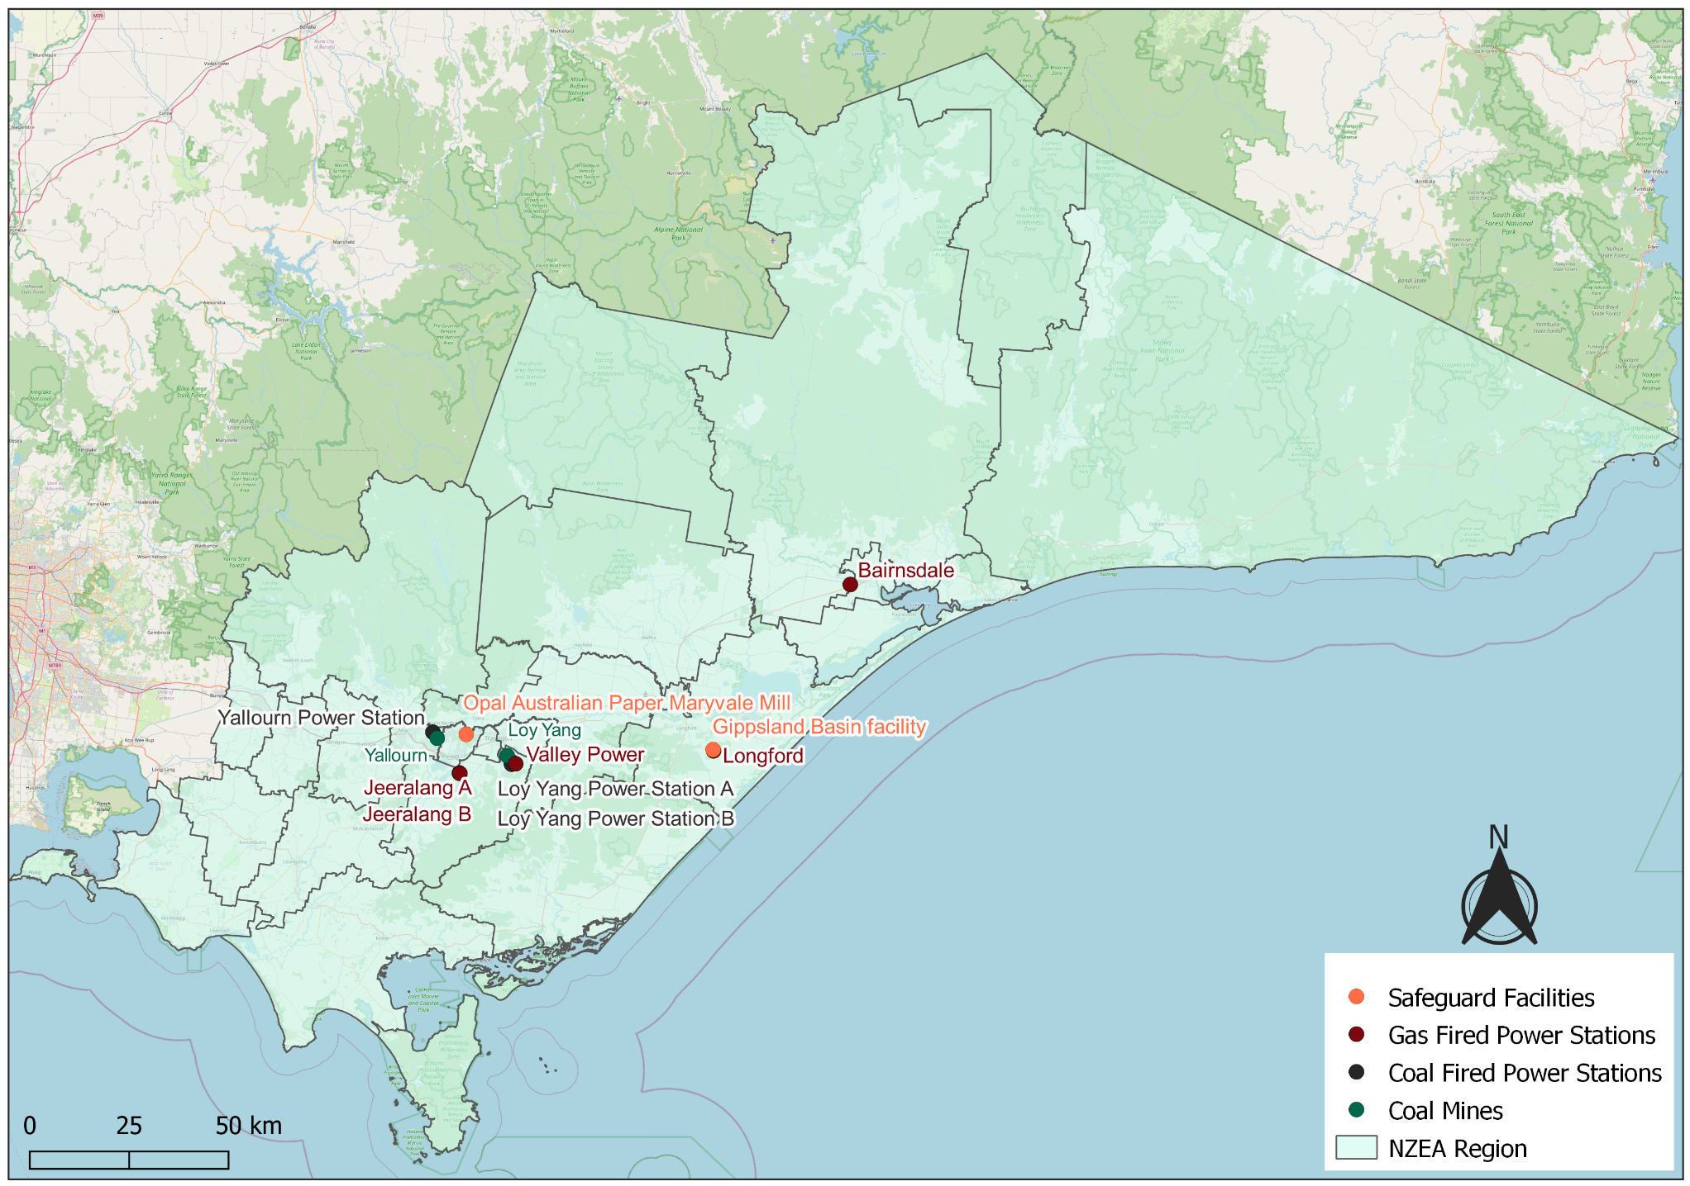
Source: AEMO (2026a), DCCEEW (2025b). WoodMackenzie (2026).
Commonwealth Funded Net Zero Projects Map (Current & Proposed)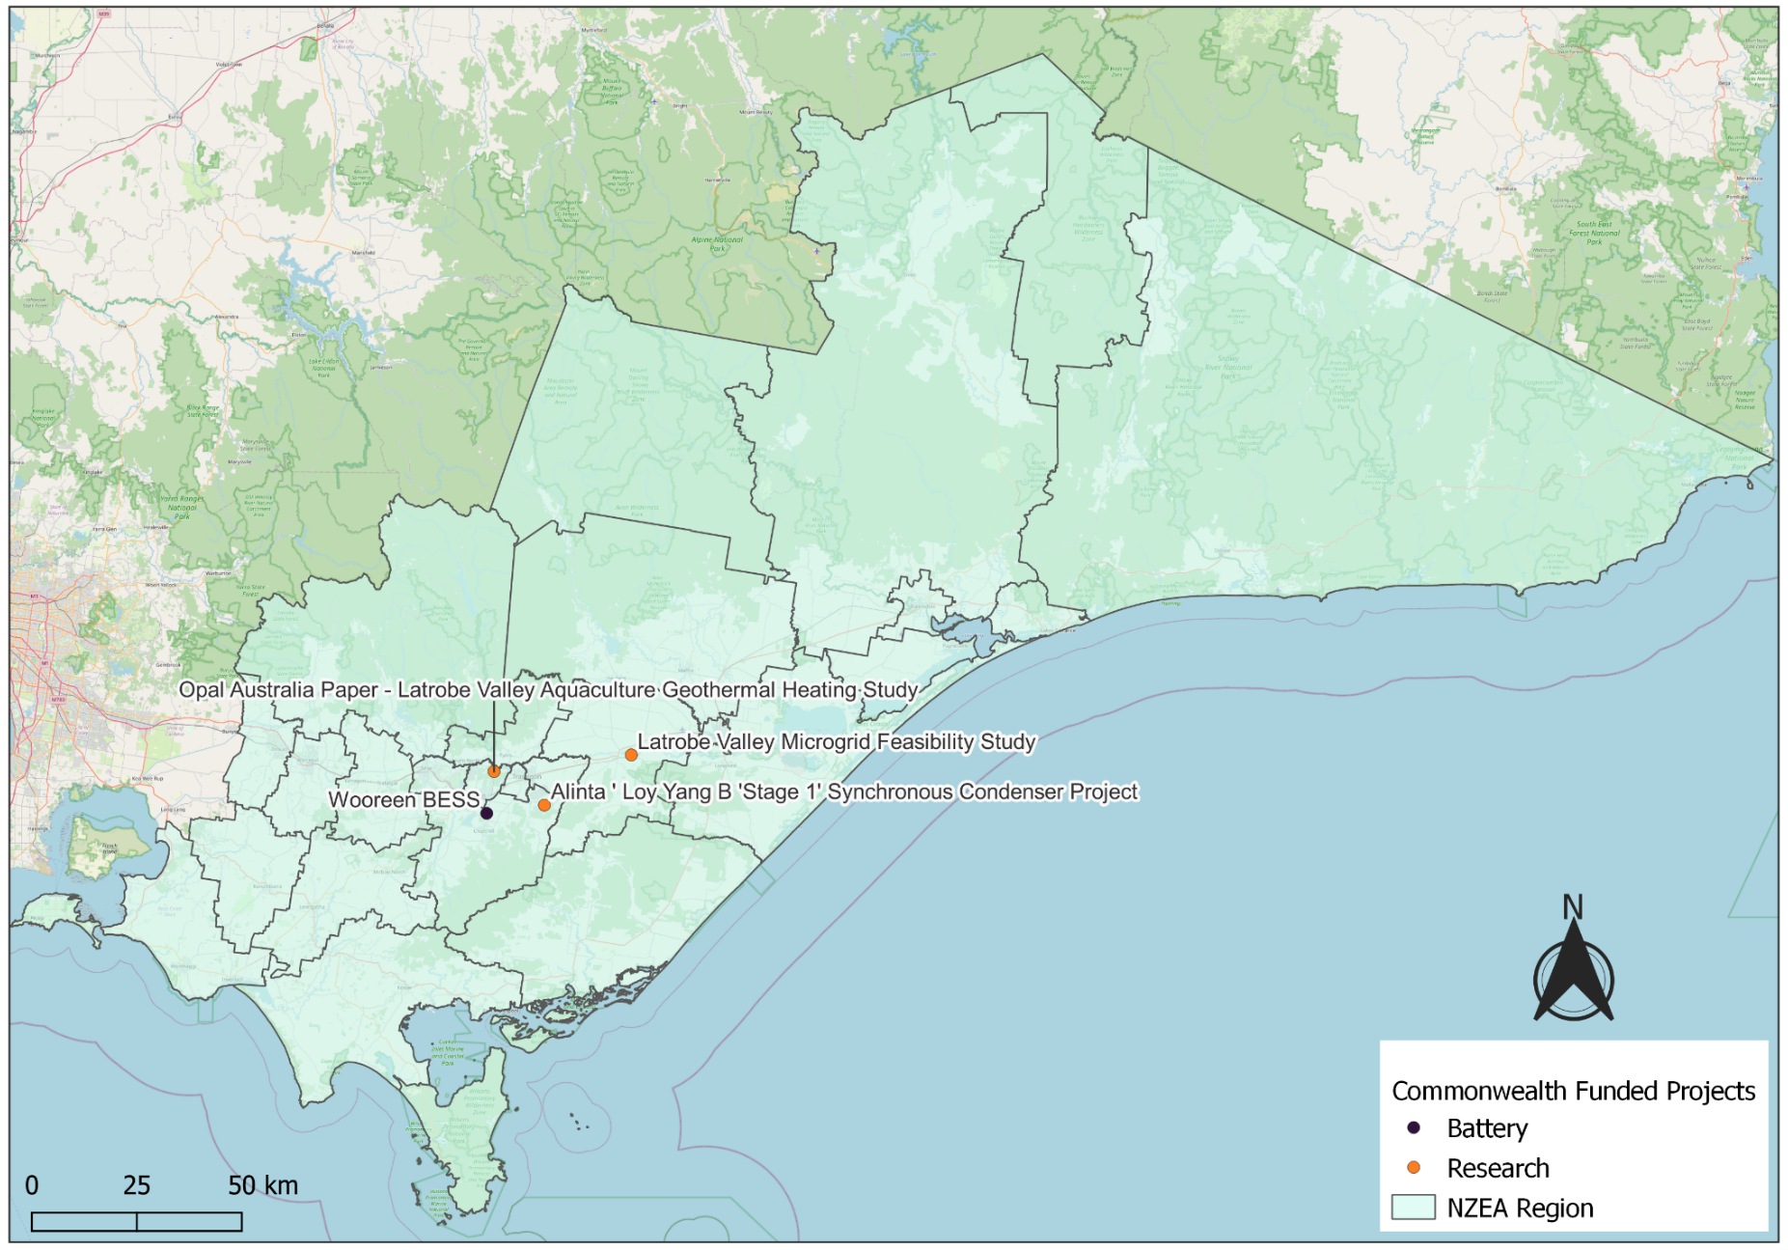
Note:
- Commonwealth funded projects include projects from the following schemes, Capacity Investment Scheme. Australian Renewable Energy Agency, Clean Energy Finance Corporation, Northern Australia Infrastructure Facility, National Reconstruction Fund, Regional Hydrogen Hubs Program.
- Information correct as of April 2026.
Source: NZIM (2026).
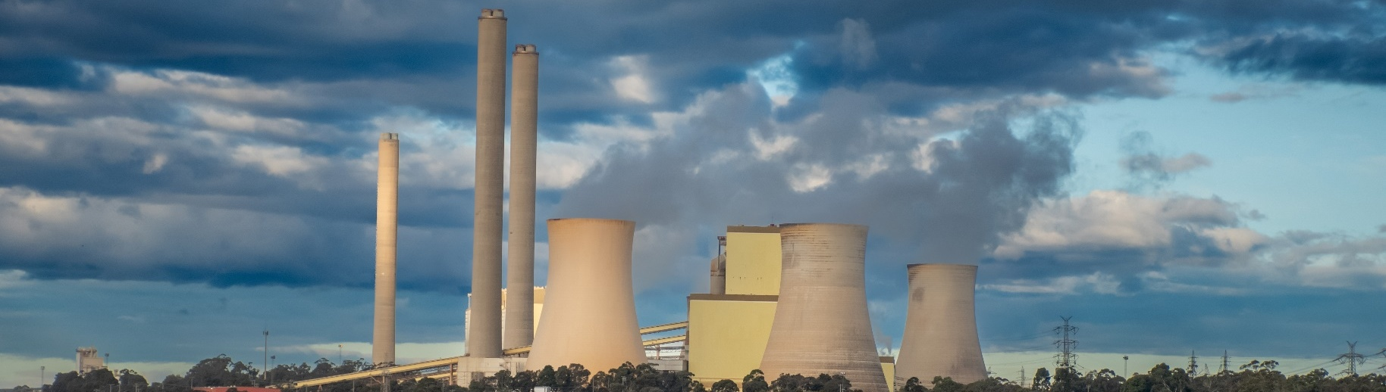

References
ABS (Australian Bureau of Statistics) (2021) Census of Population and Housing, abs.gov.au, accessed 10 February 2026.
ABS (Australian Bureau of Statistics) (2026) Regional population, abs.gov.au, accessed 1 April 2026.
AEMO (Australian Energy Market Operator) (2026a) Generation information, aemo.com.au, accessed 10 February 2026.
AEMO (Australian Energy Market Operator) (2026b) Draft 2026 Integrated System Plan (ISP), aemo.com.au, accessed 10 March 2026.
AGL (AGL Energy Limited) (2026). AGL in the Latrobe Valley, agl.com.au, accessed 26 February 2026.
CER (Clean Energy Regulator) (2026) Safeguard facility covered emissions data 2024–25, cer.gov.au, accessed 20 April 2026.
Cooper Energy (Cooper Energy Limited) (2024) Annual Report FY24, amplitudeenergy.com.au, accessed 26 February 2026.
DCCEEW (Department of Climate Change, Energy, the Environment and Water) (2025a) National Pollutant Inventory – Reports, data.gov.au, accessed 10 February 2026.
DCCEEW (Department of Climate Change, Energy, the Environment and Water) (2025b) Australia’s National Greenhouse Accounts, Emissions by State and Territory, greenhouseaccounts.climatechange.gov.au, accessed 10 February 2026.
DEWR (Department of Employment and Workplace Relations) (2026) Small Area Labour Market, dewr.gov.au, accessed 10 February 2026.
DSS (Department of Social Services) (2025) DSS Benefit and Payment Recipient Demographics – quarterly data, data.gov.au, accessed 10 February 2026.
Energy Australia (Energy Australia Pty Ltd) (2025). Yallourn Transition Presentation, accessed 18 February 2026.
JSA (Jobs and Skills Australia) (2026) Regional Labour Market Indicator, jobsandskills.gov.au, accessed 10 February 2026.
NZEA (Net Zero Economy Authority) (2026). Regional Identification Framework and Profiles, netzero.gov.au, accessed 8 May 2026.
NZIM (Net Zero Investment Map) (2026). Net Zero Investment Map, netzeromap.au, accessed 10 February 2026.
REMPLAN (REMPLAN Pty Ltd) (2026) Economy, remplan.com.au, accessed 10 February 2026.
Renew Economy (2025) EnergyAustralia breaks ground on its first four-hour big battery in Victorian coal country, reneweconomy.com.au, accessed 12 May 2026.
Renew Economy (2026) Marinus Link construction heads “into full swing” as regulator delivers final verdict on cost, reneweconomy.com.au, accessed 20 March 2026.
RenewMap (RenewMap Pty Ltd) (2026) Visualising Australia’s Energy Future, renewmap.com.au, accessed 10 February 2026.
Wood Mackenzie (2026) Coal Supply Data, woodmac.com. Last accessed 27 February 2026.

