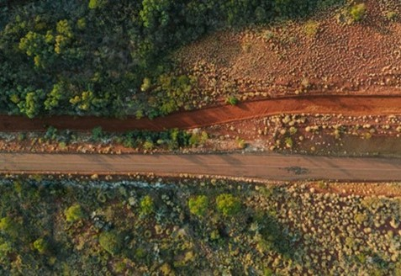



Pilbara

Regional Profiles

Overview
Pilbara is one of Australia’s largest mining regions, producing significant volumes of iron ore and hosting extensive gas extraction. The high level of energy-intensive mining activity, combined with the remoteness of operations, means the region remains heavily reliant on fossil fuels. However, government policies and mining companies’ decarbonisation commitments are expected to support the region to transition to a decarbonised future.
 | Population (2025)  - 62,170 persons  - 1.1% 5-year avg. annual growth  - WA: 2.3% 5-year avg. annual growth |  | Total Area  - 506,778.1 km²  - 20.1% of WA
 | Gross Regional Product (2022-23)  - $104.1 Billion  - 19.6% of WA |  | Employment (2022-23)  - 59,676 persons  - 4.6% of WA
Working Zones: Ashburton, East Pilbara, Karratha, Newman, Port Hedland, Roebourne and South Hedland (maps at end of profile).

Region Selection Rationale
Exposure to Decarbonisation | Economic Opportunities from Decarbonisation
- Carbon Intensity: 8 gas-fired power stations and 42 safeguard facilities. In 2024-25, safeguard facilities accounted for 69.7% of Western Australia’s Safeguard Mechanism direct (scope 1) emissions. Approximately 4.5% of jobs in the region are potentially impacted by decarbonisation.  - Urgency: The region is heavily reliant on fossil fuels, particularly gas, for electricity generation, underpinning both residential energy supply and extensive iron ore mining operations.  - Adaptive Capacity: Adaptive capacity is influenced by a mix of enabling and constraining factors. Households generally have high incomes, strong secondary school completion rates, and low unemployment, which supports adaptive capacity. However, the region’s remoteness from major population centres remains a key disadvantage.  - Readiness: Western Australia’s government plans include expansion of renewable energy infrastructure and emissions reduction initiatives. Several major mining firms have also committed to significant decarbonisation targets. | - Natural Assets: The Pilbara has substantial mineral resources that are critical to the manufacture of renewable energy technologies, which provides strong potential for the development of green industries. The region also benefits from high-quality solar energy resources.  - Workforce Compatibility: Approximately 35.0% of workers in the Pilbara are employed in roles that are highly compatible with clean energy industries.  - Enabling Infrastructure: Key infrastructure networks, such as the Port Hedland Airport and major transport corridors, including the Great Northern Highway and North West Coastal Highway, support export activity and enable labour mobility into and out of the region.
Source: NZEA (2026).

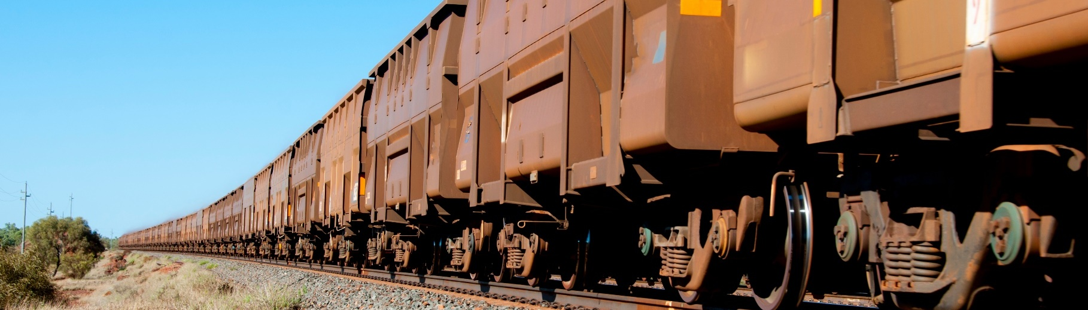
Carbon-Intensive Industries

Gas-Fired Power Stations
Facility | Owner | Public closure date | Employees | S1 emiss. (tCO2-e) (23/24) | % of WA S1 emiss. (23/24) | % of Aus S1 emiss. (23/24)
Cape Lambert | Rio Tinto | Unknown | Unknown | 108,551 | 0.2% | <0.1%
Karratha | ATCO | Unknown | 6 | 53,106 | 0.1% | <0.1%
Newman | APA | Unknown | 23 | 376,230 | 0.5% | 0.1%
Paraburdoo | Rio Tinto | Unknown | Unknown | 289,565 | 0.4% | 0.1%
Port Hedland | APA | Unknown | 11 | 340,466 | 0.5% | 0.1%
South Hedland | TransAlta | Unknown | 4 | 306,419 | 0.4% | 0.1%
West Angelas | Rio Tinto | Unknown | Unknown | 197,559 | 0.3% | 0.1%
Yurralyi Maya | Rio Tinto | Unknown | 375 | 410,351 | 0.6% | 0.1%
Total 8 | 4 | - | 419 | 2,082,247 | 3.0% | 0.6%
Note: S1 emiss. indicates Scope 1 Emissions. Further information on Scope 1 emissions can be found here.
Source: AEMO (2026), DCCEEW (2025a, 2025b).

Safeguard Facilities (Emit 100,000+ tonnes CO2 annually – power stations connected to grid are exempt)
Facility | No. | S1 emiss. (tCO2-e) (24/25) | % of WA Safeguard emiss. (24/25) | % of Aus Safeguard emiss. (24/25)
Metal ore mining | 25 | 6,797,563 | 14.4% | 5.1%
Oil and gas extraction | 9 | 21,692,719 | 45.9% | 16.2%
Electricity generation | 3 | 1,182,220 | 2.5% | 0.9%
Rail freight transport | 3 | 1,468,007 | 3.1% | 1.1%
Road freight transport | 1 | 126,242 | 0.3% | 0.1%
Fertiliser and pesticide manufacturing | 1 | 1,637,599 | 3.5% | 1.2%
Total | 42 | 32,904,350 | 69.7% | 24.6%
Note: S1 emiss. indicates Scope 1 Emissions. Further information on Scope 1 emissions can be found here.
Source: CER (2026).

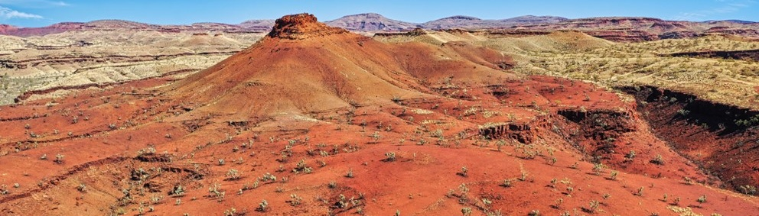
Major Commonwealth Funded Net Zero Projects (excluding cancelled and completed) (top projects by value)
This table reflects projects that have received Commonwealth funding (as of April 2026), identified through publicly available sources, consistent with the Net Zero Investment Map, including the programs below.
- Capacity Investment Scheme (CIS)
- Australia Renewable Energy Agency (ARENA)
- Clean Energy Finance Corporation (CEFC)
- Northern Australian Infrastructure Facility (NAIF)
- National Reconstruction Fund (NRF)
- Regional Hydrogen Hubs Program
Project | Description | Status | Cwth Govt Funding | Value
Mardie Salt Project | - Involves construction of large ponds, crystallisers, two process plants, and a new port facility for export of salt and other products.  - New trans-shipment port within Pilbara Ports Authority’s Cape Preston West Port area will enable exports and will be available to other developments in the region.  - Project aims to export 5 million tonnes per annum of high-purity salt via evaporation of seawater driven by solar and wind energy. | Development | $490.0M NAIF (Loan) | $1.3B
Fortescue Solar Innovation Hub | - Pilbara Energy, subsidiary of Fortescue, will partner with ARENA and emerging original equipment manufacturer (OEM) to identify, trial and deploy a range of technical and commercial innovations to drive down the levelised cost of energy of Solar PV in the Pilbara. | Concept | $45.0M ARENA | $500.0M
Decarbonising the Pilbara and Beyond | - Project involves a pre-FEED study focusing on renewable hydrogen production in the Pilbara, integrating various renewable energy technologies to supply up to 1GW of energy. | Concept | $21.5M ARENA | $94.7M
Yuri Renewable Hydrogen to Ammonia Project | - This facility will generate renewable hydrogen to produce renewable ammonia at Yara Pilbara Fertilisers’ neighbouring liquid ammonia plant. | Construction | $47.5M ARENA | $87.1M
Karratha Airport Solar Plant | - Project involves design, construction, commissioning and operation of a 1 MW solar photovoltaic facility with cloud predictive technology at Karratha Airport.  - The City of Karratha, which owns Karratha Airport, will enter into a 21-year power purchase agreement with the solar plant. | Operational | $2.3M ARENA | $6.8M
Note: Information correct as of April 2026.
Source: ARENA (2026), NZEA (2026).

Regional Renewable Energy Projects (aggregated)
The aggregated tables below draw on RenewMap’s energy project database which contains information on the location and size of public and privately funded energy generation projects. Results are shown in aggregated form to illustrate the breadth and depth of projects in the region.

Operational
Type | Projects (No.) | Total Project Size (MW) | Total Storage Size (MWh)
Battery | 4 | 263 | 265
Biogas | 3 | 18 | N/A
Hydrogen | 2 | 1 | N/A
Solar PV | 1 | 8 | N/A
Total | 10 | 290 | 265 (Known Storage)
Note:
- RenewMap is a commercial subscription and is not publicly available.
- MW = Megawatt. A unit that measures capacity of energy systems.
- MWh = Megawatt hour. In battery technology, this unit measures the total amount of energy the system can store.
- Information correct as of April 2026.
Source: RenewMap (2026).

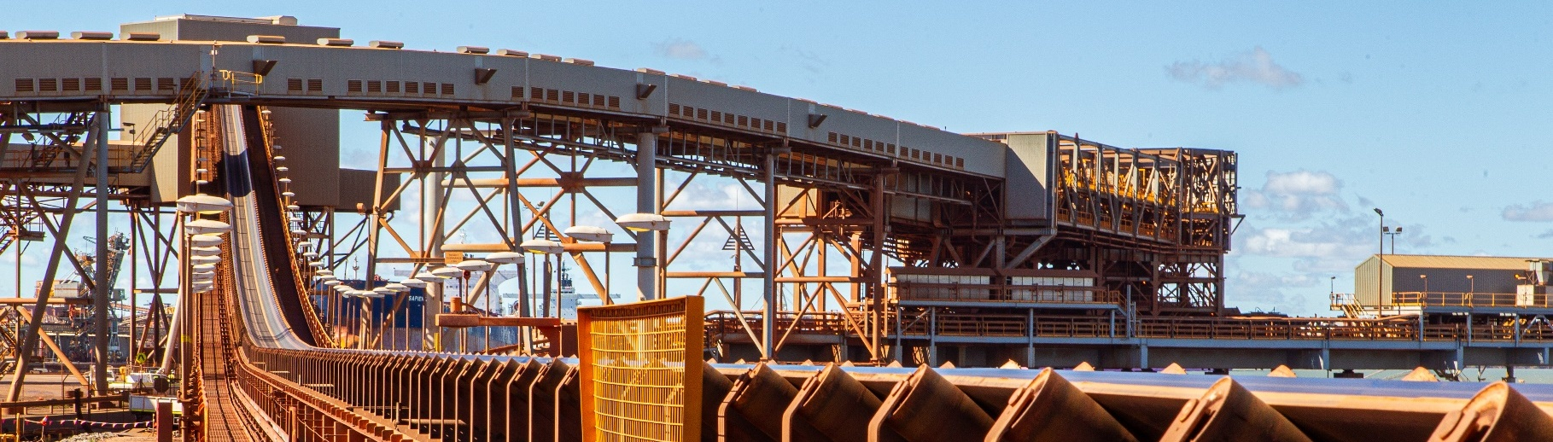
Under Development and Proposed
Type | Projects (No.) | Total Project Size (MW) | Total Storage Size (MWh)
Battery | 4 | 785 | 510
Hydrogen | 1 | 60 | N/A
Total | 5 | 845 | 510 (Known Storage)
Note:
- RenewMap is a commercial subscription and is not publicly available.
- MW = Megawatt. A unit that measures capacity of energy systems.
- MWh = Megawatt hour. In battery technology, this unit measures the total amount of energy the system can store.
- Information correct as of April 2026.
Source: RenewMap (2026).

Transmission Infrastructure Projects

North West Interconnected System (NWIS) Transmission Infrastructure Projects
Project | Description | Status | Timing | Cost
Pilbara Green Link | 550 kilometres of transmission lines will connect to Horizon Power’s infrastructure to the Australian Renewable Energy Hub (AREH) and other renewable energy projects. | Announced | Unknown | Unknown
Pilbara Energy Transition Plan | The Pilbara Energy Transition Plan identifies priority projects within strategic corridors in the Pilbara region that connect renewable resources to sites of industrial energy loads. | Announced | Unknown | Unknown
NWIS Upgrades | Includes various expansions to existing NWIS to improve capacity and facilitate the integration of renewable energy projects. | Ongoing | Unknown | Unknown
Source: DCCEEW (2023), PV Magazine (2024), WA Govt (2026).

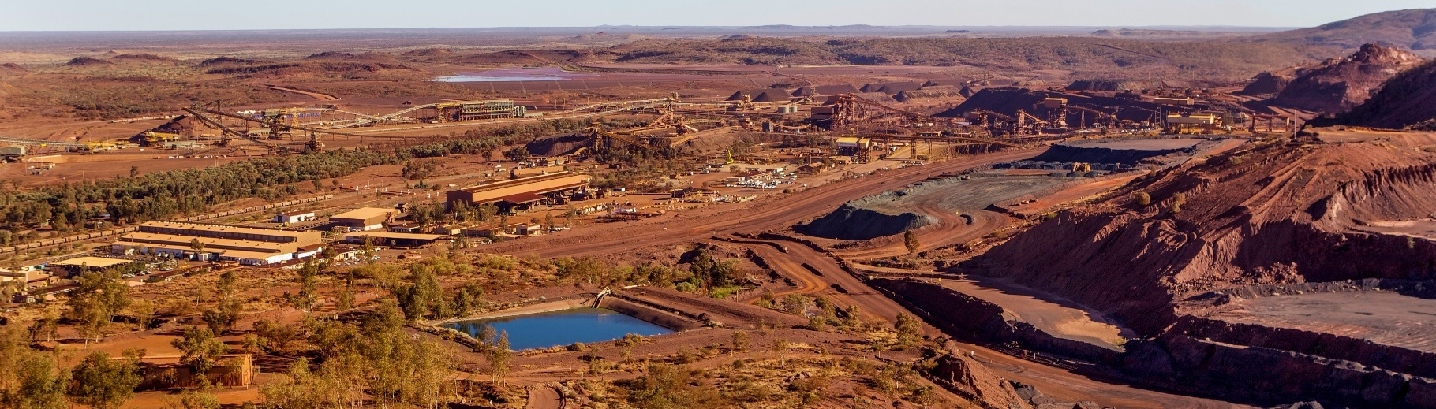

Major Industries

Gross Value Add (2022-23)
Ranked Industries (Top Five) | Value ($M) | % of GVA
Mining | $83,044.1 | 92.9%
Construction | $1,896.4 | 2.1%
Rental, Hiring and Real Estate Services | $1,097.5 | 1.2%
Transport, Postal and Warehousing | $639.8 | 0.7%
Public Administration and Safety | $353.4 | 0.4%
Note: Gross Value Add estimates are sourced from REMPLAN (2026), incorporating Australia Bureau of Statistics (ABS) 2021 Census (PoW), ABS 2024 Estimated Resident Population, ABS 2022–23 National Input–Output Tables, and ABS June 2025 Gross State Product into its modelling. Gross Value Add (GVA) measures the value of goods and services produced, minus the cost inputs used in production. Further information on GVA can be found here.
Source: REMPLAN (2026).

Employment

Place of Work (2022-23)
Ranked Industries (Top Five) | Employees (No.) | % of Employment
Mining | 31,295 | 52.4%
Construction | 6,530 | 10.9%
Accommodation and Food Services | 2,968 | 5.0%
Transport, Postal and Warehousing | 2,849 | 4.8%
Health Care and Social Assistance | 2,240 | 3.8%
Note: Employment by Place of Work (PoW) estimates are sourced from REMPLAN (2026), incorporating Australia Bureau of Statistics (ABS) 2021 Census by PoW, ABS 2024 Estimated Resident Population, ABS 2022–23 National Input–Output Tables, and ABS June 2025 Gross State Product into its modelling.
Source: REMPLAN (2026).

Employment – Place of Usual Residence (2021)
Ranked Industries (Top Five) | Employees (No.) | % of Employment
Mining | 9,072 | 34.3%
Construction | 2,394 | 9.0%
Education and Training | 1,971 | 7.4%
Health Care and Social Assistance | 1,889 | 7.1%
Transport, Postal and Warehousing | 1,680 | 6.3%
Source: ABS (2021).

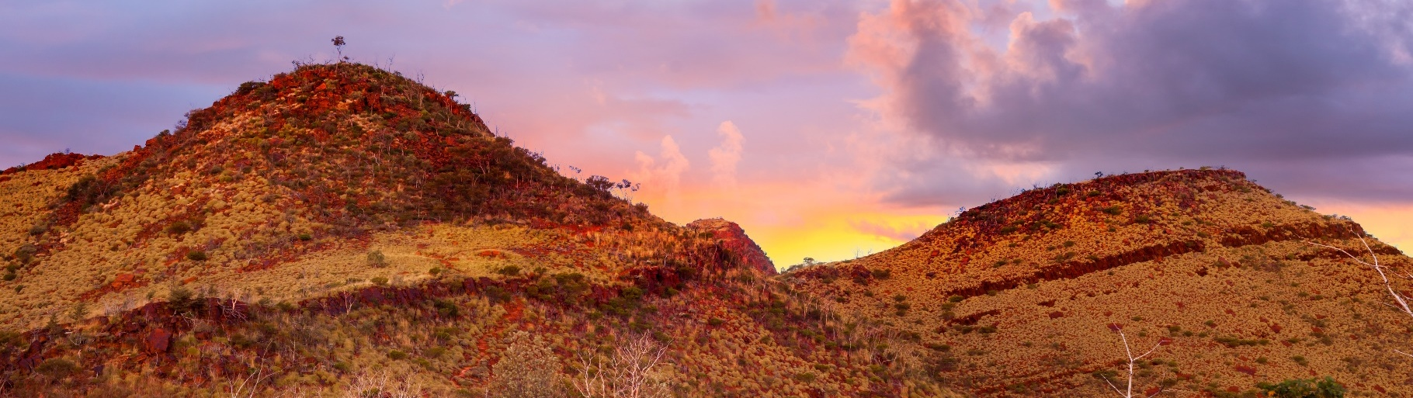
Key Economic and Social Indicators

Employment
Indicator (2021 Census unless otherwise stated) | Pilbara | Western Australia
Median working age | 38 | 40
Median income (annual gross, exc. super) | $78,000 – $80,999 | $33,800 – $41,599
Participation in workforce | 67.5% | 63.9%
Female participation in workforce | 65.2% | 60.3%
Workforce Self-Sufficiency (% of Workerforce) | 46.9% | N/A
Unemployment rate (Dec 2025) | 2.8% | 4.0%
Regional Labour Market Index (Dec 2025) | Below Average | N/A
Source: ABS (2021), DEWR (2026), JSA (2026).

Demographics
Indicator (2021 Census) | Pilbara | Western Australia
Median age | 33 | 38
First Nations (% of population) | 17.6% | 3.5%
Educational attainment (% of population aged 15 and above):
- Below Year 12 | 45.2% | 60.3%
- Year 12 or equivalent | 54.8% | 60.3%
- Certificate III and IV | 30.8% | 19.4%
- Bachelor and above | 16.4% | 26.1%
Source: ABS (2021).

Housing
Indicator (2021 Census) | Pilbara | Western Australia
Homelessness (% of population) | 1.1% | 0.4%
Commonwealth Rent Assistance (% of population) (Jun 2025) | 1.0% | 3.9%
Mortgage stress | 10.5% | 12.9%
Rental stress | 13.6% | 28.4%
Source: ABS (2021), DSS (2025).

Safeguard Facilities Map
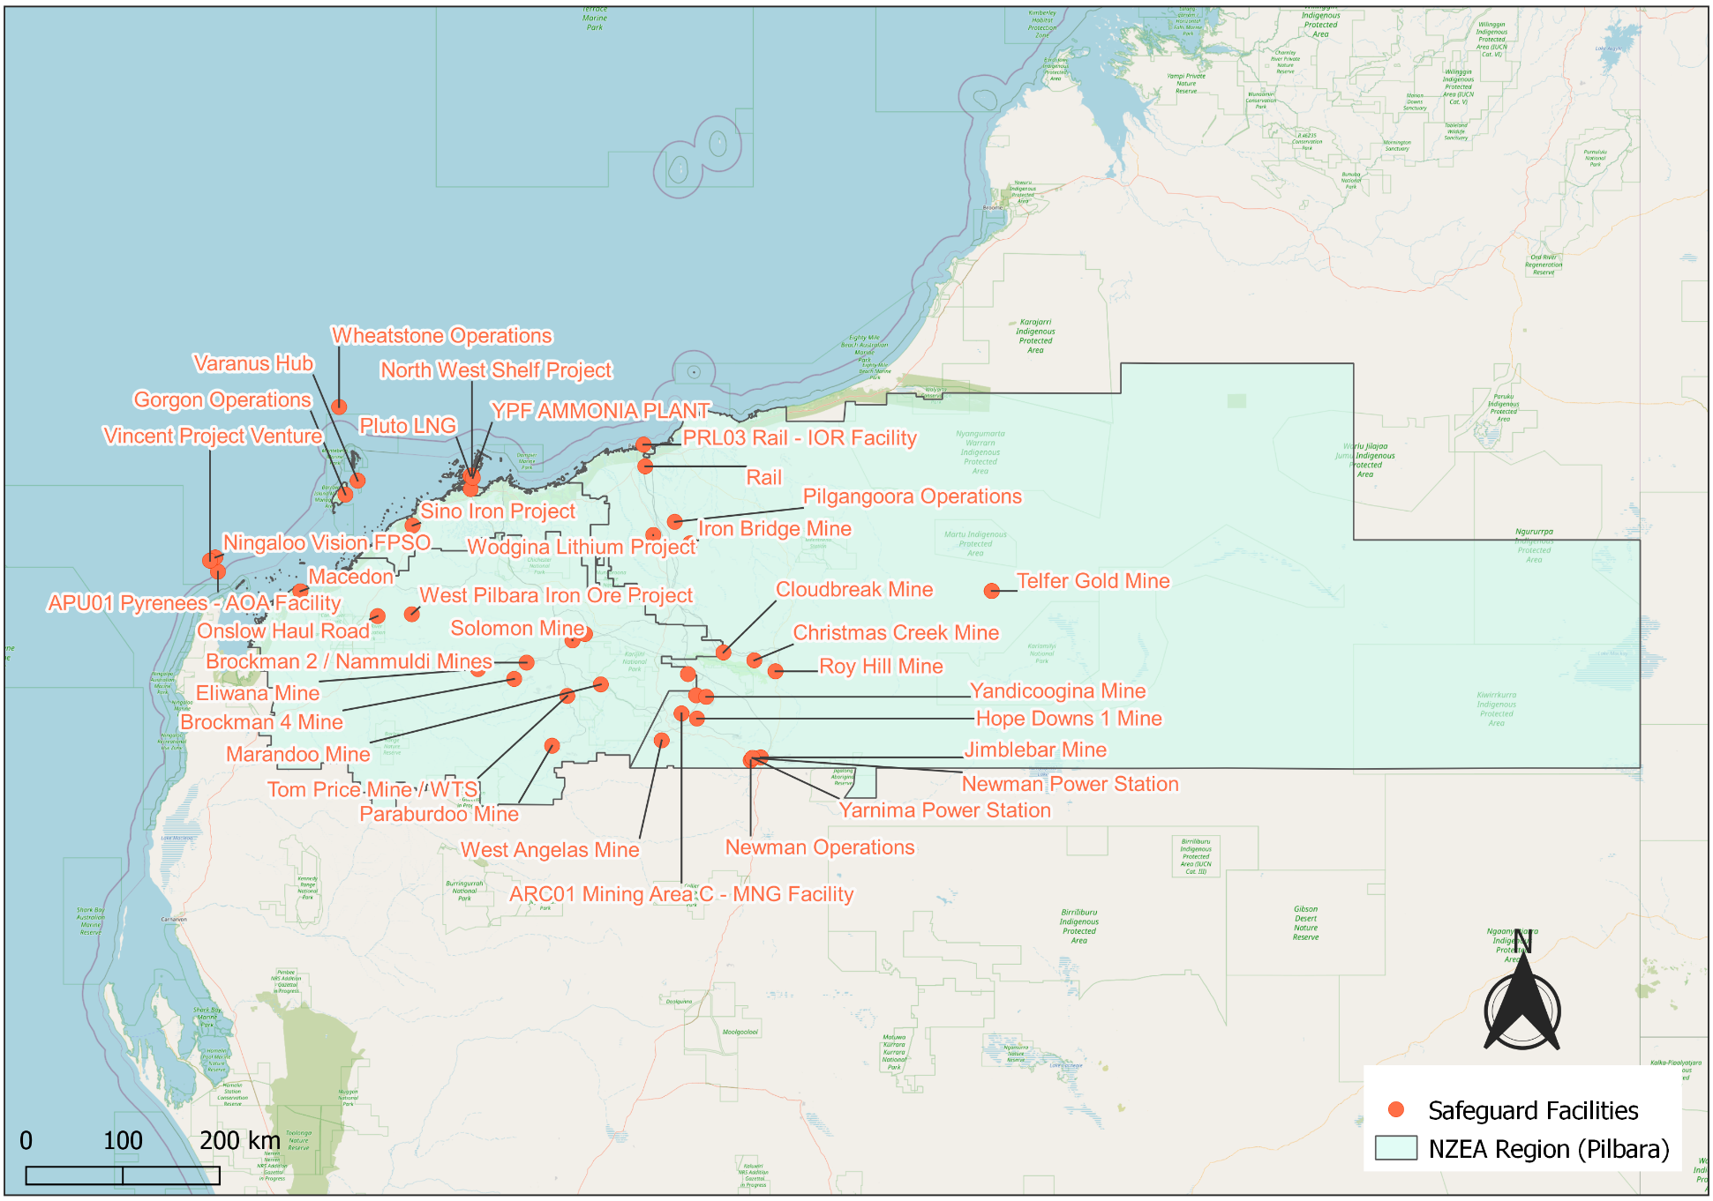
Source: DCCEEW (2025b).

Gas-Fired Power Stations Map
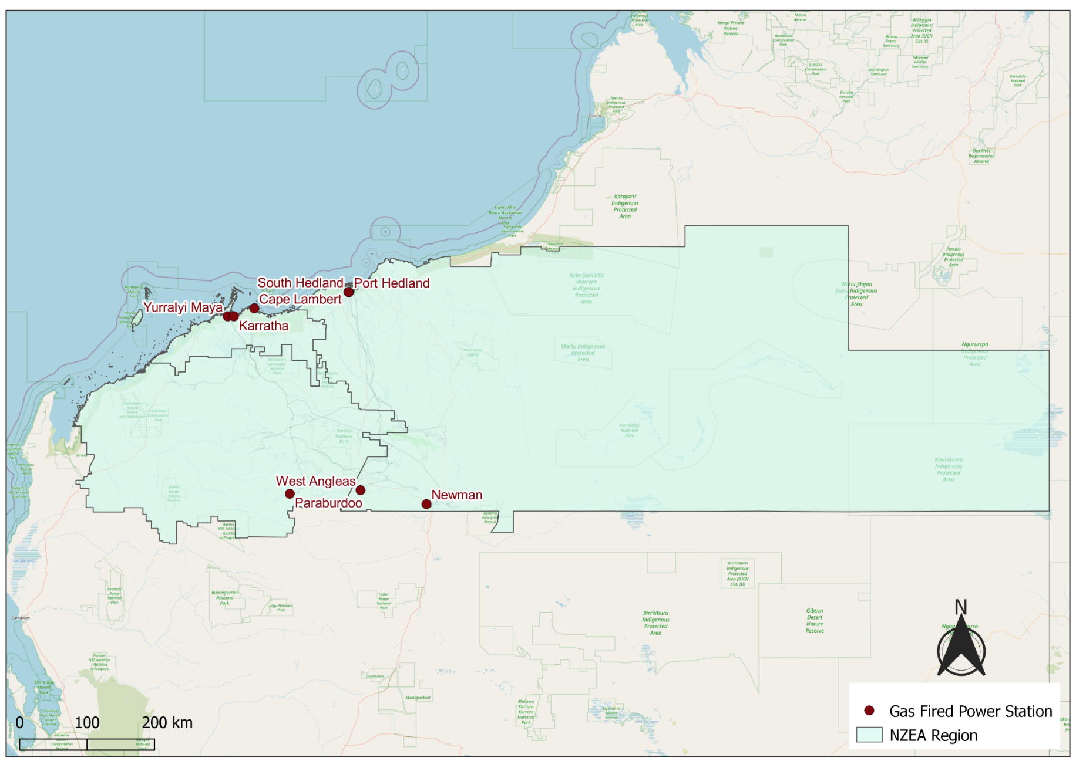
Source: AEMO (2026).

Commonwealth Funded Net Zero Projects Map (Current & Proposed)
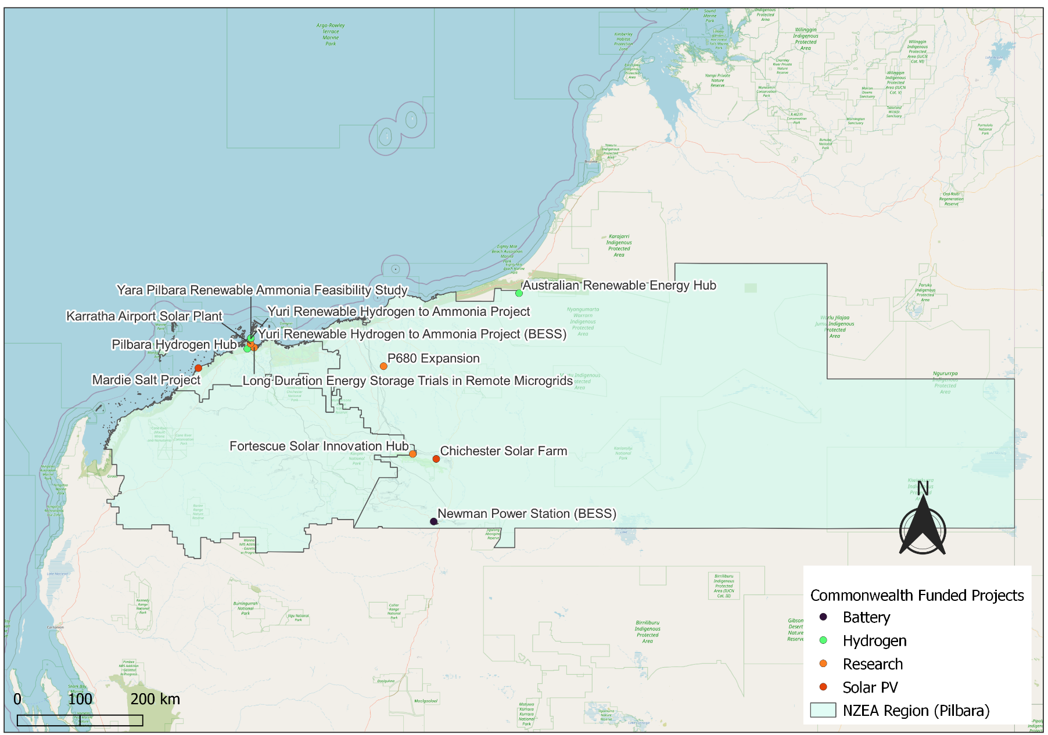
Note:
- Commonwealth funded projects include projects from the following schemes, Capacity Investment Scheme. Australian Renewable Energy Agency, Clean Energy Finance Corporation, Northern Australia Infrastructure Facility, National Reconstruction Fund, Regional Hydrogen Hubs Program.
- Information correct as of April 2026.
Source: NZIM (2026).

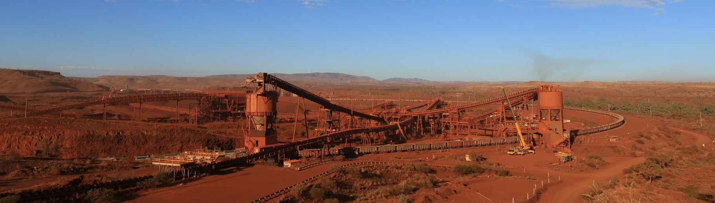
References
ABS (Australian Bureau of Statistics) (2021) Census of Population and Housing, abs.gov.au, accessed 10 February 2026.
ABS (Australian Bureau of Statistics) (2026) Regional population, abs.gov.au, accessed 1 April 2026.
AEMO (Australian Energy Market Operator) (2026) Generation information, aemo.com.au, accessed 10 February 2026.
CER (Clean Energy Regulator) (2026) Safeguard facility covered emissions data 2024–25, cer.gov.au, accessed 20 April 2026.
DCCEEW (Department of Climate Change, Energy, the Environment and Water) (2023) Joint media release: $3 billion Rewiring the Nation deal to power WA jobs and growth, minister.dcceew.gov.au, accessed 1 April 2026.
DCCEEW (Department of Climate Change, Energy, the Environment and Water) (2025a) National Pollutant Inventory – Reports, data.gov.au, accessed 10 February 2026.
DCCEEW (Department of Climate Change, Energy, the Environment and Water) (2025b) Australia’s National Greenhouse Accounts, Emissions by State and Territory, greenhouseaccounts.climatechange.gov.au, accessed 10 February 2026.
DEWR (Department of Employment and Workplace Relations) (2026) Small Area Labour Market, dewr.gov.au, accessed 10 February 2026.
DSS (Department of Social Services) (2025) DSS Benefit and Payment Recipient Demographics – quarterly data, data.gov.au, accessed 10 February 2026.
J&SA (Jobs and Skills Australia) (2026) Regional Labour Market Indicator, jobsandskills.gov.au, accessed 10 February 2026.
NZEA (Net Zero Economy Authority) (2026). Regional Identification Framework and Profiles, netzero.gov.au, accessed 8 May 2026.
NZIM (Net Zero Investment Map) (2026). Net Zero Investment Map, netzeromap.au, accessed 10 February 2026.
PV Magazine (PV Magazine Australia) (2024) Transmission line go-ahead gets Western Australia’s Pilbara Green Link moving, pv-magazine-australia.com, accessed 1 April 2026.
REMPLAN (REMPLAN Pty Ltd) (2026) Economy, remplan.com.au, accessed 10 February 2026.
RenewMap (RenewMap Pty Ltd) (2026) Visualising Australia’s Energy Future, renewmap.com.au, accessed 10 February 2026.
WA Govt (Western Australia Government (2026) Pilbara Energy Transition (PET) Plan, State of Energy, stateofenergy.wa.gov.au, accessed 30 April 2026.

