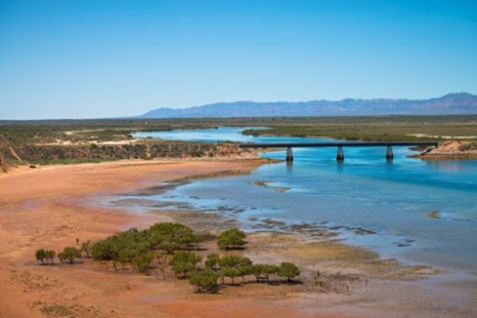



Upper Spencer Gulf

Regional Profiles

Overview
The Upper Spencer Gulf is a nationally significant clean‑energy and low‑emissions industrial region, supported by strong renewable energy resources, established heavy‑industry capability, and a growing pipeline of renewable energy projects. The region is well positioned to benefit from Australia’s decarbonisation, with existing industrial assets, a workforce well-suited to clean‑industry roles, and ongoing investment driving a transition towards renewable‑powered manufacturing and export‑oriented clean energy industries.
 | Population (2025)  - 70,069 persons  - -0.1% 5-year avg. annual growth  - SA: 1.2% 5-year avg. annual Growth |  | Total Area  - 56,076.4 km²  - 5.7% of SA
 | Gross Regional Product (2022-23)  - $6.4 Billion  - 4.1% of SA |  | Employment (2022-23)  - 28,366 persons  - 3.4% of SA
Working Zones: Jamestown, Kimba-Cleve-Franklin Harbour, Peterborough-Mount Remarkable, Port Augusta and Quorn-Lake Gilles, Port Pirie and region, Whyalla and Whyalla North (maps at end of profile).

Regional Selection Rationale
Exposure to Decarbonisation | Economic Opportunities from Decarbonisation
- Carbon intensity: As of 2024-25, 4 safeguards, accounting for 44.4% of South Australia’s scope 1 safeguard emissions.  - Urgency: While there are no announced closures, the Upper Spencer Gulf faces medium‑term transition risk due to its concentration of emissions‑intensive industries.  - Adaptive capacity: Adaptive capacity is low across all localities in the Upper Spencer Gulf. Driven by low levels of dwelling investment, low high-school completion rates and declining working age population. | - Natural Capital: The Upper Spencer Gulf has strong renewable energy resources and exceptional potential to support large‑scale clean‑energy and hydrogen‑based industries. This includes favourable conditions for solar, wind and pumped hydro, alongside potential investment in hydrogen production and low‑emissions industrial processing.  - Workforce Compatibility: A high proportion of workers in Whyalla are employed in jobs highly compatible with clean energy industries. There is moderate compatibility across the rest of the region.  - Enabling Infrastructure: The Upper Spencer Gulf benefits from established and expanding industrial, transport, and export infrastructure.
Source: NZEA (2026).
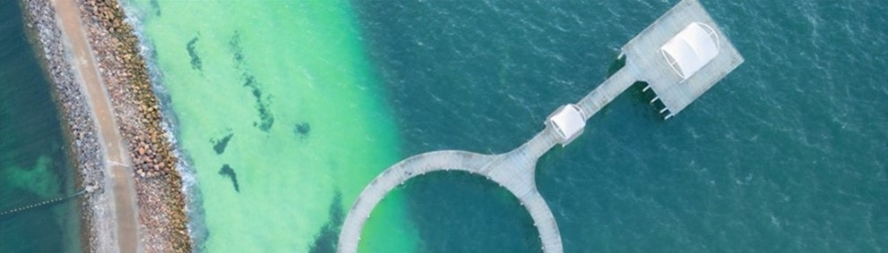
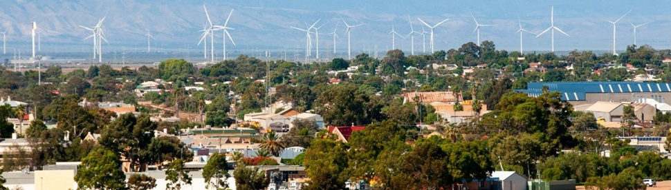
Carbon-Intensive Industries

Safeguard Facilities (Emit 100,000+ tonnes CO2 annually – power stations connected to grid are exempt)
Facility | S1 emiss. (tCO2-e) (24/25) | % of SA Safeguard emiss. (24/25) | % of Aus Safeguard emiss. (24/25)
Liberty Primary Steel Whyalla Steelworks | 1,287,610 | 30.8% | 1.0%
Nyrstar Port Pirie Facility | 426,225 | 10.2% | 0.3%
Port Bonython Plant | 77,542 | 1.9% | 0.1%
Middleback Range Iron Ore Mine (Whyalla) | 61,296 | 1.5% | <0.0%
Total | 1,852,673 | 44.4% | 1.4%
Note: S1 emiss. indicates Scope 1 Emissions. Further information on Scope 1 emissions can be found here.
Source: CER (2026).

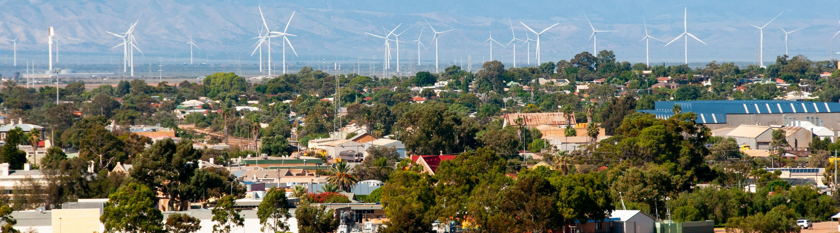
Major Commonwealth-funded Net Zero Projects (excluding cancelled and completed) (top projects by value)
This table reflects projects that have received Commonwealth funding (as of April 2026), identified through publicly available sources, consistent with the Net Zero Investment Map, including the programs below.
- Capacity Investment Scheme (CIS)
- Australia Renewable Energy Agency (ARENA)
- Clean Energy Finance Corporation (CEFC)
- Northern Australian Infrastructure Facility (NAIF)
- National Reconstruction Fund (NRF)
- Regional Hydrogen Hubs Program
Project | Description | Status | Cwth Govt Funding | Value
Port Bonython Export Hub | The Port Bonython Export Hub is a large-scale renewable hydrogen production precinct for both export and domestic markets | Announced | $70.0M Regional Hydrogen Hubs | $100.0M
Carmodys Hill Wind Farm | Carmodys Hill Wind Farm is a 256.2MW onshore wind project located in the Northern Areas region. When operational, the project will be powered by 42 wind turbines and produce enough energy to power more than 195,000 homes. | Construction | $147.0M CEFC | Unknown
Koolunga Battery Energy Storage System (BESS) | Koolunga BESS is a battery project located in the Port Pirie region. The project is expected to include 640 battery units and enabling infrastructure which will connect to the National Electricity Market (NEM). | Development | N/A Capacity Investment Scheme (CIS) | Unknown
Whyalla Steelworks Upgrades | The South Australian and Australian Governments, along with a new owner, will invest in upgrades and new infrastructure to support the long-term transition of the Whyalla Steelworks. Upgrades include a new electric arc furnace, direct reduced iron plant, casting and rolling mill improvements, and gas supply infrastructure. | Announced | $1.9B SA Govt/ Aus Govt | Unknown
Note:
- Information correct as of April 2026.
- Whyalla Steelworks Upgrades is not included on the Net Zero Investment Map.
Source: CEFC (2025), Infrastructure Pipeline (2026), NZIM (2026), SA Govt (2025).

Regional Renewable Energy Projects (aggregated)
The aggregated tables below draw on RenewMap’s energy project database which contains information on the location and size of public and privately funded energy generation projects. Results are shown in aggregated form to illustrate the breadth and depth of projects in the region.

Operational
Type | Projects (No.) | Total Project Size (MW) | Total Storage Size (MWh)
Battery | 4 | 170 | 216
Onshore Wind | 8 | 1,092 | N/A
Solar Photovoltaic (Solar PV) | 10 | 170 | N/A
Total | 22 | 1,432 | 216 (Known Storage)
Note:
- RenewMap is a commercial subscription and is not publicly available.
- MW = Megawatt. A unit that measures capacity of energy systems.
- MWh = Megawatt hour. In battery technology, this unit measures the total amount of energy the system can store.
- Information correct as of April 2026.
Source: RenewMap (2026).

Under Development and Proposed
Type | Projects (No.) | Total Project Size (MW) | Total Storage Size (MWh)
Battery | 12 | 2,087 | 9,100
Hydrogen | 3 | 275 | N/A
Onshore Wind | 4 | 4,956 | N/A
Pumped Hydro | 1 | 500 | 5,000
Solar Photovoltaic (Solar PV) | 8 | 1,485 | N/A
Solar Thermal | 1 | 90 | 720
Total | 29 | 9,393 | 14,820 (Known Storage)
Note:
- RenewMap is a commercial subscription and is not publicly available.
- MW = Megawatt. A unit that measures capacity of energy systems.
- MWh = Megawatt hour. In battery technology, this unit measures the total amount of energy the system can store.
- Information correct as of April 2026.
Source: RenewMap (2026).

Transmission Infrastructure Projects

Australian Energy Market Operator (AEMO) Draft 2026 Integrated System Plan (ISP)
Project | Description | Status | Timing | Cost
Project EnergyConnect – Stage 2 | New 330 kilovolts (kV) double-circuit interconnector between SA and NSW, with new 220 kV double circuit line to Victoria. | Committed | Nov 2027 | $3.6B
Note: ± indicates the cost uncertainty range.
Source: AEMO (2026b), Transgrid (2025).

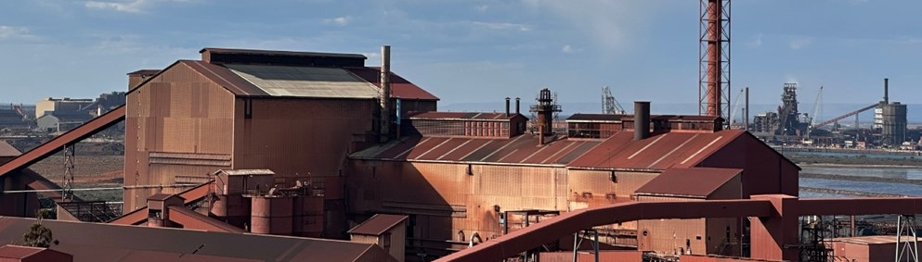
Major Industries

Gross Value Add (2022-23)
Ranked Industries (Top Five) | Value ($M) | % of GVA
Mining | $1,449.3 | 24.1%
Rental, Hiring and Real Estate Services | $660.4 | 11.0%
Agriculture, Forestry and Fishing | $541.2 | 9.0%
Health Care and Social Assistance | $529.7 | 8.8%
Manufacturing | $509.5 | 8.5%
Note: Gross Value Add estimates are sourced from REMPLAN (2026), incorporating Australia Bureau of Statistics (ABS) 2021 Census (PoW), ABS 2024 Estimated Resident Population, ABS 2022–23 National Input–Output Tables, and ABS June 2025 Gross State Product into its modelling. Gross Value Add (GVA) measures the value of goods and services produced, minus the cost inputs used in production. Further information on GVA can be found here.
Source: REMPLAN (2026).

Employment

Place of Work (2022-23)
Ranked Industries (Top Five) | Employees (No.) | % of Employment
Health Care and Social Assistance | 4,732 | 16.7%
Retail Trade | 2,930 | 10.3%
Manufacturing | 2,921 | 10.3%
Education and Training | 2,690 | 9.5%
Construction | 2,386 | 8.4%
Note: Employment by Place of Work (PoW) estimates are sourced from REMPLAN (2026), incorporating Australia Bureau of Statistics (ABS) 2021 Census by PoW, ABS 2024 Estimated Resident Population, ABS 2022–23 National Input–Output Tables, and ABS June 2025 Gross State Product into its modelling.
Source: REMPLAN (2026).

Place of Usual Residence (2021)
Ranked Industries (Top Five) | Employees (No.) | % of Employment
Health Care and Social Assistance | 4,399 | 16.1%
Retail Trade | 2,795 | 10.2%
Manufacturing | 2,714 | 9.9%
Education and Training | 2,514 | 9.2%
Agriculture, Forestry and Fishing | 2,301 | 8.4%
Source: ABS (2021).

Key Economic and Social Indicators

Employment
Indicator (2021 Census unless otherwise stated) | Upper Spencer Gulf | South Australia
Median working age | 42 | 40
Median income (annual gross, exc. super) | $26,000 – $33,799 | $33,800 – $41,599
Participation in workforce | 53.5% | 60.0%
Female participation in workforce | 51.1% | 56.8%
Workforce Self-Sufficiency (% of Workforce) | 95.2% | N/A
Unemployment rate (Dec 2025) | 10.9% | 4.2%
Regional Labour Market Index (Sep 2025) | Below Average | N/A
Source: ABS (2021), DEWR (2026), JSA (2026).

Demographics
Indicator (2021 Census) | Upper Spencer Gulf | South Australia
Median age | 44 | 41
First Nations (% of population) | 8.5% | 2.5%
Educational attainment (% of population aged 15 and above):
- Below Year 12 | 62.1% | 44.3%
- Year 12 or equivalent | 37.9% | 55.7%
- Certificate III and IV | 23.8% | 18.9%
- Bachelor and above | 10.8% | 24.4%
Source: ABS (2021).

Housing
Indicator (2021 Census) | Upper Spencer Gulf | South Australia
Homelessness (% of population) | 0.9% | 0.4%
Commonwealth Rent Assistance (% of population) (Sep 2025) | 6.2% | 5.4%
Mortgage stress | 11.8% | 12.0%
Rental stress | 22.3% | 30.1%
Source: ABS (2021), DSS (2025).

Safeguard Facilities Map
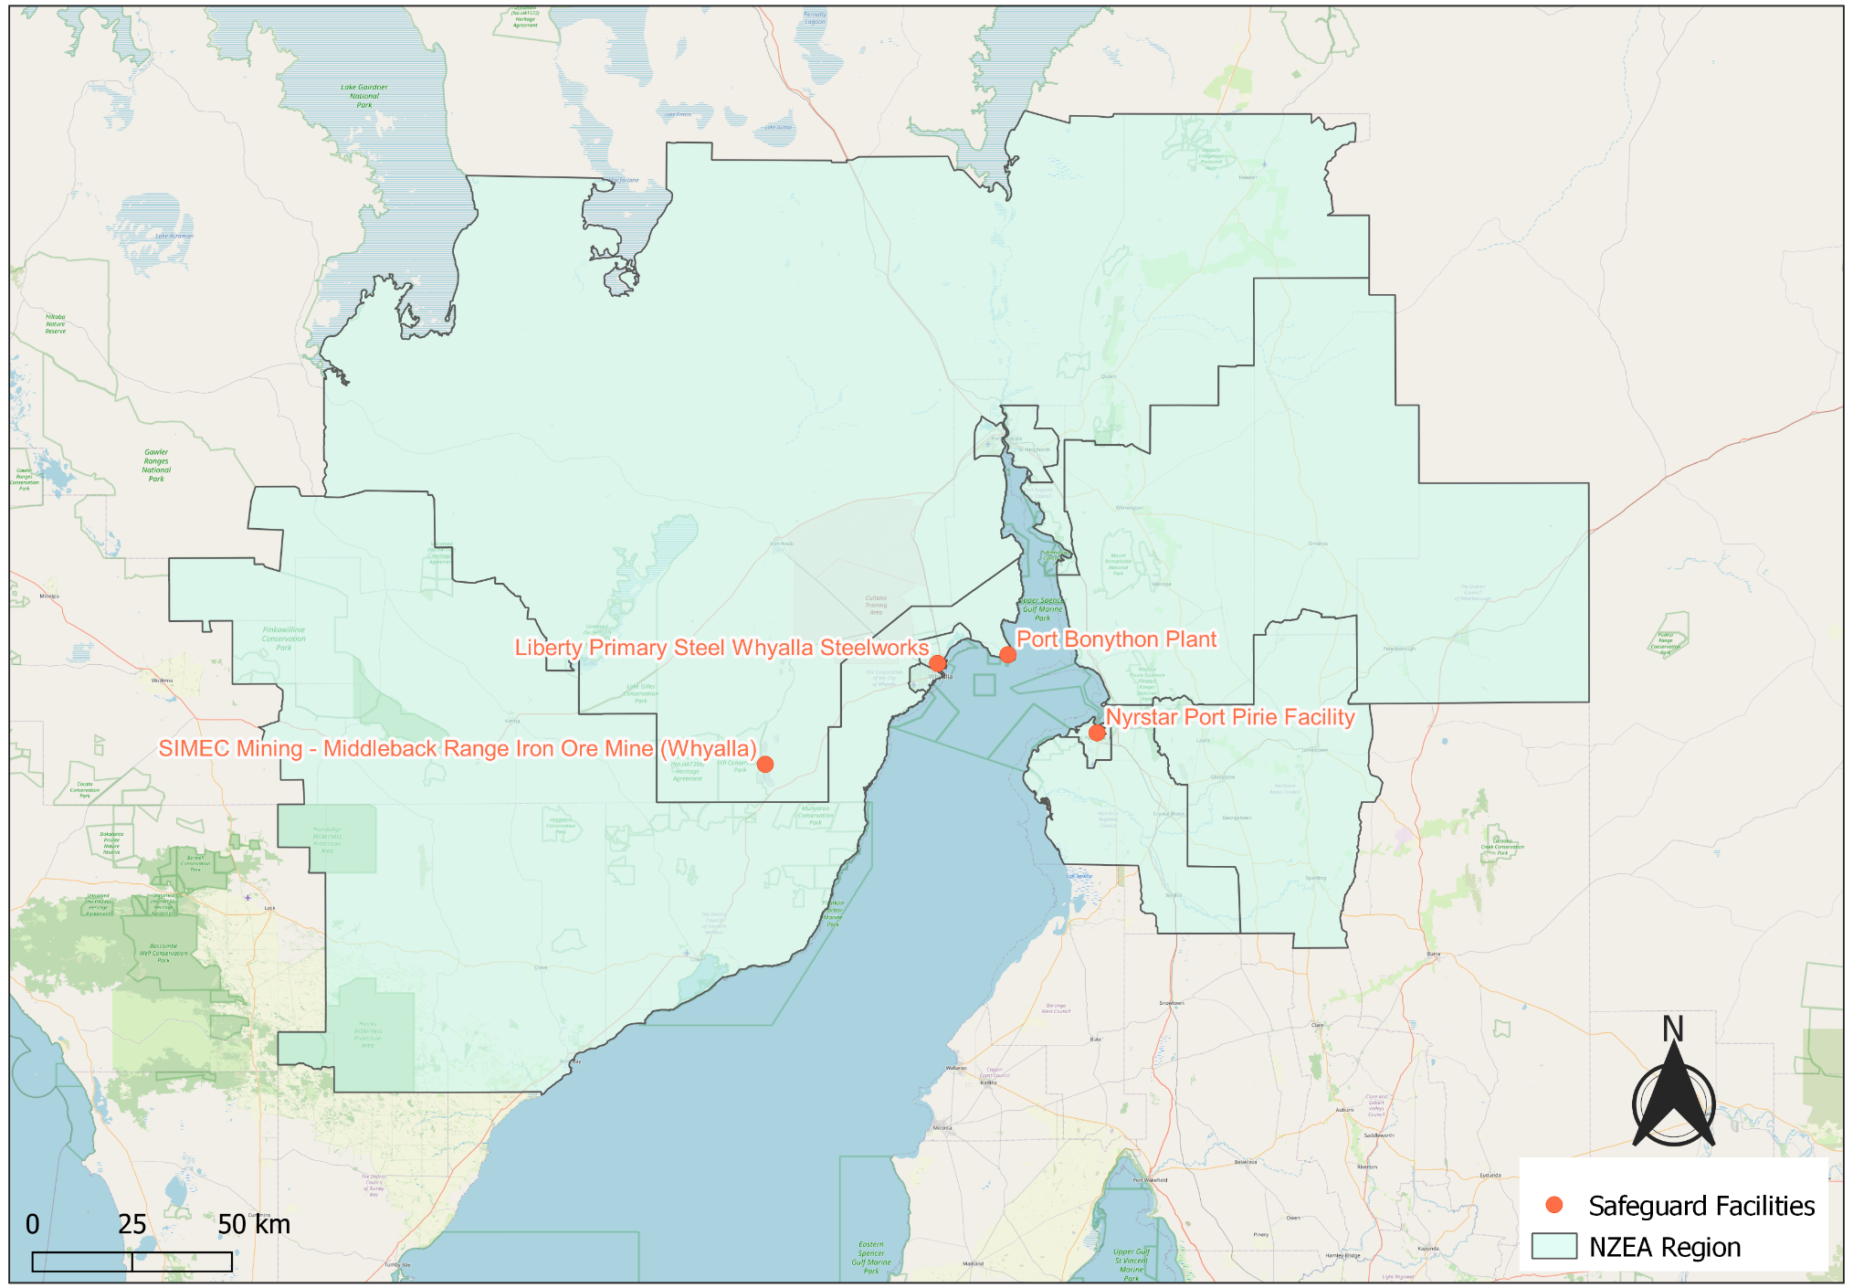
Source: DCCEEW (2025b).

Commonwealth Funded Net Zero Projects Map (Current & Proposed)
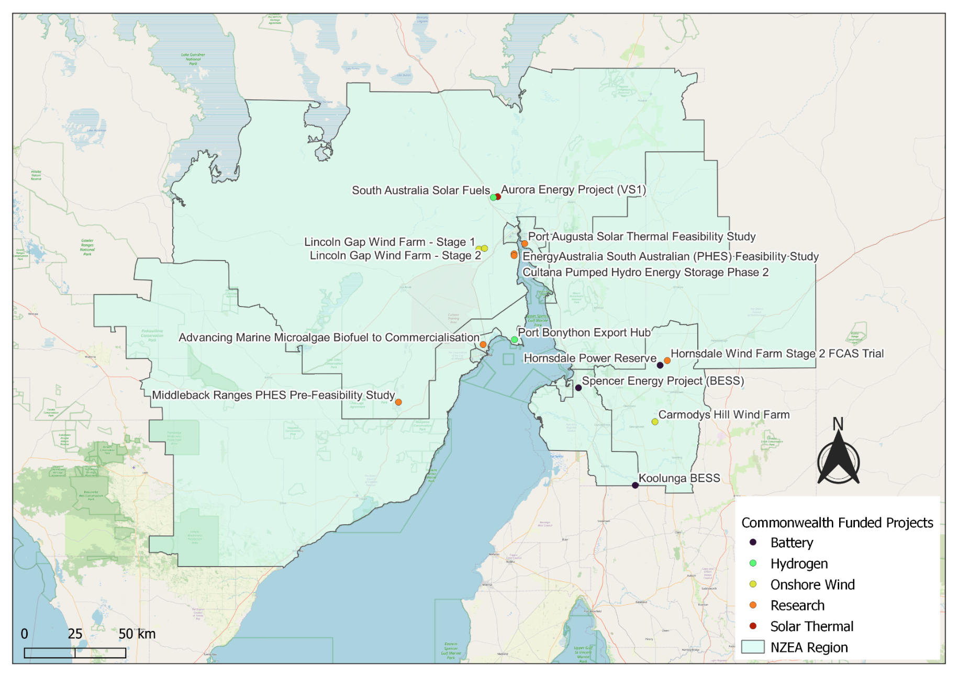
Note:
- Commonwealth funded projects include projects from the following schemes, Capacity Investment Scheme. Australian Renewable Energy Agency, Clean Energy Finance Corporation, Northern Australia Infrastructure Facility, National Reconstruction Fund, Regional Hydrogen Hubs Program.
- Information correct as of April 2026.
Source: NZIM (2026).

References
ABS (Australian Bureau of Statistics) (2021) Census of Population and Housing, abs.gov.au, accessed 10 February 2026.
ABS (Australian Bureau of Statistics) (2026) Regional population, abs.gov.au, accessed 1 April 2026.
AEMO (Australian Energy Market Operator) (2026a) Generation information, aemo.com.au, accessed 10 February 2026.
AEMO (Australian Energy Market Operator) (2026b) Draft 2026 Integrated System Plan (ISP), aemo.com.au, accessed 10 March 2026.
CEFC (Clean Energy Financial Corporation) (2025) CEFC supports SA clean energy ambitions with new wind farm investment, cefc.com.au, accessed 1 May 2026.
CER (Clean Energy Regulator) (2026) Safeguard facility covered emissions data 2024–25, cer.gov.au, accessed 20 April 2026.
DCCEEW (Department of Climate Change, Energy, the Environment and Water) (2025a) National Pollutant Inventory – Reports, data.gov.au, accessed 10 February 2026.
DCCEEW (Department of Climate Change, Energy, the Environment and Water) (2025b) Australia’s National Greenhouse Accounts, Emissions by State and Territory, greenhouseaccounts.climatechange.gov.au, accessed 10 February 2026.
DEWR (Department of Employment and Workplace Relations) (2026) Small Area Labour Market, dewr.gov.au, accessed 10 February 2026.
DSS (Department of Social Services) (2025) DSS Benefit and Payment Recipient Demographics – quarterly data, data.gov.au, accessed 10 February 2026.
Infrastructure Pipeline (Australia New Zealand Infrastructure Pipeline) (2025) Koolunga BESS, infrastructurepipeline.org, accessed 1 May 2026.
JSA (Jobs and Skills Australia) (2026) Regional Labour Market Indicator, jobsandskills.gov.au, accessed 10 February 2026.
NZEA (Net Zero Economy Authority) (2026). Regional Identification Framework and Profiles, netzero.gov.au, accessed 8 May 2026.
NZIM (Net Zero Investment Map) (2026). Net Zero Investment Map, netzeromap.au, accessed 10 February 2026.
REMPLAN (REMPLAN Pty Ltd) (2026) Economy, remplan.com.au, accessed 10 February 2026.
RenewMap (RenewMap Pty Ltd) (2026) Visualising Australia’s Energy Future, renewmap.com.au, accessed 10 February 2026.
SA Govt (South Australia Government) (2025) Sovereign Steel Package, whyalla.sa.gov.au, accessed 8 May 2026.
Transgrid (2025) EnergyConnect update, transgrid.com.au, accessed 2 April 2026.

